1.0 OBJECTIVE

This procedure provides installation details for underground cable laying for external HT cable with specification, quality control and Safety Plan pertaining to this project.

2.0 SCOPE

Method of installation is accordance to latest IEC, IEE, MS, JKR & TNB requirements and local authority standards.

3.0 TOOLS AND EQUIPMENTS

Excavator, nylon rope, winch, spade, cable jack, trailer, stands, cable stocking, pump, swivels and compactor.

4.0 WORK METHOD STATEMENT

4.1 Cable Alignment/Routing

- Refer to latest external coordination drawing and shop drawing to identify the exact location for excavation. All 33kV cable will be laid inside HDPE 150mm PN10 pipes.
- Prior to excavation, the Surveyor sets out the area to be excavated and "Permit to excavate" is submitted for approval. Excavation commences only upon receipt of approved work permit.
- Client’s Surveyor to verify & accept the routing.

4.2 Excavation

- Excavate the trenches to a width sufficient for satisfactory, not less than 2.0 meters for 8 nos of PN10 pipes and not less than 1.5 meter for 4 nos of PN10 pipes. Maintain safe working
conditions and assure compliance with all relevant Acts, Regulations and requirements of public or statutory authorities.
- Request for inspection to be provided to inspect the excavated area.

4.3 PN10 Pipe Installation
- PN10 Pipe Inspection
- Request for inspection for pipe delivery and installation to be provided
- All PN10 pipe used will be as per approved material submittal.
- Upon delivery the pipe shall be visually inspected for damage, which may have occurred during transport.
- PN10 pipe standard length are 6 mtr per length.

- PN10 Pipe Installation.
- The excavation depth shall be 1.2 meter from finish road level.
- First layer/base shall be 150mm of clean sand. The PN10 pipe are laid on top of the sand and then bedded with another of 250mm of clean sand. The detail of the arrangement is shown in fig.1.
- PN10 pipe socket shall be used to joint all pipes.
- The pipe will be tested individually for blockages. Finally, each PN10 pipe are then installed with draw wire.

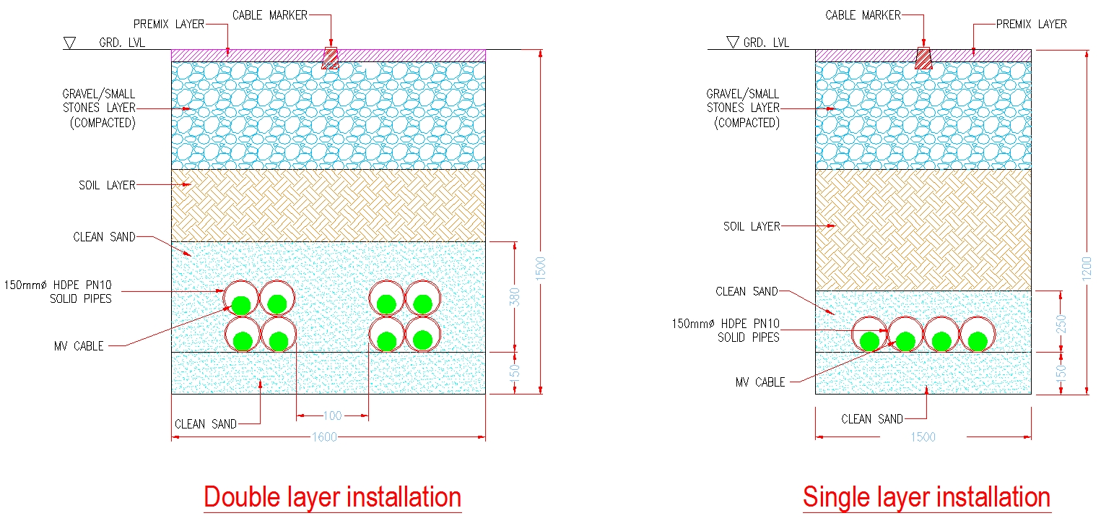
Add Warning Tape

Fig. 1 Underground cable laying detail

4.4 Cable Laying

4.4.1 Drum Inspection and Mounting

- Request for inspection will be issued for cable delivery inspection

- Upon delivery, the cable drum should be visually inspected for damage, which may have occurred during transport. The manufacturer’s seal on the inner and outer cable ends
should be examined and the condition of armouring, serving and sheath inspected for mechanical damage, corrosion and leakage of impregnating oil. If the cable is found defective it shall not be installed and the cable shall be returned to the supplier for replacement.

- During installation the cable should be carefully examined for any sign of damage as it leaves the drum. This is particularly important on the outer layers, where drum batten
nails can cause damage.

- If it is necessary to roll the cable drum, it should be rolled in the direction indicated by the arrow on the drum.

- The drum should be mounted on jacks, cable trailer or cable stands such that the cable is preferably pulled from the top and always in the direction opposite to that indicated by
the arrow. Lighter cables may be laid by mounting the cable drum on its side on a truck- mounted turntable and laying the cable directly into the trench. When pulling from large drums, i.e. over 2m in diameter, the cable should be supported to prevent stressing the cable, from the drum to the trench on a suitable ramp.

- Alternatively, cables can be rolled directly into a trench from the drum mounted on an excavator moving along the trench.

- To limit the chance of damage to the cable prior to removing the cable drum battens, a check should be done to ensure that the drum-spindle is level and permits even rotation of the drum.

- During pulling there is a tendency for cable slack to accumulate on the drum, slack shall be avoided and one possible method to achieve this is to limit drum rotation by using
plank brake shoes against one or both flanges of the drum. If the inner end of the cable on the drum, referred to as the” Z” end, protrudes through the side of the drum, then it should be watched during pulling to ensure it is not damaged. It is advisable to tie a rope
to the Z end, and pull through any slack cable that appears. Pulling through Z end prevents
buckling, and possible damage to the inner coils on the drum.

4.4.2. Drum Positioning

- Cable drums shall be positioned in line with the direction of cable pull.

4.4.3 Protection of Cables from Damage

- Cables being drawn into place shall be kept clear of abrasive surfaces by suitable means,
e.g. rollers, cable tiles, etc., to prevent any damage to the cable sheath. The cable must be
placed in the trench without sustaining abrasion damage, and without allowing rocks etc.,
to fall into the trench.

- If the cable is hand flaked directly from cable drum or coil into final position or other method that does not drag the cable over ground cable rollers are not required.

- On long cable runs where a cable changes direction, both horizontal and vertical, rollers shall be used to ensure a smooth pull and avoid damage to the cable. Cables, which are
pulled into position by a winch, must use suitable cable stockings and swivels to prevent damage.

4.4.4 Cable Pulling Tensions

- The tensions of the pull shall not exceed that specified by the manufacturers for the particular type and size of cable being pulled and shall be smoothly and continuously applied.

- The trench or duct line should be set out so that any necessary deviations from a straight line occur over the largest possible radius. When pulling cable into duct lines incorporating bends lower
maximum pulling tensions may be necessary to avoid the wire pulling rope cutting into the side of the duct.

4.4.5 Pull Speed

- To avoid damage due to overruns, the cable should be pulled just fast enough to keep the drum rotating smoothly

- Higher speeds are possible when pulling small cables into straight trenches or ducts with good
conditions at the feeding and pulling ends. Drums with long lengths of cable, however, should not
be rotated rapidly as overrun can cause cable damage if pulling is slowed or stopped suddenly

4.4.6 Cable bending Radius

- Where a 3x1 core HV cable is to be laid to transformers or switchgear, the three twisted cores can be separated into three individual cores to reduce the minimum bending radius required.

4.4.7 Bedding

- All cables shall be firmly and uniformly bedded on sand, free from rocks or other hard formation. The cable shall be surrounded with a thickness of sand prior to backfilling,
bottom by 150mm and top by 250mm as shown in Fig.1.

4.4.8 Depth of Cover of Cables

- The depth of cover of cables shall be 1,500mm. However, the depth of cover of cables in nominal cable alignment shall be increased as required so that cables joints will have the necessary depth of cover.

4.4.9 Cable Cover and Marker Tape

- Cable covers, if required and PVC marker tape shall be laid at the required levels, as shown in drawing.

4.4.10 Cable Sealing

- On completion of the pull, any pulling eyes fitted should be removed and the cable resealed unless about to do termination. Resealing is required to repair any damage that may have occurred to the cable seal through pulling.

4.4.11 Pulling through Ducts

- Care shall be taken to avoid damaging the outer sheath of the cable where it enters and leaves the duct. Single core bundled XLPE high voltage cables are particularly susceptible due to their uneven shape and thin outer sheath. A suitable lubricant should be used to reduce the friction between the cable and the duct. A tapered or belled entry shall be used at the entry end of ducts during pulling to prevent damage to cable.

- There are numerous methods by which the cable can be pulled into the final installed position. Generally, the most economical methods employ power winches. If considering only those pulling methods using mechanical winches, then there are four distinct methods:

- Armour Pulling
This system uses the actual armour wires of the cable as the pulling medium. The armour wires, left extended past the end of the cable, are formed into a pulling eye and the winch rope attached to it. This method is not applicable to XLPE cables

- Stocking Pulling
Cable pulling using a cable stocking is probably the most common form of installation for cable up to and including 33kV. The cable stocking is slipped on to the end of the cable and the winch rope attached. On applying tension, the stocking shrinks diametrically until a firm grip is obtained. Care must be taken when using this method to ensure that pulling tension is not excessive, otherwise sheath stretch may result.
- Nose Pulling

The strength of the cable sheath limits the length and size of the cable that can be pulled by stocking pulling. For long and large cross section cables, pulling-eyes can be fixed directly to cable conductors for pulling the cable.
- Bond Pulling

When pulling tensions exceed the tension limit of the cable, straight end pulls may have to be replaced by bond pulls. The cable is lashed to a steel wire rope, which takes all the strain of the pulling.

4.5 Reinstatement

4.5.1 General

- All work sites shall be leveled and left clean and tidy. Debris, trees, stumps and excess soil from the excavation shall be removed from site or will be stored at UGL's designated areas
- Trenches shall be subsequently backfilled, reinstated and compacted to their original level.

4.5.2 Compaction

• Spoil or other approved filling material shall be carefully placed in the trench. Stones, rocks and paving
material shall be removed. The whole of this backfilling shall be carried out to avoid future
subsidence.
- The backfilled material will be compacted with a 1-ton compactor.

4.5.3 Leveling

- The surface shall be left in such a condition as not to constitute a hazard and shall be the same as the original unexcavated land.

5.0 INSPECTIONS

- In-progress inspections to be conducted for all backfill levels.
- Compaction will be inspected and documented with request for inspection
- All testing and inspections will be documented with request for inspection form, attached progress pictures and test reports.

6.0 SAFETY & ENVIRONMENT

- All installation works will be carried-out in accordance with Project Safety & Environmental Plan, client’s Safety Procedures and statutory regulations.
- All necessary personal protective equipment will be provided and worn.
- All the tools and equipments used at site must be compliance to safety requirement.
- The site of all work activities will be kept in clean and tidy manner.
- The wall of the excavated area shall be protected with canvas for safety purpose.
- Pump will be provided to keep excavation free of water.

7.0 REFERENCES

- MS ISO 9001: 2015 Element 7.1.6.
- Contract specs

