- OBEJECTIVE
This procedure provides installation for 11kV/33kV Switchgear installation with Quality Control and Safety Plan pertaining to this project.

- SCOPE OF WORKS
Method of installation is in accordance to the latest IEC, IEE, MS and local authority standards.

- TOOLS AND EQUIPMENTS
1. Crane, Hoist , Lifting Belt, 50mm Dia. Pipe Roller, Palette
2. Torque Wrenches, Spanners, Screw driver
3. HV Testing Equipment for Pressure Test, 5000V Insulation Tester

- SAFETY & ENVIRONMENTAL PROGRAMME
- All installation works will be carried-out in accordance with Project Safety Plan, Owner Safety Procedures and statutory regulations.
- All necessary personal protective equipment will be provided and worn.
- All the tools and equipments used at site must be compliance to safety requirement.
- The site of all work activities will be kept in clean and tidy manner.

- REFERENCES
MS ISO 9001: 2015

- DEFINITIONS
- NIL-

- WORK METHOD STATEMENT

Prior to delivery of switchgear to site, the following observation must be done;

1) Transportation routing, unloading area, access & storage must be studied.

2) Visual inspection of switch room to ensure no opening/services which lead to water trap is within the room especially the ceiling level.

3) Ensure wall/door opening is big enough for the access of the switchgear into the room.

4) To visual inspect floor base mounting dimension onto the floor. Switchgear positioning must accessible from front and back for future upgrading/maintenance.

Installation method shall as per manufacturer recommendation procedure next pages.

- HANDLING

The switchgears are dispatched in units or sections, comprising one or two cubicles depending on the mode of shipment. All the interconnecting main busbars are supplied as loose items. Earth bars are fixed on the bottom rear of the cable compartment with connecting links attached. Insulation boots are also fitted in the panel, except for non-standard designs. Except for the 2000A breakers (which are separately packed}, the circuit breaker is racked in to the CONNECTED position and secured with an angle bracket to prevent any possible movement of the vacuum circuit breaker during transportation. The bracket must be removed before the circuit breaker can be racked out.

Relay movements are tied and induction discs are wedged during transportation. These shipping stops must be removed before testing and commissioning.

For transportation and shipment, lifting brackets are provided. They are bolted to the top corners of the panel. A recommended method of slinging and lifting is shown in Fig. 2.4. The lifting brackets, spacers and grommets must be removed when the panels are put into position for coupling and connection. Screws and nuts of the lifting brackets must be retained for the
coupling of the panel.

Note: Attach the lifting brackets to the sections to be lifted as shown in Figure
2.4. A maximum of two panels coupled together can be lifted as a unit. When sea-freighted, up to two(2) standard panels may be packed in one crate.

- UNPACKING

Generally, each switchgear is supplied complete with the following items:

Foundation channels, unistruts, spring nuts and bolts (optional)
• Breaker spring charging handle
• Earthing switch operating handle
Breaker racking handle
Set of three {3) of interconnecting busbars per panel.

Upon arrival at site, the-consignment shall be unpacked within one (1) week and checked against the packing list or the delivery note. It Is advisable to locate the switchgear at the sub-station before unpacking. Any shortage or damage to the Items should be reported within two (2) weeks, accompanied with a full description of the missing/damaged parts. Any delay in making the
claims will not be entertained.

- STORRAGE

The switchgear is meant for indoor operation and should be stored in a clean, dry and well-ventilated environment. Unless otherwise specified, It is not weather-proof and should not be left outdoor where rain and moisture may
cause irreparable damages.

For temporary indoor storage of less than two (2) weeks, cover the switchgear with plastic sheets to protect it against Ingress of dust. For prolonged storage, It is recommended to switch on the panel heaters to
prevent condensation.

Figure 2.4.1 - 2.4.3: Typical method of lifting
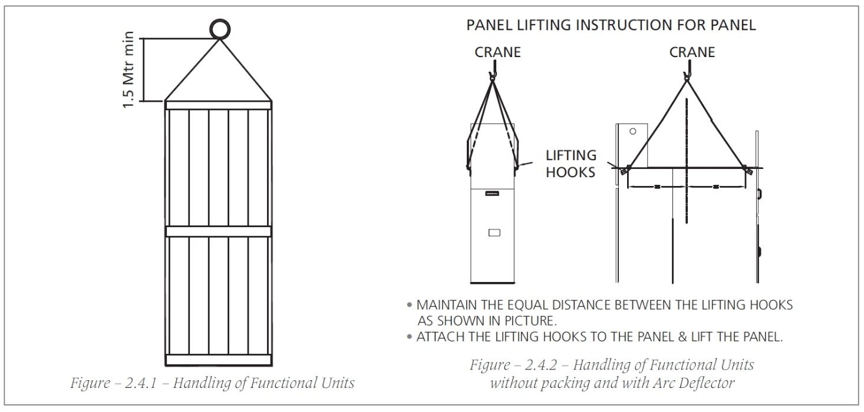

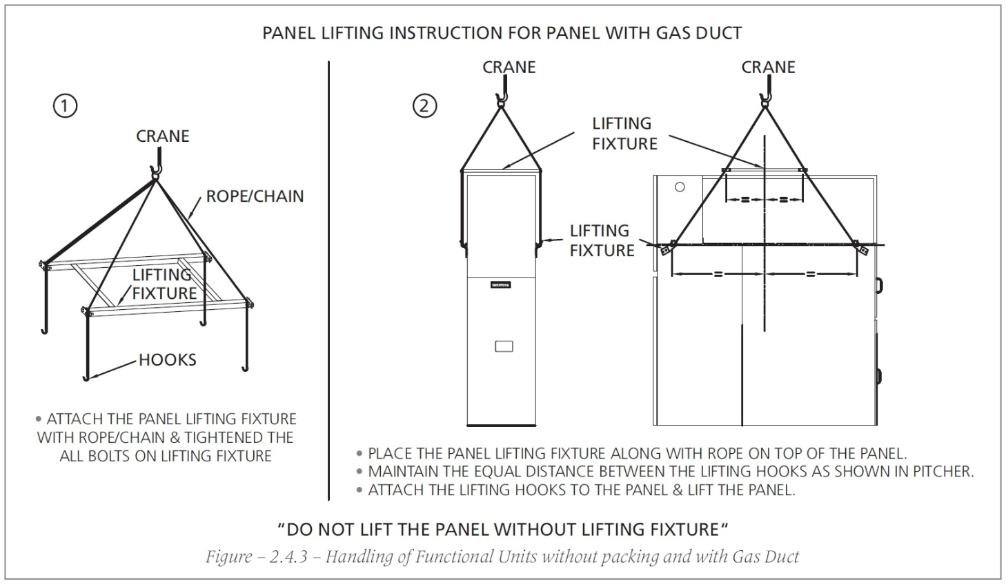

- INSTALLATION

- Foundation Preparation
It is essential that the floor level be fairly flat. If the floor Is not level, the switchgear may be deformed during installation, resulting in eventual malfunction of the equipment. Pay particular attention to the following
requirements for correct erection:

• The panel must be placed on e flat and level foundation. Foundation channels or uni-struts may be used to ensure this condition. However, ensure that the space in between Is cement filled. The level of the floor should be within +/- 0.5mm/m and +/- 2mm across the entire width of the switchgear.
• Mark the allocated positions of the panels on the cement surface for easy positioning.

• The area of the sub-station floor In front of the switchgears must be flat and level so that the breaker can be easily racked In and out of the panel. Special cement with "hardener" should be used In these areas to prevent the cement from cracking under the weight of the breaker.

> CARE SHOULD BE TAKEN WHEN TIGHTENING THE FOUNDATION BOLTS AS EXCESSIVE TIGHTENING WILL DISTORT THE BOTTOM PLATE.

- Erection of Cubical
Units or sections should be erected and coupled in the following manner:

- Withdraw the circuit breaker from the housing during the positioning of the panel to reduce weight.

- Remove all lifting brackets, spacers and rubber grommets In the Inter-panel fixing holes on the panels sides. Replace the grommets after coupling
- Position the first panel in the allotted space as marked earlier. In case of a long switchgear, it is recommended to start with the erection of the center panel Instead of from the far end of the switchgear.
- Rack the breaker Into the panel and check the panel's vertical alignment at its front, rear and side.
- Position the second panel next to the center panel. The sides of the panel must be vertical. This can be achieved by ensuring that the panel is compactly coupled. Line up the front and side, ensuring no interpanel gap.
- Rack the breaker Into the panel and check panels alignment as for the first panel.
- Couple the panels together by bolting the adjacent side frames.
- Fix the foundation bolts at the base plates of the panels.
- Seal the interpanel gaps at the busbar compartment with silicon glue to prevent ingress of dust.
- Remove top covers from the busbar compartments for busbar Installation. Refer to section "Connection of Main Busbars". Replace the top covers of busbar compartments.
- Connect the copper links of the earth busbars. Refer to section "Connection of Earth Busbar"
- Connect Inter-panel control wrings. Refer to section "Connection of Control Wirings"

The switchgear Is now ready for the termination of the power cables and field control cables.

- Extension to Existing Switchgear
At both ends of the switchgear, the end busbar compartment is blanked off using a metal cover, which is fixed from the inside of the busbar compartment. Hence, the exterior of the compartment is free from all protrusions.

When an existing switchgear is required to be extended, the new panel can be erected in position whilst the existing switchgear is still energized.

The coupling of the Interconnecting busbars between the existing switchgear and the new panel only entails a short period of de-energizatlon of the existing switchgear to enable the removal of the end cover and installation of the interconnection busbars. The disruption to the power supply is minimized in this manner.

- Connection of Main Busbars
The main busbars arrangement Is as shown In Fig. 3. The arrangement is to be strictly followed otherwise the busbar joints will be unevenly stressed.

- Ensure that busbar mating surfaces are clean and apply a thin film of contact grease for bare bar connections only. Then, install the interconnecting busbars using the correct size of bolts and nuts.
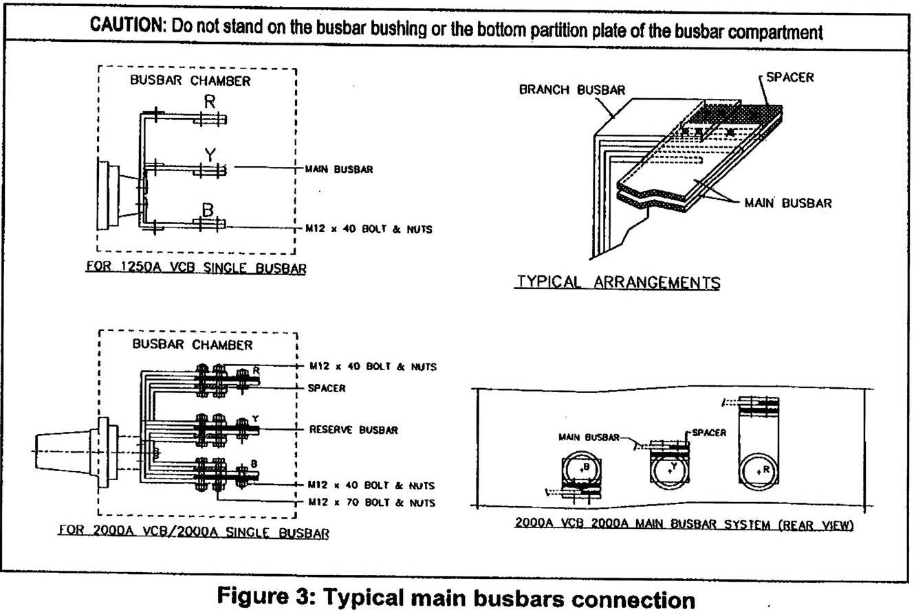

- Tighten the M12 bolts with a torque wrench set to 40 Nm. Mark tightened bolts with a marker pen.

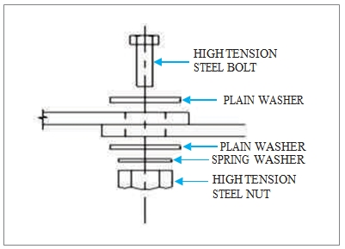
Figure 4: Bolting of copper connections

- Remove all foreign particles and dust.
- Clean the Insulation boots before fixing them on all busbars joints.

Figure - 5 -Typical Insulation Boot

Sealed "end boots'' should be used for busbars at both ends of the switchgear i.e. red and blue phase for the far left and right panels respectively, as viewed from the front of the panel.

Secure the boots with the boot pins provided. All boot pins must be properly fastened to ensure that the boot will not drop off. For non-standard design, HV Insulation tape must insulate any other exposed live parts that are not covered

with the Insulation boots. Ensure that all joint surfaces are clean and securely bolted before wrapping with the sealant.

- Connection of Earth Busbar
Earthing busbar links, supplied together with the panel are to be fixed onto the external earth bar along the rear of the panels as shown in Fig. 6. Ensure that all the joints between the earth bar sections are clean and securely bolted with M10 bolt torqued at 25 Nm.

The connection to the station earthing system should have a cross section of no less than that of the earth bar mounted on the switchgear.

- Connection of Control Wiring
Terminals for the connection of auxiliary control supplies and other external wirings are provided in the multi-core cable box mounted at the rear of each panel.

Remove the cover of the multi-core cable box to gain access to the terminal blocks. Complete the termination of the cables according to the relevant
wiring diagrams.

It is preferred that all multi-core control cables are installed using compression glands of type E1 to 884121. It is designed to secure armored wires and bond them to the earthed metal and also, provide watertight seals between the sheath and gland. All glands shall be fitted with an earth bond terminal attachment.

Ensure that each cable Is firmly and neatly terminated. A 'pull' test should be performed to verify the connections. Appropriate cable markings shall be provided for ease of identification. Replace the core of the multi-core cable box upon completion of the work.

- Power Cable Installation
The power cable entry point Is provided with a removable gland plate and Is located at the base of the cable compartments. Standard cable entry Is from the bottom. Top entry Is available If specified at the time of placing the
order.

- Preparation of Cable Gland Plate
The gland plate is provided to facilitate cable entry. The procedure for fixing the gland plate is as follows.
Note: Connect only one end of the cable earth, not both.

• The cable gland plate can be cut into two for easy Installation.
• Measure the diameter of the cable.
• Cut a semicircle on each half of the gland plates to match the cable diameter as shown in Fig.6.
• Adjust the position of the power cable and mount the cable gland plates onto the welded studs at the base plate. Tighten the nuts securely.

• If there is any gap between the power cable and the gland cover, apply sealing compound around the cables to fill the gap.
• The cable earth screen should be properly connected to the panel earth.

For single core cables, there should be a gap between the split plates and the former sealed with the compound. This• is to prevent eddy current
circulation.

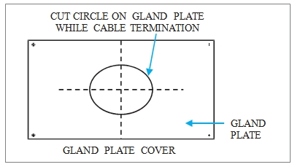
Figure - 6 - Gland Plate Installation

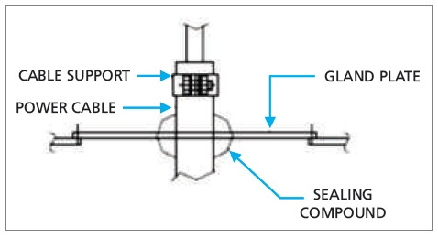
Figure - 7 -Assembly of Cable Gland Plate

- Power Cable Termination
Fig.7 shows the cables should be terminated vertically and exposed live l parts at cable terminations are to be insulated with tape. Cable supports
are provided to prevent undue stress on the bushing caused by the weight of an unsupported cable.

For top cable entry design, cable supports is an optional item. If not provided, ensure no undue stress at the cable connection by positioning the cable lug opening to the same level as the bar hole.

Refer to the instruction manuals supplied by the manufacturer of the termination kits for preparing the cable termination.

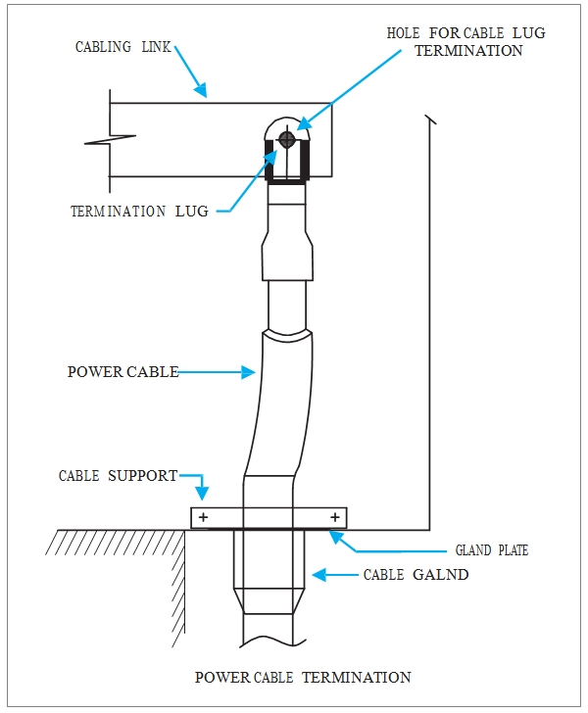
Figure 8 - Assembly of Cable Gland Plate

Upon completion of cabling, plug the opening of the cable entry to prevent small animals from entering the switchgear.

Inspection After Installation

Check the door to ensure that it can be opened and closed smoothly.
Check that all bolts and nuts are securely bolted.

Note:
Bolts and nuts are marked by manufacturer to enable detection of loose connections.

If these markings are shifted, re-tighten nuts.

Ensure that all interpanel gaps are sealed.

Ensure that all exposed busbar connecting joints are fitted with insulation boots or taped properly.
Ensure that no tools or loose parts are left inside any compartment.
Clean any debris and dust inside and outside of the panels.

