1.0 OBJECTIVE

This procedure provides installation for street lighting flange type installation with specification, quality control and Safety Plan pertaining to this project.

2.0 SCOPE

Method of installation is accordance to latest IEC, IEE, BS, JKR & TNB requirements and local authority standards.

3.0 TOOLS AND EQUIPMENTS

Excavator, nylon rope, winch, hand tools and compactor.

4.0 WORK METHOD STATEMENT

4.1 Planning & Preparation Works
- Refer to latest external coordination drawing and shop drawing to identify the exact location for excavation.
- Request for inspection for plinth delivery and installation to be provided
- Prior to excavation, the Surveyor sets out the area to be excavated and "Permit to excavate" is submitted for approval. Excavation commences only upon receipt of approved work permit.
- Client’s Surveyor to verify & accept the routing.

4.2 Excavation
- Excavate to a depth sufficient for satisfactory, as recommended by the manufacturer of the pre-cast concrete plinth that only the bolting points are visible at ground level. Maintain safe working conditions and assure compliance with all relevant Acts, Regulations and requirements of public or statutory authorities.
- NOI to be provided to inspect the excavated area.

4.3 Pre-cast concrete plinth installation
- Lower the plinth into the excavated hole by excavator using lifting belt.
- Align and level the plinth with the verified ground level.
- Pull the power supply cable from cable pit into the plinth’s elbow pipe and out at the top of the plinth.
- Back fill and cover the plinth leaving only the top of the plinth visible.

4.4 Installation and Erection of Lighting Pole
- Assemble poles, arms and fitting on the ground.
- Pull internal wiring cable through the arms to the termination board inside the pole.
- Attach and adjust lanterns to the arms and tighten the brackets and terminate the wire in the lantern’s termination block.

- Wrap the pole with the lifting belt and lift it with crane or backhoe. Insert the main supply loop in and loop out cables into the pole. Care to be taken to cover the lifting points with rags or thick cardboard to protect pole’s paintwork (if applicable).
- Bolt on a set of nuts onto the foundation bolts. Place pole’s bottom flange –base over the foundation bolts and sit the pole flange on the foundation bolt nuts. Screw on the locking nuts on to the foundation bolts at the top of the flange base.
- Check and vertically align the pole by tightening the adjustment nuts.
- Tighten the locking nuts on the foundation bolts at the top of the flange base and verify with torque wrench.
- Check the underground loop in and loop out cables’ insulation with an earth insulation test before terminating the cables into the termination block. (Refer to Installation Detail 1)
- Check the insulation and earth continuity of the pole lighting cable with the earth insulation tester and multi – meter respectively before the cable is terminated at the pole terminal block.
- Carry out the adjustment to the aiming of the light fitting according to approved drawing and lock the fitting into place by tightening all the adjustment bolts/screws.

Installation Detail 1: Street Lighting Pole
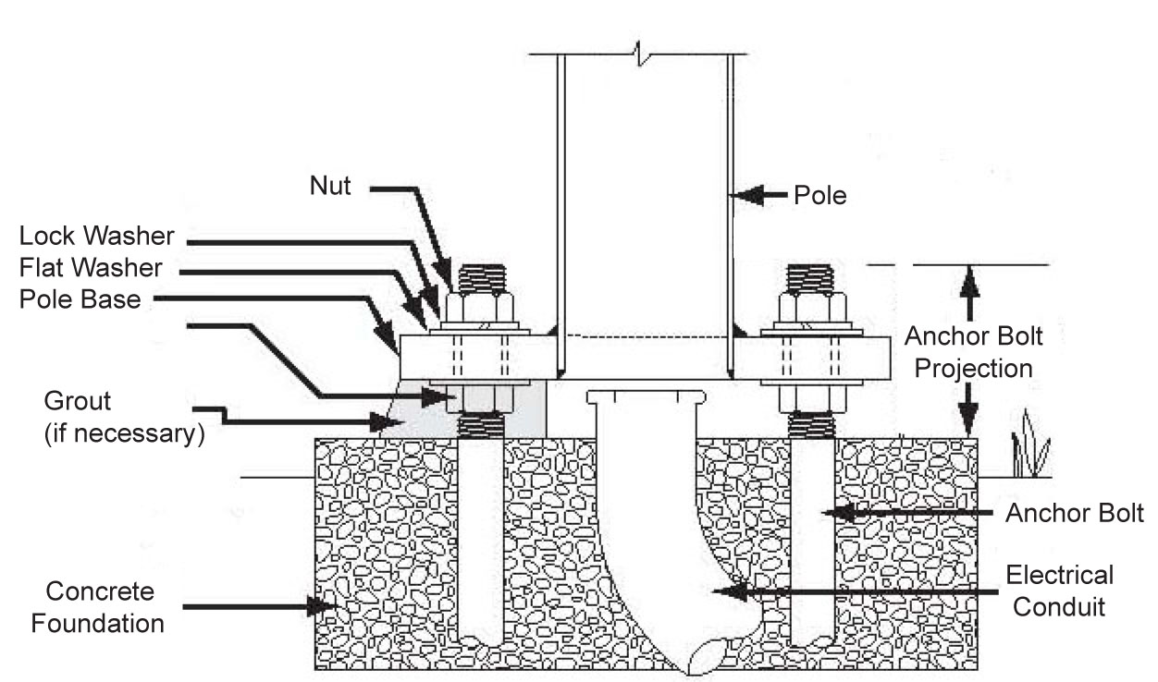
Anchor Bolt Bolt
uPVC Pipe
(if necessary)
Concrete Foundation
Anchor Bolt Projection
Grout
Lock Washer Flat Washer Pole Base Adjustment Nut
Lock Nut
Pole

Installation Detail 2: Street Lighting Plinth

4.5 Reinstatement

4.5.1 General

- All work sites shall be leveled and left clean and tidy. Debris, trees, stumps and excess soil from the excavation shall be removed from site or will be stored at client’s designated areas

4.5.2 Compaction

• Spoil or other approved filling material shall be carefully placed in the trench. Stones, rocks and paving
material shall be removed. The whole of this backfilling shall be carried out to avoid future
subsidence.
- The backfilled material will be compacted with a 1-ton compactor.

4.5.3 Leveling

- The surface shall be left in such a condition as not to constitute a hazard and shall be the same as the original unexcavated land.

5.0 INSPECTIONS

- In-progress inspections to be conducted before backfilling to verify depth of plinth installation
- Compaction will be inspected and documented with request for inspection form.
- All testing and inspections will be documented with request for inspection form, attached progress pictures and test reports.

6.0 SAFETY & ENVIRONMENT

- All installation works will be carried-out in accordance with Project Safety & Environmental Plan, client’s Safety Procedures and statutory regulations.
- All necessary personal protective equipment will be provided and worn.
- All the tools and equipments used at site must be compliance to safety requirement.
- The site of all work activities will be kept in clean and tidy manner.
- The wall of the excavated area shall be protected with canvas for safety purpose.
- Pump will be provided to keep excavation free of water.

7.0 REFERENCES

- MS ISO 9001: 2015 Element 7.1.6.
- Contract specs
- Inspection Checklist for Lighting Pole installation

