9th December 2024

MR. PHILIP YONG EXECUTIVE DIRECTOR MCC TECHNIQUE SDN BHD

RE: ISO 45001:2018 CONSULTANCY PROPOSAL

Thank you for inviting us to prepare a consultancy proposal on the above services for your company.
We are pleased to offer our consultancy and training services as stated in our project proposal reference no. ECT 2024-12-2179 dated 9th December 2024 in its intention to ISO 45001:2018 standard.
We wish to confirm that our package includes all the relevant training, consulting and audits required to effectively and successfully implement your management system, leading to a GUARANTEED ISO 45001:2018 standard certification. Our package quoted is eligible for a 100% HRD Corp claim, if applicable.
Please do not hesitate to contact us at the contact no. 012-3892375 or email
michelle@elitemanagement.com.my should you require further details/clarification.
We trust that we have met your requirements and look forward to your favourable reply/confirmation.

Thank you and best regards. Yours sincerely,

ELITE CONSULTANTS & TRAINING PLT


MICHELLE CHEAH PRINCIPAL CONSULTANT
This document is the property of Elite Consultants & Training PLT and shall not be copied/passed to a third party without the written consent of the Originator.

ISO 45001:2018 OCCUPATIONAL HEALTH AND SAFETY MANAGEMENT SYSTEMS CONSULTANCY PROPOSAL SPECIALLY DESIGNED FOR:

COMPANY NAME | MCC TECHNIQUE SDN BHD
ATTENTION | MR. PHILIP YONG
POSITION | EXECUTIVE DIRECTOR
ADDRESS | NO. 12, JALAN PPU 2A, TAMAN PERINDUSTRIAN PUCHONG UTAMA, 47100 PUCHONG, SELANGOR.
MOBILE NUMBER | 016-662 2021
EMAIL | philip@mcc.com.my

TABLE OF CONTENTS |  | PAGE
1 | INTRODUCTION | 3
2 | SCOPE OF CONSULTATION PROGRAM | 4
3 | CONSULTATION APPROACH | 5
4 | PROJECT TIMESCALES | 6
5 | PROJECT AGREEMENT | 7
6 | TERMS AND CONDITIONS OF AGREEMENT | 8
7 | DOCUMENT LEVEL | 9
8 | SAMPLE CERTIFICATE | 10
9 | CONSULTANT PROFILE | 11
10 | TRACK RECORD | 12
11 | PROJECT TIMELINE / GANTT CHART | 14

INTRODUCTION

ISO 45001:2018 (Occupational Health and Safety Management Systems) is now published in March 2018 & it will replace OHSAS 18001:2007.
An Occupational Health and Safety (OH&S) Management Systems provides a framework for an organization to identify and control its health and safety risks, reduce the potential for accidents, comply with legislation and improve operational performance.

ISO 45001 requires an organization to formally document the areas that are covered by their OH&S policy and to keep evidence that it is operating according to the requirements of the standard. It is relevant to any organization that wants to conform to legislation and demonstrate to staff and stakeholders that it has systems in place to minimize and eliminate risks.

Requirements of ISO 45001:2018

  - Clause 4: Context of the Organization
  - Clause 5: Leadership and Worker Participation
  - Clause 6: Planning for the Occupational Health and Safety Management Systems
  - Clause 7: Support
  - Clause 8: Operation
  - Clause 9: Performance Evaluation
  - Clause 10: Improvement

Benefits of ISO 45001:2018

  - Improve employee’s morale and safety
  - Savings in cost of insurance premiums
  - Reduced occupational health & safety risks
  - Prevention of potential accidents and ill health
  - Enhance reputation among regulators, customers and public

SCOPE OF CONSULTATION PROGRAM
The consultation program shall cover the following scope of work:
STAGE | NO. | CONSULTATION PROGRAM | MAN-DAY
STAGE 1  Awareness Training, Project Planning and Gap Analysis | 1 | Awareness Training  - To conduct one session of ISO 45001:2018 Understanding & Application Training | 4  (Remote/onsite)
 | 2 | Project Kick-Off Meeting & Gap Analysis  - To review the existing client's current practice against ISO 45001:2018 Requirements  (Gap Analysis), and to provide a Compliance Checklist/Action List.  - Establish a steering committee and appointment of a Management Representative.  - Establish Project Planning/Timeline and determine the scope of certification.  - Establish a Project Documentation Framework, which consists of OH&S Manual, Job Descriptions, Procedures, Forms, OH&S Policy & OH&S Objectives.  - Plant tour and comment/advice on the premise design layout of current existing buildings/facilities that comply with ISO 45001:2018 requirements. | 4  (Remote/onsite)
STAGE 2  Establishment of Documentation, Documentation Briefing & Implementation | 3 | Documentation  - Determination of Organization Context (Internal Issues and External Issues)  - Determination of Needs and Expectations of Workers and Other Interested Parties  - Identification and Assessment of Risks and Opportunities  - Identification of Hazard Identification, Risk Assessment and Control (HIRAC)  - Identify Applicable Legal Requirements and Other Requirements  - Emergency Preparedness and Response  - Evaluation of Compliance  - OH&S Target and Program  - Facilitate Consultation & Participation of Workers  - Management of Change  - Emergency Preparedness and Response  - To conduct one session of OH&S Legal Requirements Training.  - Document integration with ISO 9001:2015 | 20  (Remote/onsite)
 | 4 | Documentation Briefing & Implementation  - Conduct documentation briefing on ISO 45001:2018 established for effective implementation and monitoring (Documentation Adequacy Audit).  - Prepare Data Analysis Reports for OH&S Objectives. | 20  (Remote/onsite)
STAGE 3  Training, Internal Audit and Management Review | 5 | Internal Audit Training  - To conduct one session of ISO 45001:2018 Internal Audit Training.  - A certificate of training attendance will be provided. | 8  (Remote/onsite)
STAGE 3  Training, Internal Audit and Management Review | 6 | Internal Audit  - To conduct an Internal Audit for all OH&S Management Systems processes.  - To prepare an Internal Audit Report.  - To establish the root causes analysis and corrective action based on the internal audit findings and follow-up of corrective action for internal audit findings. | 8  (Remote/onsite)
STAGE 3  Training, Internal Audit and Management Review | 7 | Management Review  - To facilitate Management Review Meeting with top management.  - To prepare Minutes of Management Review Meeting. | 8  (Remote/onsite)
STAGE 4  Certification Audit | 8 | Certification Audit  - Assist in the selection of the Certification Body (CB).  - Conduct audit plan briefing for Stage 1 Audit and Stage 2 Audit.  - Certification Body to perform Adequacy Audit (Stage 1 Audit) & Compliance Audit (Stage 2 Audit).  - Support on rectification of non-conformance reports (NCR) issued by the certification body (if any).  - Certification Body recommendation and approval, issuance of the certificate. | 4  (Remote)

CONSULTATION APPROACH

Process Flow | Methodology | Intervention | Deliverables
Stage 1 Invoice & Payment, Kick-off & Awareness Training  Documentation Establishment  Documents Reviewed by Client (HODs)  Stage 2 Invoice & Payment  Internal Audit Training  Internal Audit  Management Review Meeting  Stage 3 Invoice & Payment  Certification Audit  Obtain ISO 45001 Certificate | Stage 1:  - Stage 1 invoice will be issued upon signing of this agreement. Upon clearance of stage 1 payment, we shall liaise with the appointed person in charge (PIC) to facilitate the first kick-off meeting & Awareness Training.  - WhatsApp group will be created by our Lead consultant as an important communication tool. All relevant ISO members will be invited to this WhatsApp group. | - Consultant  - Committee  - Employees | - Awareness Training Material  - ISO 45001  Standard
 | Stage 2:  - The consultant will have a face-to-face/remote session with the relevant personnel/ head of the department to establish all levels of documentation.  - The consultant will assist in preparing all relevant documentation.  - The consultant will send the soft copy of the documents to the relevant personnel to review and confirm.  - The consultant will brief all the relevant personnel about the developed management systems, and the customer will start to implement the management systems. | - Consultant  - Committee  - Employees | - Integrated Manual  - Procedures  - Job  Descriptions  - Work  Instructions  - Forms  - Risk & Opportunity Assessment  - HIRARC
 | Stage 2 Invoice will be issued once all the documentation is completed and payment shall be made before proceeding to the next stage.
 | Stage 3:  - The consultant will email the Internal Audit Training Material and Training Attendance Record to the customer for sharing and training arrangements. A certificate of Internal Audit Training (Digital Certificate) will be provided.  - The consultant will conduct an Internal Audit & prepare an Internal Audit Report, and guide the customer in resolving Nonconformance Report (NCR) for inadequacy.  - The consultant will guide and assist the customer in compiling a Data Analysis Report for OH&S Objectives.  - The consultant will facilitate the Management Review Meeting together with the top management and relevant key personnel to review the effectiveness of the management systems established.  - The consultant will prepare the Minutes of Management Review Meeting. | - Consultant  - Committee  - Employees | - Internal Audit Training Material  - Internal Audit Training Certificate  - Internal Audit Report  - Management Review Meeting Minutes
 | Stage 3 Invoice will be issued on the day of conducting the Management Review Meeting and payment shall be made before proceeding to the next stage.
 | Stage 4:  - The consultant will assist in arranging the Certification Body (CB) for the certification audit.  - After the external audit, the consultant will assist in resolving NCR (if any). | - Consultant  - Committee | - Audit Program  - Audit Report
 | The customer will obtain the ISO 45001 Certificate from the Certification Body. (Normally one month after compliance audit with condition NCR closed) | - Customer | 16. Certificate

(4.1) PROJECT TIMESCALES
ELITE CONSULTANTS & TRAINING PLT (ECT) is able to commence the project within two weeks upon receiving of Client’s confirmation.
The project is expected to take about 5 months (to be changed according to CLIENT requirements). The project timescales should be taken as a guide only. Clients can shorten the total time taken if they find that they can speed up their progress. Alternatively, the project timescales may be stretched longer if the Client needs more time for effective implementation. The client shall acquire at least 3 months of implementation records before proceeding with the certification audit. The schedule does not include the duration required for the third-party certification process.

(4.2) REASONS FOR CHOOSING ELITE CONSULTANTS & TRAINING PLT
- At ELITE CONSULTANTS & TRAINING PLT, we strongly believe in getting to the root of the matter and not just the quick fix. Hence, our consultants employ a holistic, forward- looking and integrated approach to assist you in whatever services we deliver.
- We are grateful that these values are very much appreciated by existing clients, and new clients referred by those who have experienced working with us.
- Below are some of our proven track records:
  - Proven 100% of attainment of certification by Certification Bodies.
  - Professional and experienced consultant and trainer in the relevant industries.
  - Wide range of consultancy and training services to fulfil our client needs at all times.
  - Extensive exposure in all types of industries and proven track records in completion of the project as per project schedule.
  - Excellent communication and interpersonal skills to ensure effective consultancy and training results.

(4.3) LONG-TERM SERVICES AVAILABLE WITH NO ADDITIONAL COST INCURRED
No limitation on value-added “REMOTE” consultancy services provided through electronics media after certification to ensure consistency and effectiveness of the management systems implementation.

(4.4) MANAGEMENT SYSTEMS MAINTENANCE (AFTER CERTIFICATION)
We provide after-sales services to assist our customers in maintaining their management systems through separate consultancy proposals such as:
- Updating and reviewing current management systems documentation.
- Conducting internal audit and guiding internal auditors to perform an internal audit.
- Conducting management review together with management staff and training management systems committee to manage their systems.
- Responding to certification audit findings.

PROJECT AGREEMENT
MCC TECHNIQUE SDN BHD officially confirms that ELITE CONSULTANTS & TRAINING PLT is appointed to provide consultation services of ISO 45001:2018 described in proposal number ECT 2024-12-2179 dated 9th December 2024 subject to the Terms and Conditions contained therein, for the agreed sum of RM 20,000 (Ringgit Malaysia Twenty Thousand only) inclusive of Klang Valley transportation and accommodation expenses, 100% HRD Corp claimable, if applicable.

The covered scope shall be inclusive of:
  - Provision of Engineering, Procurement and Construction of Mechanical and Elefctrical Services for Industrial, Commercial, Residential and Amenities Sector (To be advised).
ELITE CONSULTANTS & TRAINING PLT (ECT) undertakes upon signing this Agreement to provide the services requested, subject to the Terms and Conditions specified.

Payment Schedule:
1st Payment (40%) | RM 8,000.00 | Payable within 14 days upon signing of this Agreement
2nd Payment (40%) | RM 8,000.00 | Payable within 14 days upon completion of Stage 2
3rd Payment (20%) | RM 4,000.00 | Payable within 14 days upon completion of Stage 3

Signed for and on behalf of ELITE CONSULTANTS & TRAINING PLT (CO. NO. LLP0010071-LGN)
Date: 09/12/2024

Signature
Name: MICHELLE CHEAH PRINCIPAL CONSULTANT

Signed for and on behalf of MCC TECHNIQUE SDN BHD

Date:

Signature
Name:

Designation Company Chop

TERMS AND CONDITIONS OF AGREEMENT

- ECT shall deliver and complete the consultancy and/or training in accordance with the scope of services as stipulated in this agreement and assure our Client to establish the stated management system and/or secure external certification where applicable.

- Unless stated otherwise, the professional fee quoted is a lump sum package based on the estimated man- days required by ECT’s consultants on the project. No additional charges will be incurred if the actual consultancy sessions exceed the proposed number of man-days. On the contrary, should ECT complete the project in fewer man-days than the proposal, the unutilized consultancy sessions will not be refundable.
- The fee quoted excludes fees of the certification body, calibration body and external laboratory services if applicable. The client is advised to obtain a separate proposal from their preferred certification body, calibration body and external laboratory.
- The fee quoted excludes any translation services (i.e. from English to any other languages) on the management systems documents. No additional services of awareness training and internal audit training throughout the consultancy sessions.
- Unless otherwise stated, the copyright of training videos and materials throughout the scope of services shall be vested to ECT. No training video recording is allowed during training sessions and the scope of services.

- Unless quoted otherwise, the fee is inclusive of transportation and accommodation expenses to and from the Client’s premises with the address as stated in the proposal. In case of additional locations, a mileage at RM 1.00/km and/or accommodation expenses (hotel with 3 stars and equivalent) incurred are chargeable to the Client. ECT shall submit actual receipts to facilitate the claim for the said expenses.

- ECT shall submit an invoice for work done according to the stages in the proposal. Payment for such invoices shall be due and payable by the Client within fourteen (14) calendar days from the invoice date.
- The validity period of this proposal is six (6) months from the date of the proposal.

- Client shall provide appropriate facilities, including but not limited to, internet connection, secured storage facilities for Confidential Information, and secretarial assistance as and when required during ECT’s consultancy at Client’s premises.
- Confidentiality Information including but not limited to trade secrets, know-how, ideas, patents research, business plans, marketing information, information of customers, financial situations, information relating to “Personal Data” and any other technical, commercial and/or financial information, either expressed in notes, letters, facsimiles, memoranda, agreements, contracts, analyses, reports, minutes, documents, manuals, compilations, software codes or formulae, electronic mails, or disclosed orally and either identified as confidential at the time of disclosure or reasonably understood, because of the circumstances of disclosure or the nature of the information itself, to be confidential.

- Non-disclosure either party shall not at any time during or after the agreement divulge or allow to be divulged to any party any Confidential Information relating to or in connection with this agreement or the business or affairs of the other party. Either party shall only disclose the Confidential Information to its employees, staff, and personnel on a “need-to-know” basis.
- As security for the fulfilment of this agreement, all payments made in accordance with the terms of payment in this agreement are non-refundable.

- In the event the Client intends to terminate the signed proposal, a written notice of termination shall be served to ECT within fourteen (14) calendar days. The Client shall thereafter remit the balance payment

according to the ongoing consultancy stage in the payment schedule to ECT within fourteen (14) calendar days from the invoice date.
- Either party reserves the right to claim for the balance payments of incomplete activities as defined in this proposal if another party fails to deliver and/or cooperate for the completion of the scope of services in the proposal within ten (10) months from the date of signing of this proposal.

- ISO 45001:2018 DOCUMENT LEVEL

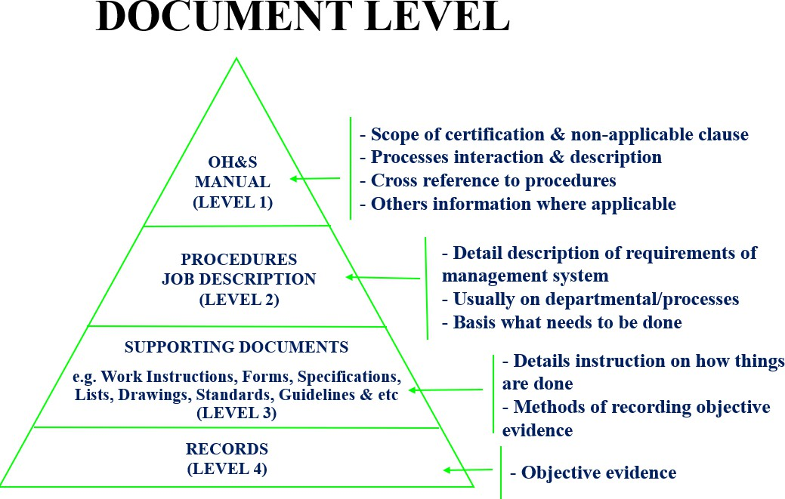

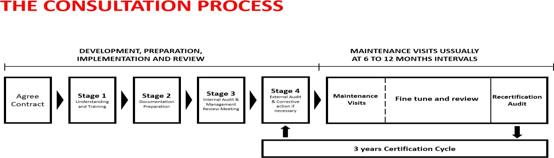

- SAMPLE ISO 45001:2018 CERTIFICATE
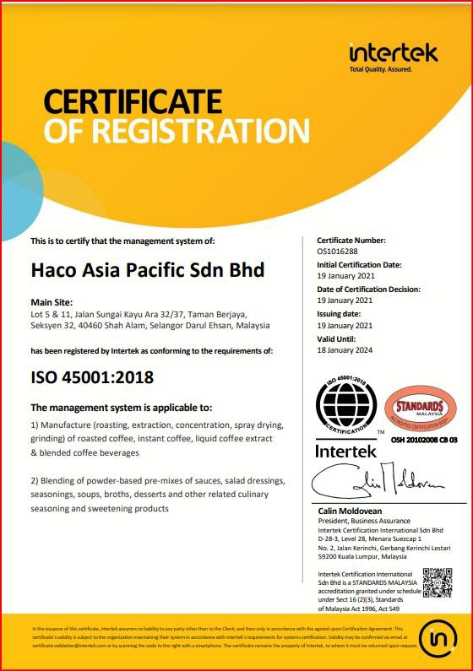
SAMPLE

- CONSULTANT PROFILE

Tommy Yap Gwo Jang (IC No: 720610-14-5115, Trainer ID: 1000122108, TTT Certification No: 16359) graduated with a master’s degree in construction management (Project Management) from Heriot-Watt University Scotland, United Kingdom. He is our director, a member of the Royal Institution of Chartered Surveyors (UK) (RICS) (Cert. No.1211164), a member of the Institute of Quality Malaysia (IQM), and an HRD Corp certified trainer.
Tommy has more than twenty years of working experience in the multinational construction and manufacturing industries. He was entrusted with responsibilities as the Management System Representative, as well as internal quality auditing, before establishing his training and consultancy firm.

He now serves as a consultant and in-house trainer for private companies and non-profit organizations.

Throughout his consultancy career, he has assisted companies in the establishment and attaining the certification of management systems, among others, ISO 9001:2015, ISO 14001:2015, ISO 45001:2018, ISO 37001:2016, ISO/IEC 27001:2022, ISO 41001:2018, GRS, FSC, SEDEX,
BSCI, RBA, SA8000, URSA, ESG standards. Also, he is often engaged by companies as a consultant involved in management systems maintenance, and internal auditing.

Tommy is very committed to facilitating and delivering company performance training, as well as, quality and productivity improvement solutions. Tommy’s area of specialization is in helping organizations to achieve higher productivity, effectiveness and efficiency in their daily work process flow using proven quality-related techniques and tools.

ISO 45001:2018 TRACK RECORD

ISO 45001:2018 (Occupational Health & Safety Management System) Consultation & Training
No. | Company | Scope of Registration | Certification Body
1. | City Zone Express S/B | General logistics service solution, including general cargo transportation, customs declaration, international freight forwarder, warehousing and distribution service and cross-  border land transportation service | NQA
2. | CREC Development (M) S/B | Provision of Civil & Building Construction Works, Property  Management and Project Management Services. | INTERTEK
3. | CRRC Kuala Lumpur Maintenance S/B | Provision of maintenance & repair of electric multiple units. | LRQA
4. | CT Services (M) S/B | Provision of calibration services for pressure, time &  frequency, temperature, mass, torque, force, and electrical. | BUREAU VERITAS
5. | Denka Construction Solutions Malaysia S/B | Design, manufacturing and trading of specialty chemicals for construction and building. | DNV
6. | Econpile (M) S/B | Provision of installation, testing of bored piles, micro piles and driven piles and construction of sub-structure. | BM TRADA
7. | Eko Tenamik S/B | Manufacture of AC and DC Power Supply Equipment | BUREAU VERITAS
8. | Enotek Engineering S/B | Construction and Maintenance of Retail Buildings and Stations | BUREAU VERITAS
9. | Global Testing Services (M) S/B | Provision of HV Electrical Testing (chemical plant on shore, switch check, switchgear check, TNB substation) | SIRIM
10. | Haco Asia Pacific S/B | Manufacture of coffee products & culinary dried mix | INTERTEK
11. | HULS Engineering S/B HULS Geosynthetics S/B HULS Asia S/B | - Provision of Construction Services in Civil & Structural Engineering, Hydraulic Engineering (Coastal & River) and Waste Engineering (Liquid & Solid)  - Supply and Installation of Geosynthetics Products | SIRIM
12. | HZN Associates (M) S/B | Provision of supply, repair and maintenance of oil & gas and  marine equipment. | BSI
13. | Ikrar Jaya Bina S/B | Provision of civil, structural, M & E, building, infrastructure, and piling works | BUREAU VERITAS
14. | Innochems Technologies S/B | - Provision of producing and supplying specialty chemicals  - Provision of chemical cleaning and decontamination  services | AJA
15. | Interplex Malaysia (PB) S/B | Manufacture of medical devices | SIRIM
16. | Jati Tinggi Holding S/B | Provision of electrical & telecommunication cabling, building of infrastructure and related civil engineering works | INTERTEK
17. | Nexperia Malaysia S/B | Design and Production of Semiconductor Products | DEKRA
18. | Octagon Maju S/B | Provision of design, fabrication, assembly and installation of  signage | DNV GL
19. | Petra Modular (M) S/B | Design and manufacture of modular housing | LRQA
20. | Prigel Ventures S/B | Provision of Transport of Passengers, Logistics & Support Transport Activities.  Trading and supply of Mechanical & Electrical Parts related to Boats and Vessels for marine and oil & gas industries.  Warehousing and storage. | BUREAU VERITAS
21. | Rosado Tradeline S/B | Project Management for Building Construction and Civil Engineering Works | INTERTEK

22. | STEC Mastika Nuri S/B | Provision of building construction and associated  infrastructure. | GCL
23. | T7 Global Berhad T7 Gastec S/B  Tanjung Offshore Service S/B | Provision for the Management Services to Its Group of Companies.  Provision for the Project Management Services, Construction and Fabrication, Procurement and Supply, Installation and Commissioning of Mechanical, Onshore and Offshore  Facilities | BUREAU VERITAS
24. | VSMS S/B | Provision of the exhibition, event, roadshow, conference services & interior design services. | GIC
25. | Worktime Engineering S/B | Building construction, infrastructure, telecommunications, civil engineering, mechanical & electrical, other related  engineering works and project management | INTERTEK
26. | YM Teras S/B | Project management for infrastructure, civil engineering and  mechanical and electrical works | INTERTEK

PROPOSAL NO.: ECT 2024-12-2179 CONFIDENTIAL DATE: 09/12/2024

PROJECT TIMELINE / GANTT CHART

No. | Project Stage | Month
No. | Project Stage | 1 |  |  |  | 2 |  |  |  | 3 |  |  |  | 4 |  |  |  | 5 |  |  |  | 6 |  |  |  | 7 |  |  |  | 8 |  |  |  | 9 |  |  |  | 10 |  |  |  | 11
1 | ISO 45001:2018 Awareness Training & Gap Analysis
2 | Establishment of ISO 45001:2018 Documentation – Manual, Standard Operating Procedure (SOP), Job Description, Forms,  Work Instructions, List etc.
3 | Completion of Manual, Standard Operating Procedure (SOP) and other documents. Reviewing of Manual, Standard Operating Procedure (SOP), Job Description, Forms, Work Instruction, List together with MCC TECHNIQUE  SDN BHD
4 | Implementation of ISO 45001:2018 management systems
4 | ISO 45001:2018  Internal Audit Training Internal Audit
5 | Management Review Meeting together with MCC TECHNIQUE SDN BHD |  |  |  |  |  |  |  |  |  |  |  |  |  |  |  |  |  |  |  |  |  |  | ISO 45001:2018 CERTIFICATE UKAS / DSM
6 | ISO 45001:2018 Application and Certification (Stage 1 & Stage 2)
7 | Following up post-certification NCR(s) if any

Remark: The proposed project timeline is subject to the progress of the project and commitment/feedback from the client.
This document is the property of Elite Consultants & Training PLT and shall not be copied/passed to a third party without the written consent of the Originator.

ELITE CONSULTANTS & TRAINING PLT (Co. No. LLP0010071-LGN)
No. 51-2, Jalan Sierra 10/2, Bandar 16 Sierra, 47120 Puchong, Selangor. TEL: 03-5888 0430, 03-5888 7112
Mobile: 012-389 2375, 012-256 8283 EMAIL: info@elitemanagement.com.my WEBSITE: www.elitemanagement.com.my

Page 14 of 15

