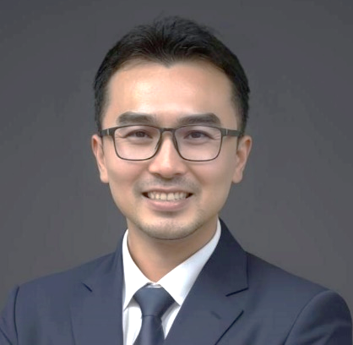

CURRICULUM VITAE

NAME : Mak Jee Chew
NATIONALITY : Malaysian

QUALIFICATION : Bachelor’s Degree in Aerospace Engineering
IRCA Certified ISO 9001 Lead Auditor PECB Certified ISO37001 Lead Auditor
Certified HRFC Trainer (TTT Certificate: 5665)

PROFILE

Mr. Mak Jee Chew is a highly accomplished professional with extensive experience and multi-disciplinary expertise in engineering, laboratory management, ISO certification, divisional leadership, internal audit and risk management. With a degree in aeronautical engineering and a proven track record, he consistently delivers outstanding results across his various roles.

In his role as a laboratory quality management representative, Mr. Mak has successfully established and managed an ISO 17025 accredited laboratory, ensuring strict adherence to rigorous quality standards.

Additionally, he has showcased exceptional leadership skills by successfully leading three divisions encompassing internal audit and risk management, customer service, and IT. Under his guidance, these divisions have achieved operational excellence and exceeded strategic objectives.

As an ISO certification lead auditor, he has audited over 100 organizations, providing invaluable feedback for compliance and continuous improvement.

As a management consultant, he has aided over 60 organizations in establishing and maintaining ISO management systems, consistently achieving a flawless passing rate.

Overall, Mr. Mak Jee Chew's exceptional qualifications, diverse experience, and unwavering commitment to excellence make him a highly sought-after professional/ partner. With a proven track record of success and an unwavering dedication to excellence, Mr. Mak is poised to make a significant impact to the organization he works with.

Work Experience

Cambridge Management Sdn Bhd (2017 – 2023)
Consultant
- Responsible in consulting, auditing and training in manufacturing, construction, trading and services sectors for TQM, Business Consultancy, ISO 9001, ISO 14001, GDPMD, ISO 13485, AS 9100, ISO 29001, ISO27001, ISO37001, ISO50001, ISO17025 and OHSAS 18001/ISO45001 management systems.
- Responsible in design and developing of new training materials to meet the market needs
- Responsible in training for wide range of subjects, ranging from ISO related courses, people development, process development, management soft skills and etc.
- IRCA Certified ISO9001 Lead Auditor
- PECB Certified ISO37001 Lead Auditor

Secure Parking Corporation Sdn Bhd (2013 – 2017)
Audit & Risk Management Manager cum Customer Service Manager & IT Manager
- Responsible for the planning of the group internal audit programme
- Responsible to lead a team of internal auditors to perform audits and risk assessment on the organization covering over 100 sites throughout Malaysia
- Responsible for the reviewing of audit reports and non-conformance reports (NCR) and reporting to the top management on the organization's risk and compliance status
- Responsible for the review and establishment of Standard Operating Procedures
- Responsible for the organization’s ISO9001 certification audit
- Responsible for the operations of the Customer Service Department
- Responsible for the operations of the IT Department

TUV NORD (M) Sdn Bhd (2010 – 2013)
Certification Lead Auditor
- Perform third party ISO9001 certification audit
- Certified and experienced auditor of various industries including manufacturing, construction, trading and services sectors in the context of ISO 9001 standards
- Extensive knowledge and experience in audit having audited more than 100 organizations

TUV NORD (M) Sdn Bhd (2007 - 2010)
Test Laboratory Quality Management Representative
- Responsible for the setup of a new test laboratory from the planning and set up till the establishment of the test laboratory management system in accordance to ISO17025 standard
- Responsible as the test laboratory QMR
- Responsible for the test laboratory operations including test setup & planning, hands-on testing, and preparation & review of test reports
- Responsible for the test laboratory sales & marketing activities

