

The Cruze Lot 10 & 12
Duties & Responsibilities of the Emergency Response Team (ERT)

MCC TECHNIQUE SDN. BHD. MCCT SDN. BHD. LOGIKONTROL SDN. BHD. VIRBIZ SDN. BHD.
FLEXWATCH ENGINEERING SDN. BHD.

1

Scope
- Introduction.
- Emergency Situations.
- False Alarm.
- ERP Definitions.
- Emergency Procedures.
- Emergency Call Centers.
- ERP Organization.
- Role & Responsibilities.
- Purpose of Fire Drill.
- Building Fire Safety & Prevention.
- In The Event Of Fire…
- Evacuation Do’s & Don’t.
- Emergency Evacuation Assembly Point.
- Required Forms.
- Questions & Answers.
2

Introduction
Administration Department of Mcc Technique Sdn. Bhd. will coordinate with all building occupants at The Cruze Lot 10 & 12 to ensure that they are well versed with the operation of the Emergency Response Plan (ERP) and are constantly put into practice for protection of human and asset from any further harm or damage during an emergency situation.
3

Emergency Situations
- Fire Emergency.
- Earthquake Emergency.
- Bomb Threat Emergency.
- Hazardous Materials & Gas Leak Emergency.
- Serious Injury Emergency.
- Evacuation of the Disabled During Emergency.
4

ERP Definitions
‘Occupant’ refers to all inhabitant (employees, vendors, etc.) and visitors in the building (The Cruze).

‘Emergency Response Authorities (ERA)’ refers to members of Police Force (Polis Di Raja Malaysia), Fire Brigade (Bomba), Medical or Hospital Units (Ambulance), Civil Rescue Squad, Rela volunteers, etc.

‘Emergency Response Team (ERT)’ consists of a team of floor wardens and appointed personnel under the direction of the ERP Commander to address emergency situations.
5

Emergency Procedures
- AD-PRO-08: Emergency Response Plan for The Cruze (Lot 10 & 12).
- AD-REC-AA: Appendix A – The Cruze (Lot 10 & 12) Organization of Emergency Response Team (ERT).
- AD-REC-AB: Appendix B – The Cruze (Lot 10 & 12) Evacuation & Escape Route Maps.
- AD-REC-AC: Appendix C – The Cruze (Lot 10 & 12) Evacuation Assembly Point & Head Count Checklist.
- AD-REC-AD: Appendix D – The Cruze (Lot 10 & 12) List of Disabled Employees & Needy Building Occupants.
- AD-REC-AE: Appendix E – The Cruze (Lot 10 & 12) List of Trained First Aid & CPR Personnel.
- AD-REC-AF: Appendix F – The Cruze (Lot 10 & 12) Emergency Response Plan Event Report.
6

Fire Emergency Procedure
- Any capable occupant (and visitor, when necessary) are to remove or evacuate anyone in immediate danger during a fire emergency situation.

- Once each occupant or visitor are alerted to the fire danger, they will go to the nearest exit, activate the fire alarm on first sight, exit the building according to the Emergency Response Plan (ERP), and proceed directly to the Designated Assembly Point. Floor Wardens are to guide the occupants or visitors to exit the building appropriately whenever possible.

- In case of facing fire occurrence, the occupant or visitor are to confine the fire to the room/area by closing the door to the area where the fire is located and by ensuring all doors leading to the office, main hallways or walk ways are closed (not locked).

- Occupant or visitor can attempt to extinguish the fire only if they have received training on the use of portable fire extinguishers, and when the fire is in its beginning stage, and it can be extinguished safely.

- Disabled and non-ambulatory (unable to walk personnel) should request assistance from those nearest to them. Advice Bomba or Polis of any personnel trapped who may require assistance to evacuate.
7

Earthquake Emergency Procedure
- If occupants are indoors (inside the building), they are advised to stay put should an earthquake occurs. They are to take shelter under a desk, table, or in between a doorway or door frame. If they are not able to get under anything sturdy or stand in between a doorway or door frame, they are to get on their knees and cover their head with their hands and arms to protect themselves from falling debris.

- The occupants are to stay away from windows, outside walls, light fixtures, filing cabinets and bookshelves. They are not to attempt to use the lift.

- If the occupants are at outdoors, they are to go to an open area away from trees, buildings, walls, roadways and power lines.

- A series of evacuation alarm bell for total evacuation will be made over a long period until all building occupants had been evacuated. When the building is evacuated, the occupants are not return to their work area or intended venue until authorized.

- All occupants are to be aware of potential dangers after an earthquake such as escaping gas, unstable building structures, electrical hazards, etc. They are also to be aware of aftershocks.
8

Bomb Threat Emergency Procedure
- If a bomb threat had been alerted or discovery of a possible bomb or suspicious object(s), the first thing to do is to notify the nearest Polis Station or Call 911 by providing the necessary details of the type of threat, discovery time and location accordingly.

- Any member of the ERT will immediately report to the Polis in charge and allow the Polis to begin their investigation of the bomb threat. Emergency evacuation of the building due to bomb threat will be determined by the Polis Officer in charge or ERT Commander.

- Should a bomb threat emergency evacuation of the building is required, the Polis Officer in charge or the ERT Commander shall make a series of alarm bell for total evacuation using the building fire protection system. When the building is evacuated, the occupants are not return to their work area or intended venue until authorized.
9

Hazardous Materials & Gas Leak Emergency Procedure

- A hazardous material is a substance that presents a physical or health hazard. A health hazard refers to a substance for which there is significant evidence that health effects may occur for exposed victim. Gas refers to cooking gases stored in cylinders located at restaurants, kitchen and pantries.

- All members of ERT and occupants are to vacate the affected area or building and attempt to secure or block the access to the affected area where gas and hazardous materials had been detected.

- Immediately call Polis at 911 and provide as much information as possible to the Polis personnel on duty.

- A series of evacuation alarm bell will sound requesting for total evacuation. When the building is evacuated, the occupants are not return to their work area or intended venue until authorized.
10

Serious Injury Emergency Procedure
- Members of ERT, ERA and capable occupant are to check the scene for any person who are injured. They are to assess the condition of the victim to determine the danger potential and the extent of the injury. They are not move or relocate any seriously injured victim(s) unless there is an immediate danger such as fire, flood, earthquake, explosion or poisonous gas. If the victim must be moved, they are to do it as quickly and carefully as possible. If there is no immediate danger, they are not move the victim and advise the bystanders the victim is not to be moved.

- Call Polis at 911 immediately if any injured victim is found. Additionally, the call for an ambulance should be made if the victim has trouble breathing or is breathing in a strange way; has heart seizure or pain in the chest or abdomen; is bleeding severely; has slurred speech; appears to have been poisoned; has injuries to the head, neck, or back; or has possible broken bones.

- The victim is to be kept calm and as comfortable as possible. Those trained personnel are to administer CPR or First Aid, whenever necessary. Available First Aid kit should be used and precautions should be taken to minimize exposure to blood and other bodily fluids. Remain with the victim until members of ERT or ERA arrives.
11

Evacuation of the Disabled During Emergency Procedure

- If persons with a disability (including a short term disability) of which limits them from using the staircases will congregate in the lobby area of each floor by the lift where they will be assisted by either by the members of ERT or ERA.

- In the event an emergency renders the lift being unsafe or dangerous for use, any members of ERT, ERA or capable occupant shall lent a hand to assist or carry the disabled person down one or more floors via the front or back stairways for pick-up and relocation.

- If assistance is not immediately available, disabled persons should stay in the exit door or at the top of the stairway or landing. The members of ERT will advise the ERA of the location of the disabled person(s) in the event all other actions failed.

- Disabled employees or building occupants who will need special assistance in the event of an emergency are to be listed.
12

False Alarm Procedure
False alarm are caused by (1) human error due to not familiar with the fire alarm system or not properly trained; (2) poorly designed fire protection system whereby installation do not take into consider site condition; (3) lack of maintenance or upkeep; (4) outdated or old fire protection system; (5) malfunction fire protection equipment.

If the fire alarm system triggers off, the ERT Commander will immediately dispatch a member of the ERT to investigate at the area as indicated in the fire control panel. If upon investigation that the alarm was erroneously triggered off, the ERT Commander of any member of ERT will isolate the fire control panel and immediately make verbal/handphone announcement for false alarm and to call back those who had evacuated the building.

An incident report regarding the false alarm will be lodged to the ERP Commander. The building maintenance personnel in charge will be informed to check the fire control panel for any fault alarm.

Floor warden will usher back all those occupant who had responded to the false alarm to go back to their working place (if any).
13


Our Priorities In Emergency Situation
1st
- Protection of life.
2nd
- Prevent spreading of Hazard.
3rd
- Save Assets in the Affect Area.
4th
- Eliminate the Hazard.
14

Emergency Call Centers
Polis - 911.

Ambulance - 911

Bomba – 911

ERT Commander (Philip Yong – 016 6622 021)
15

ERP Organization (The Cruze Lot 10 & 12)
- Emergency Response Authorities (ERA) refers to Polis DiRaja, Bomba, Medical Units/Hospital (Ambulance), Rescue Squad, Pasukan Rela, etc.
- Emergency Response Team (ERT) comprises ofERT Commander, appointed personnel as ERT members and all floor wardens.
16

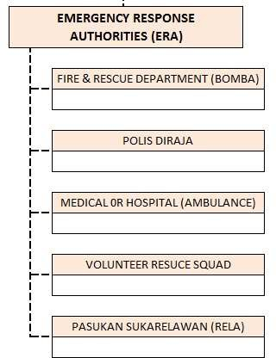
Emergency Response Authorities (ERA)
17

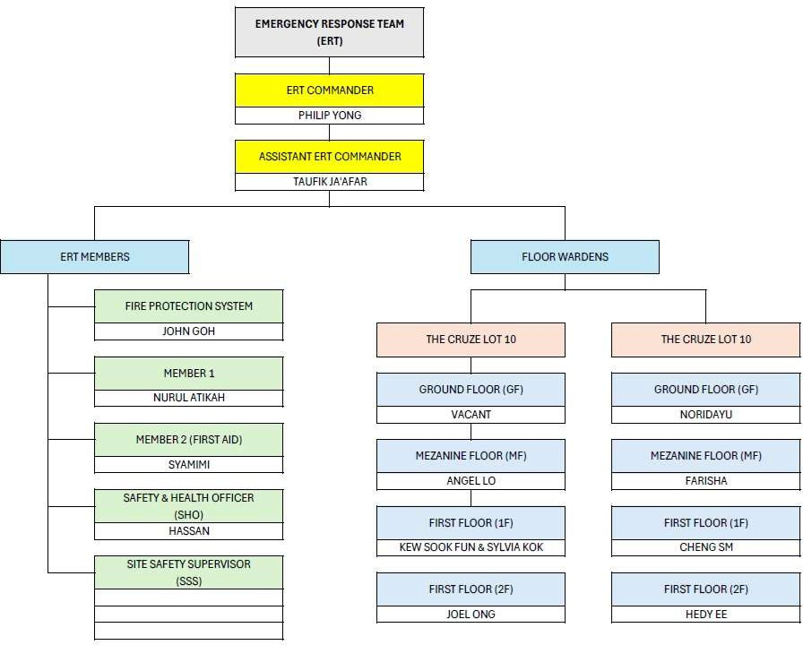
Emergency Response Team (ERT)
18

Role & Responsibilities (1)
ERT/Emergency Commander (Philip Yong)
- Conduct risk assessment on possible emergency incidents and formulate the ERP procedures.
- Implement the ERP.
- Appoints and manage ERT.
- Liaise with ERA regarding emergency, security and safety issues.
- Identify the Evacuation Assembly Points.
- Ensure building facility systems that addresses emergency situations are in working order.
- Documentation of all emergency drills and incidents.
19

Role & Responsibilities (2)
ERT Commander / Emergency Commander (continue)
- Act out the responsibilities of Emergency Commander whenever an emergency arises.
- Immediate activate the ERT and alert all occupants of the emergency situation by making the appropriate emergency announcement via the public address system.
- In case of fire emergency, activate the fire alarm system.
- Call the relevant ERA and inform ERT Assistant Commander.
- Investigate the emergency situation and take necessary actions to diffuse the situation.
- Ensure proper evacuation of occupants.
- Give the all-clear command when emergency had been addressed.
20

Role & Responsibilities (3)
Assistant ERT Commander
- Escort Polis personnel to screen security surveillance at The Cruze during emergency situations.
- Ensure back up support required for Polis doing the building surveillance during emergency situations.
- Assist ERP Commander to manage and implement emergency procedures.
- Liaise with ERA regarding emergency, security and safety issues.
- Provide building maintenance personnel to assist in the operation of the fire alarm system, stairways, lifts, etc.
21

Role & Responsibilities (4)
ERT Member (Fire Protection System at The Cruze Lot 10 & 12)
- Conducts regular maintenance on assigned fire protection system.
- Response immediately to any emergency situation and ensure the fire protection system is functional.
- Attend to any emergency repair, if necessary.
- Report to ERT/Emergency Commander on any faults discovered and corrective action taken during the emergency.
22

Role & Responsibilities (5)
Appointed Floor Warden
- Be familiar with:
  - Fire Alarm / Emergency Warning System.
  - Entry / Exit Points.
  - Emergency Staircase / Alternative Escape Routes.
  - Complete Layout of Floor.
  - Operation of Access Control Doors.
  - Location of Fire Extinguishers / other Fire Fighting Equipment on the Floor.
  - Names and mobile nos. of all staff members on the floor.
  - Details about disabled or mobility-impaired persons on the floor.
23

Appointed Floor Warden (continued)
- On being informed about the fire, immediately contact the Polis Bantuan Control Room.

- Assess emergency situation with Emergency Response Team (ERT).
- Inform the Floor Warden above and below floors.
- Assist the ERT in extinguishing fire if it is in initial stage.
- Start process of evacuation as per emergency announcement made over the public address system or on hearing the fire alarm bell ringing.
- Usher all occupants towards the desired exit staircase and inform them to immediately proceed to Ground Floor and then to go to the Evacuation Assembly Point for Head Count.
24

Appointed Floor Warden (continued)
- Get the floor checked with the help of ERT or ERA, if required.
- Assist Needy and Disabled.
- Assist Visitors, if any.
- Check Toilets, Store Room, Conference Room, etc.
- Move to Evacuation Assembly Point.
- Take Head Count attendance at Evacuation Assembly Point and ensure that every occupant in the assigned floor are accounted for.
- Give correct Attendance Head Count to the Emergency Commander.
- Attend debriefing by ERP Coordinator or Emergency Commander after emergency situation had been called off.
25

Focus on:
Fire Drill Emergency Procedure
26

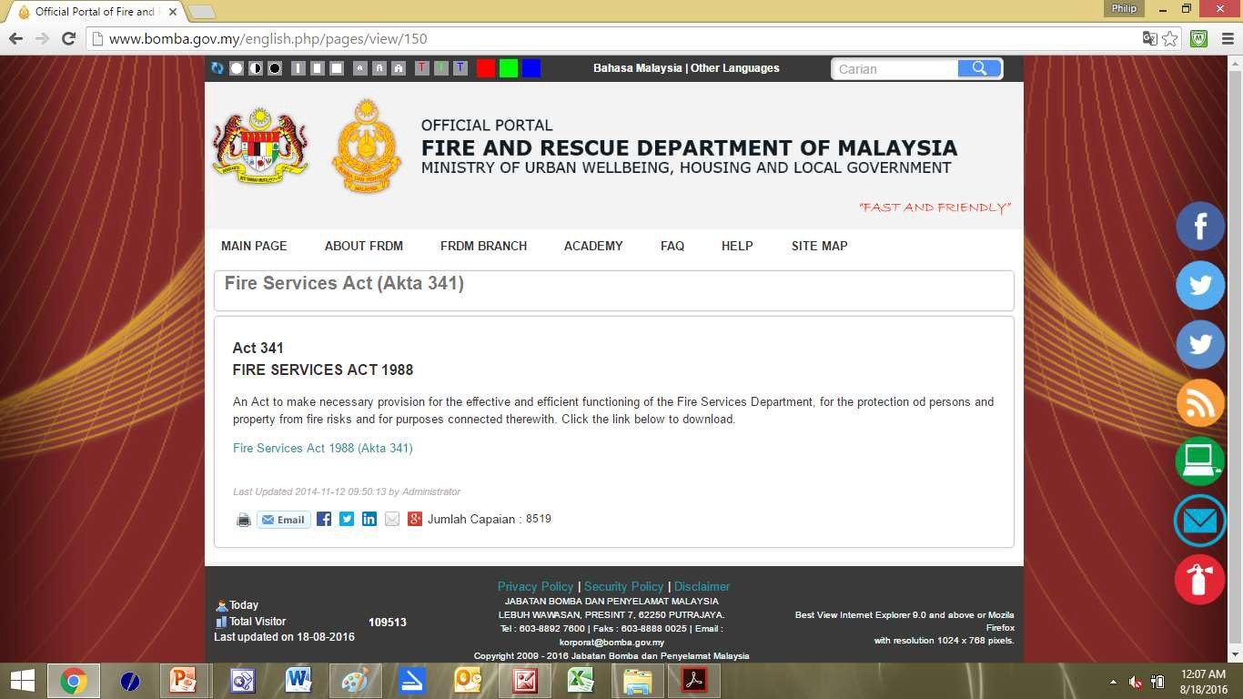
Protection of People & Property From Fire Risks

Jabatan Bomba Malaysia
27

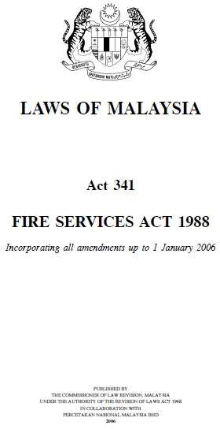

Softcopy available free.
28

Purpose of Fire Drills
- To ensure that everyone in the building is aware of how to exit the building in the quickest, easiest and safest way possible if a fire, smoke, carbon monoxide or other emergency did occur.

- To measure the state of readiness.

- To test the effectiveness of the ERP.
29

Building Fire Safety & Prevention
- Evacuation/Escape/Exit Route Maps.
- Fire Control Panel.
- CCTV Surveillance Room.
- Loud speakers.
- Location of Fire Fighting Equipment.
- Location of First Aid Kits.
- Designated Assembly Point.
30

Evacuation – Do’s & Don’ts
31



Floor warden to brief the staff members regarding do’s & don’ts in advance
32

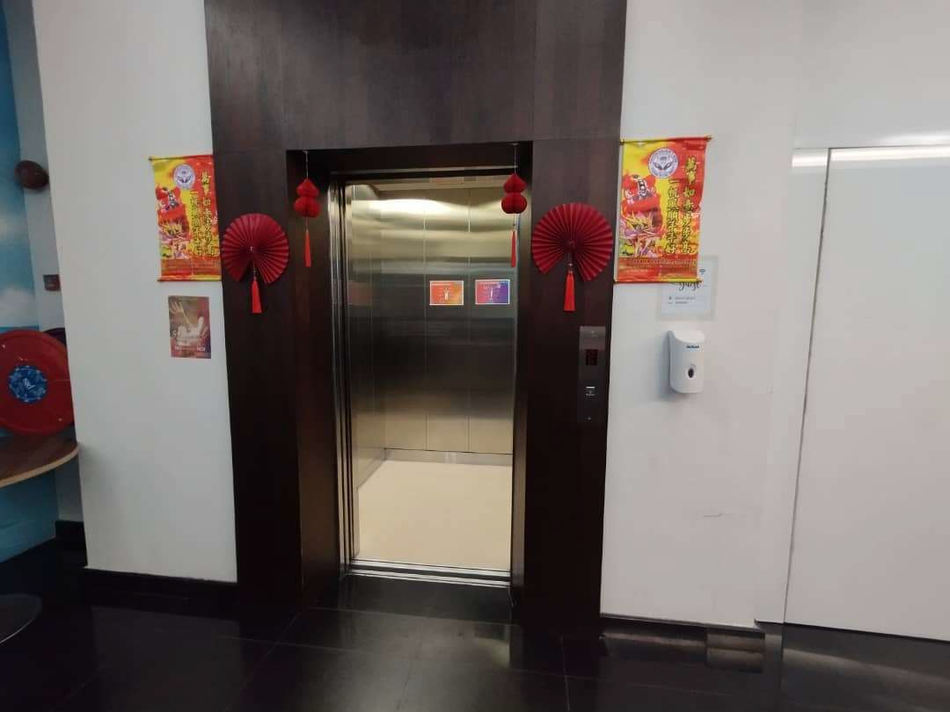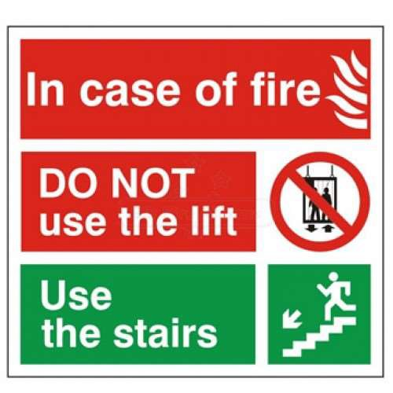
Do Not Use Lift
33

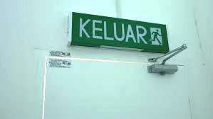
Follow KELUAR Signs
34

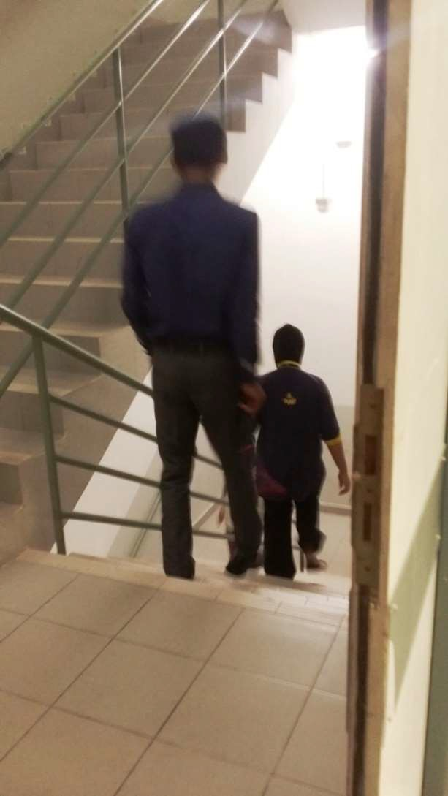

In Staircase

- Move in Single File
- Keep on Either Side
- Do not Overtake
- Help the Needy
35

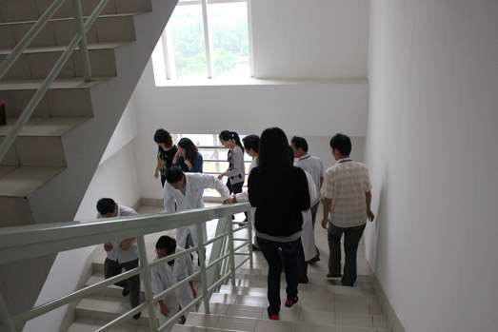

In Staircase

Do not take your time to go down the staircase – be hasty even it is a drill.
36

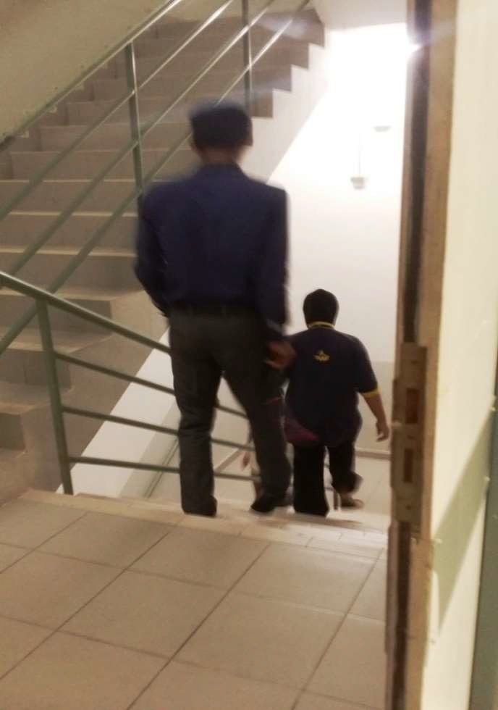

Last Fire Drill Conducted – April 2015
Building occupants evacuating the building via the staircases.
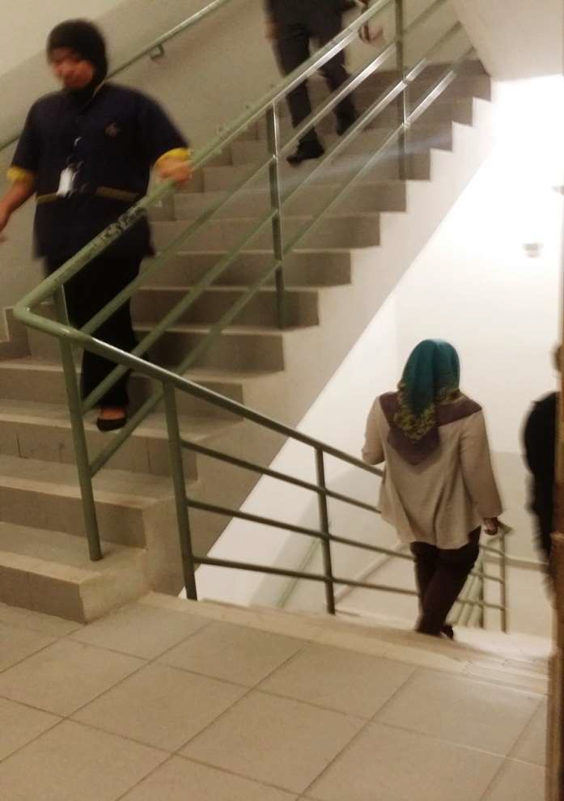
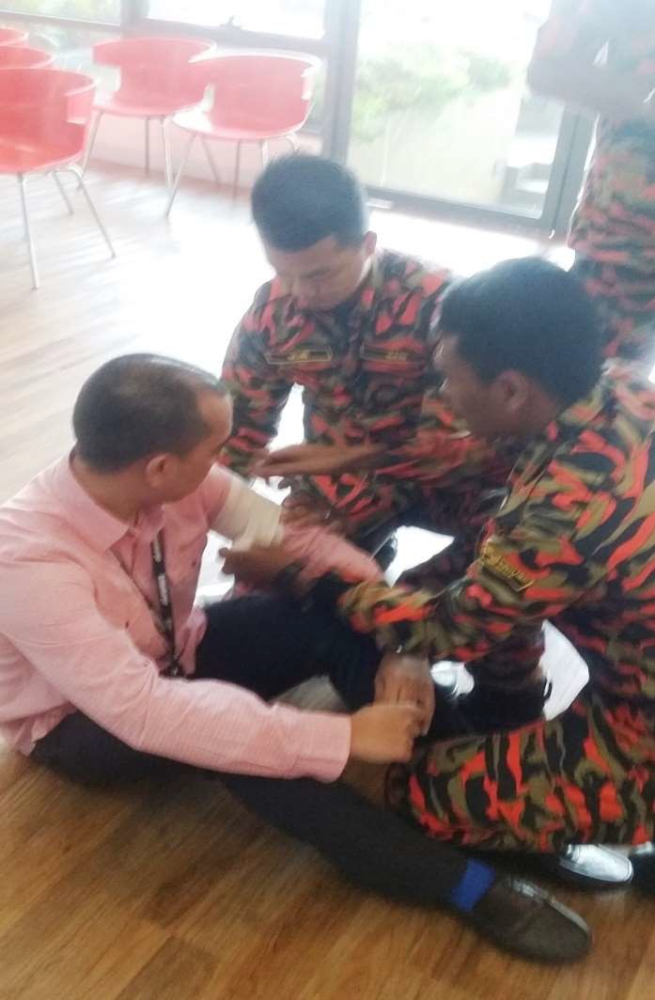
37

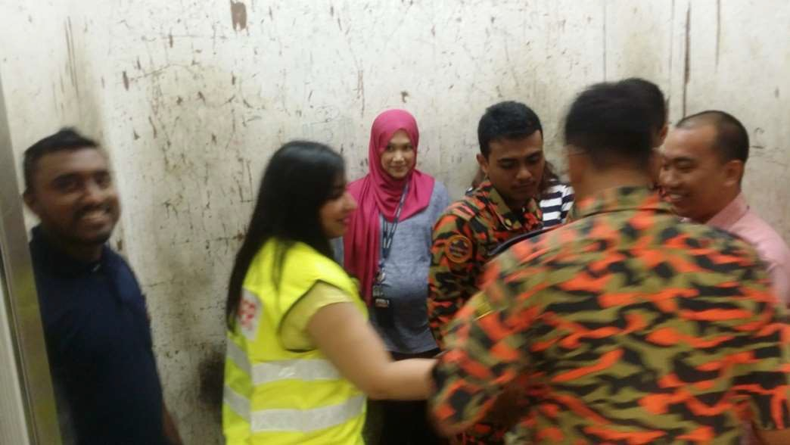

Last Fire Drill – Bomba Involvement

Bomba personnel giving ‘first aid’ treatment to a mock up ‘victim’.
38

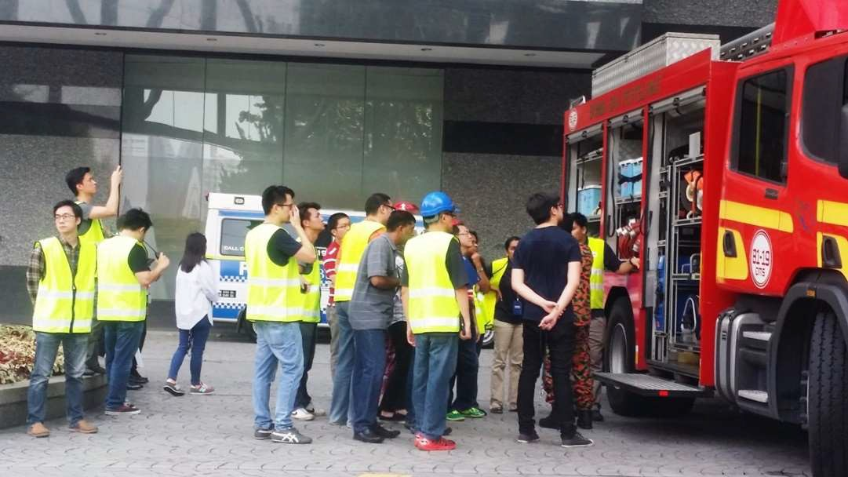

Fire Drill – Bomba Involvement

Bomba briefing Floor Wardens on the functions of the fire fighting vehicle.
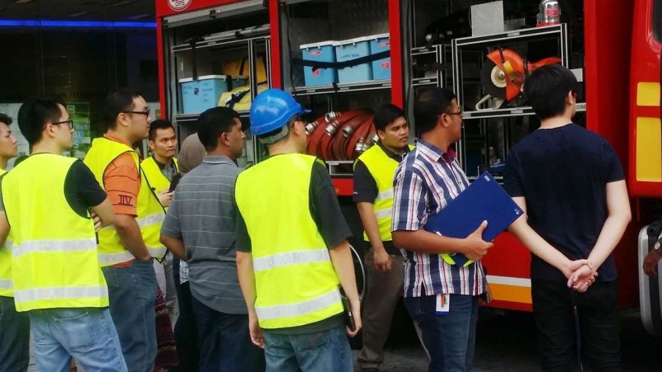
39

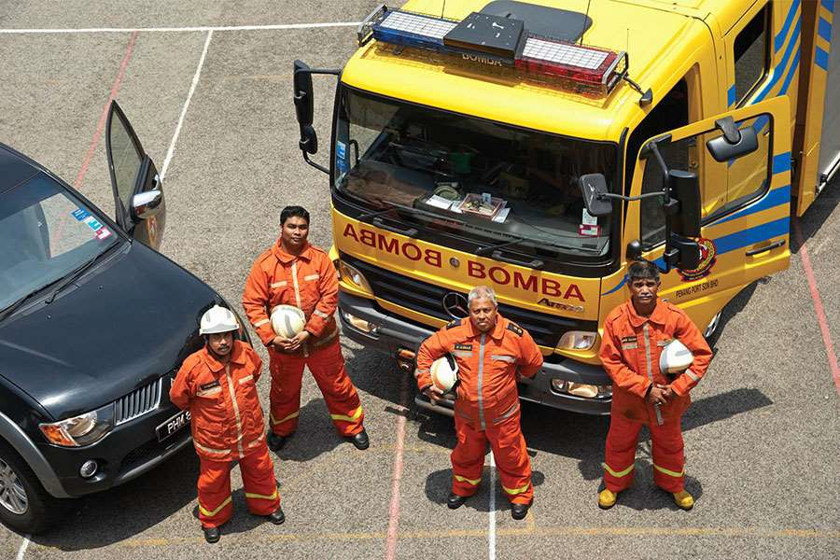

Bomba Rescue Team
40

In the event of a fire……
- A member of the Emergency Response Team (ERT) will activate the building fire alarm system.
- You will hear the fire alarm bells ring continuously.
- Wherever you are in the building, take the evacuation in a calm orderly manner, leaving all personal belongings behind.
- Those sitting by the windows will make sure the windows are close before leaving the office.
- Proceed quickly (do not run to avoid panic) to the appointed Evacuation Assembly Point.
41

In the event of a fire……
- Look for the Floor Warden in charge and ensure a Head Count on you had been recorded by the Floor Warden.
- Everyone will wait at the Evacuation Assembly Point until told by the ERP Coordinator or Emergency Commander that it is safe to re-enter the building and the all-clear is given.

- Remember: On no account must you re-enter the building until the “all-clear” is given by the ERP Coordinator.

- The safety of the building occupants are paramount and any instructions given by the Bomba or Polis Bantuan or Floor Warden should be acted upon immediately.
42

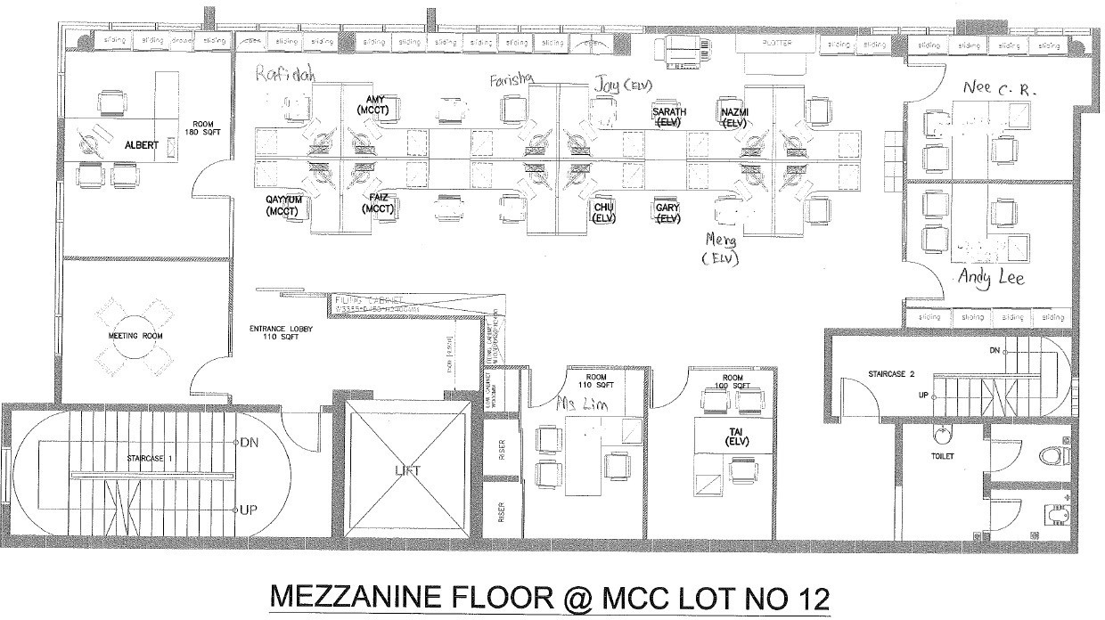

Mezzanine/1st/2nd Floor Exit Routes
Do not use the lift to exit the building.
43

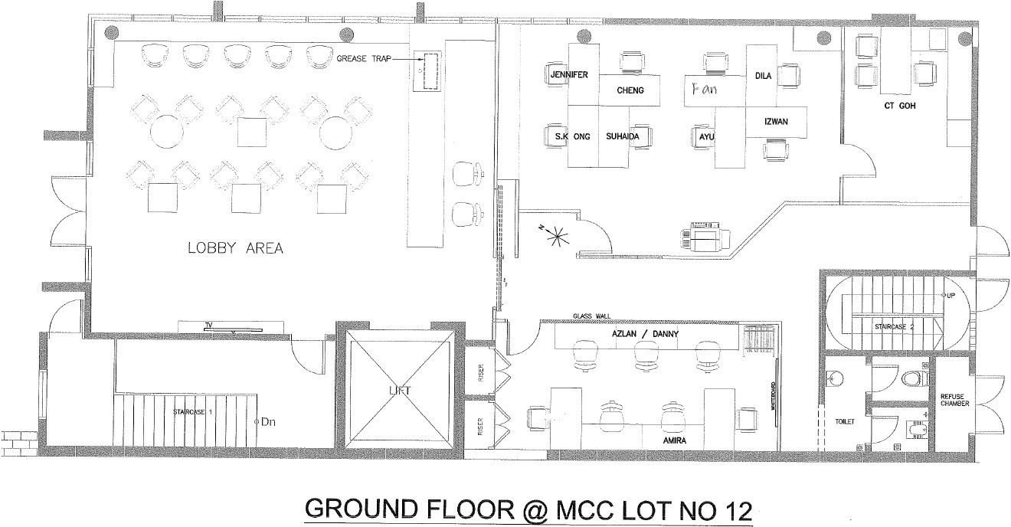

Ground Floor Exit Routes
44

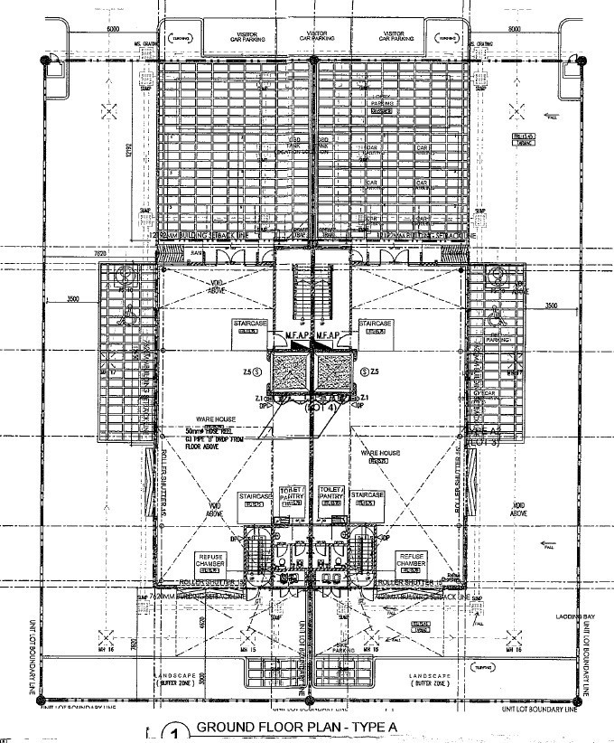
LOT 12
LOT 10
Designated
Assembly Point For Lot 12 Staff
EXIT ROUTES
Designated
Assembly Point For Lot 10 Staff
45

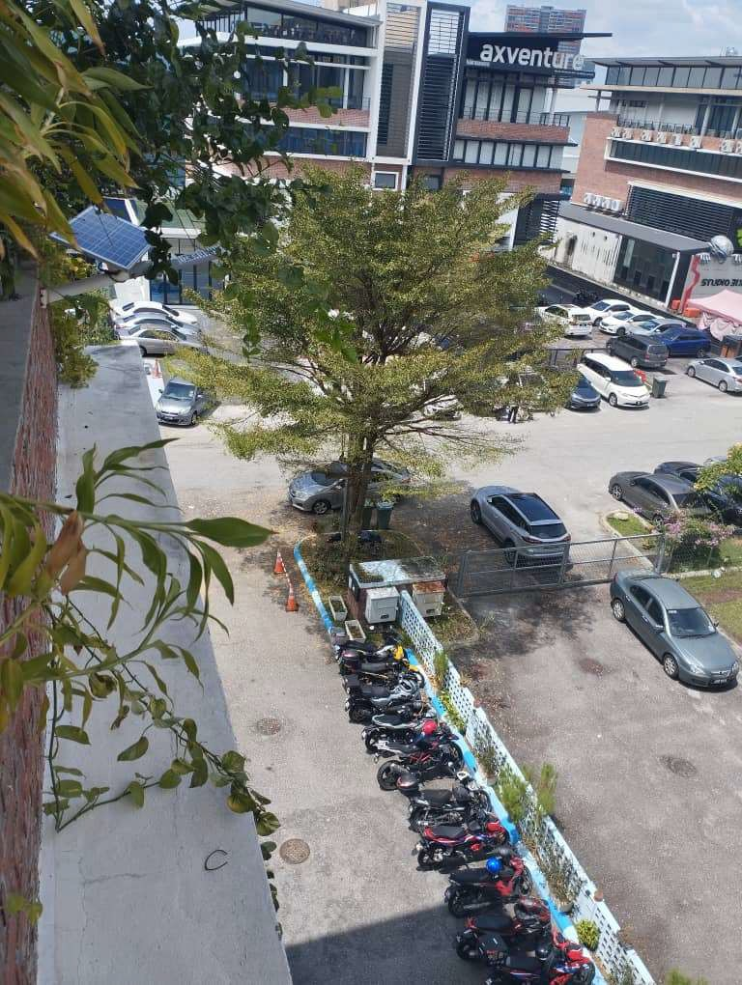

Evacuation Assembly Point for Lot 12 Staff
46

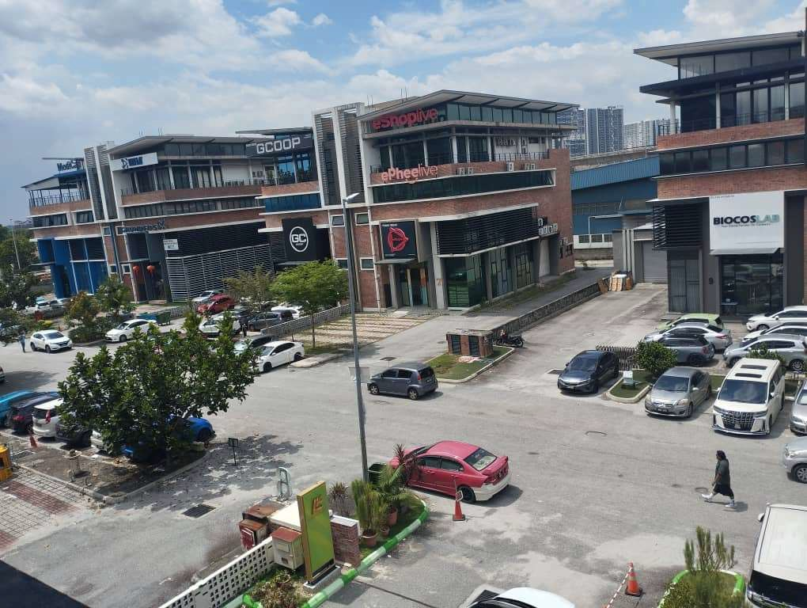

Evacuation Assembly Point for Lot 10 Staff
47

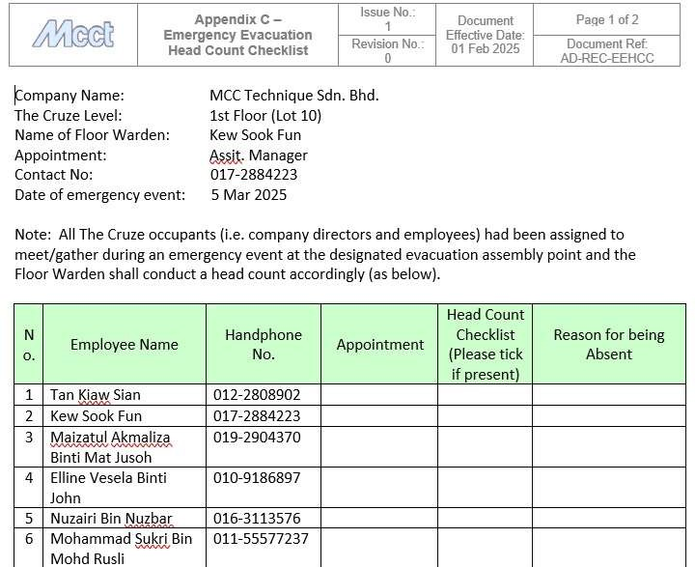
Required Forms
48

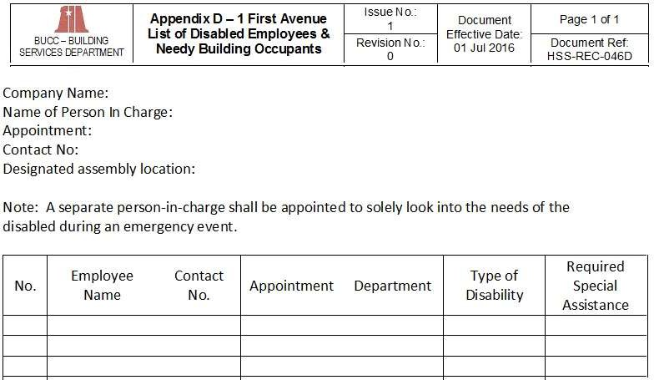
Required Forms
49

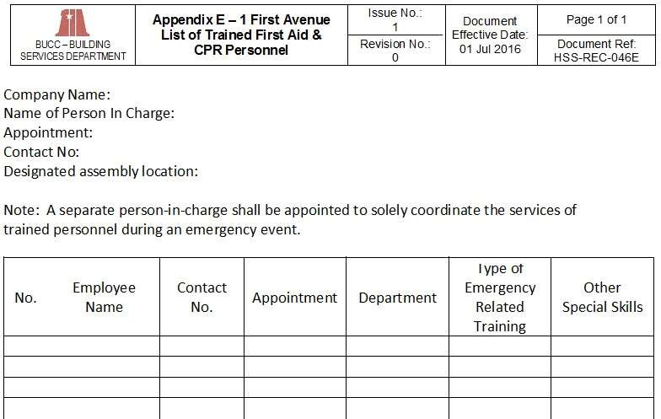
Required Forms
50

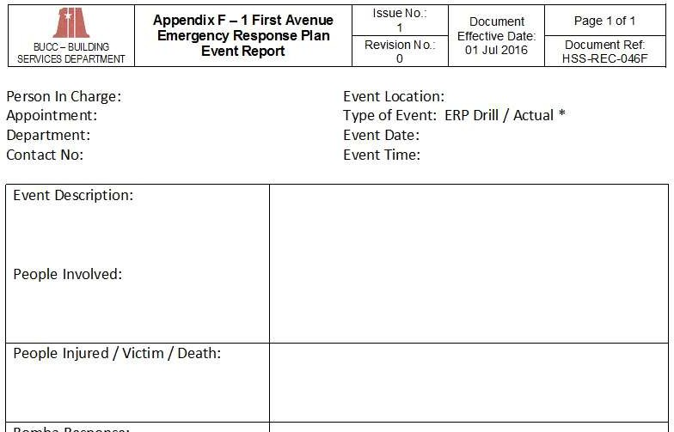
Required Forms
51

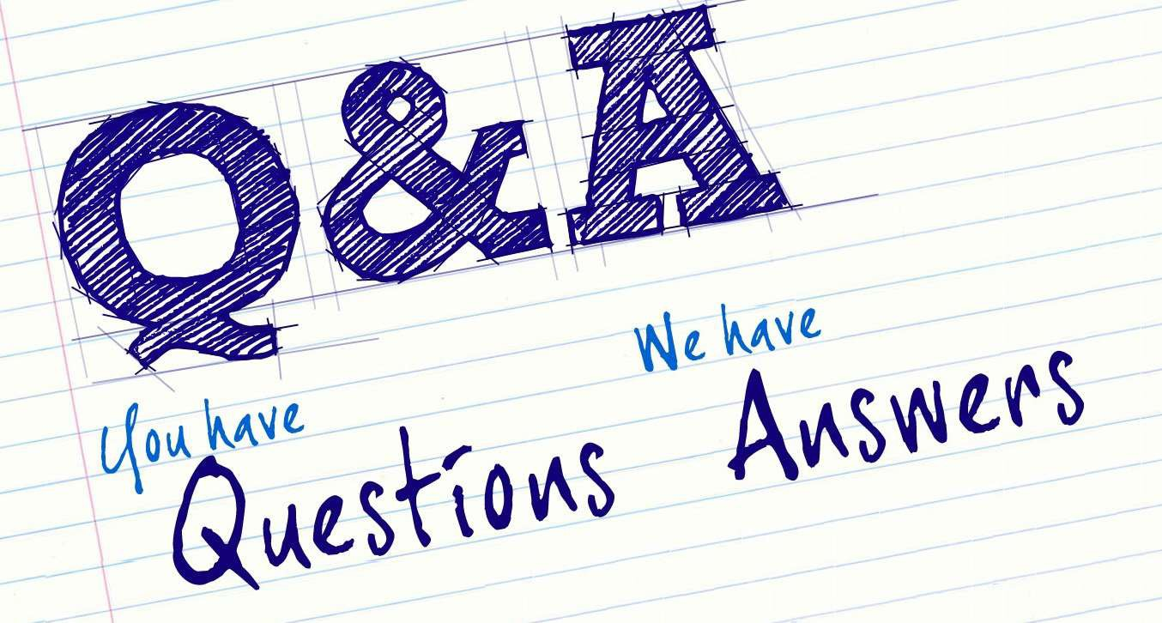

52
52

