

Our reference: CA155-6075
Date: 4th March 2025

To whom it may concerned,
(Neighbour to MCC Technique Sdn. Bhd.)

Dear Sir/Mdm,

RE: NOTIFICATION OF FIRE DRILL ON 05 MARCH 2025 (WEDNESDAY)
@ 10.00AM TO 12.00PM
As part of our commitment to Department of Occupational & Safety (DOSH) policy and requirement, we would like to notify, there will be Fire Drill conducted as per below details:

Location | : | MCC TECHNIQUE SDN. BHD.  LOT 10 & 12, JALAN PPU2A, TMN PERINDUSTRIAN PUCHONG UTAMA, 47100 PUCHONG, SELANGOR
Date | : | 5th March 2025
Time | : | 10.00AM – 12.00PM

During the drill, there will be fire alarm activated and all occupants in our building need to evacuate.

If you have any questions, please reach out to our person in charge Nurul Atikah (013-4446321).

Thank you.


Yours Faithfully,
MCC TECHNIQUE SDN. BHD.
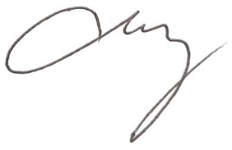

PHILIP YONG
Executive Director

