HEXATECH | Project Implementation Method Statements Manual: Elec. MS for ESD Floor Installation | Issue  No: 1 | Effective Date:  01/03/17
HEXATECH |  | Rev  No: 0 | Document Ref:  MS-E002

1. OBJECTIVE OF PROCEDURE

• This procedure provides Installing a static control (ESD) floor with specification, quality control and safety plan pertaining to the project. A static control floor tile provides a conductive pathway from the person / equipment to ground, thus allowing electrostatic charges to flow safely from the body / equipment.

2. REFERENCES
• Method of installation is accordance to European standard BS EN 61340.
• Methods of Measurement: ANSI/ESD 7.1, ASTM F150 and DIN-51953

3. TOOLS AND EQUIPMENTS
• Trowel--1/16" x 1/16" x 1/16" square notch and 150 lbs Roller (see Diagram 3)
• Vinyl floor welding kit and accessories

4. SAFETY & ENVIRONMENTAL PROGRAMME
• All installation works will be carried out in accordance with Project Safety Plan, Owner
Safety Procedures and statutory regulations.
• All necessary personal protective equipment will be provided and worn.
• All the tools and equipment used at site must be compliance to safety requirement.
• The site of all work activities will be kept in clean and tidy manner.

5. PREPARATION OF INSTALLATION

To check that the following environmental and subfloor conditions are met:

• The installation should not begin until the work of all other trades has been completed, especially overhead trades.
• Areas should be cleaned, preferably fully enclosed, weather-tight with the permanent HVAC system set at <25O C for a minimum of 72 hours prior to, during and after installation. The flooring material should be conditioned in the same manner.
• Areas to receive flooring shall be adequately lighted to allow for proper inspection of the substrate, installation and seaming of the flooring and for final inspection.
• Floors shall be smooth, flat, level, permanently dry, clean and free of all foreign material such as dust, paint, grease, oils, solvents, curing and hardening compounds, sealers, asphalt and old adhesive residue.
• Concrete shall have a minimum compressive strength of 3500 psi. Patch and repair minor cracks and other imperfections with Portland-based patching compounds.
• Floor covering should not be installed over expansion joints.
• It is essential that moisture tests be taken on all concrete floors regardless of the age or grade level. One test should be conducted for every 1000 sq. ft. of flooring (minimum of 3). The moisture emission from the concrete shall not exceed 5.0 lbs per 1000 sq.ft. in 24 hours. If the test results exceed the limitations, the installation must not proceed until the
problem has been corrected.

Page 1 of 6

HEXATECH | Project Implementation Method Statements Manual: Elec. MS for ESD Floor Installation | Issue  No: 1 | Effective Date:  01/03/17
HEXATECH |  | Rev  No: 0 | Document Ref:  MS-E002

6. GUIDELINES

• Each tile must be grounded.
• To lay conductive copper foil strips underneath the tiles.
• The copper strip needs to be grounded.
• It is recommended to have one or more grounding point per 30m² of ESD
• The installation of the floor tile begins from the middle of a room.
• In very large rooms (> 40m2), divide the room into smaller areas.
• How ESD tile work (see Figure 2).
• Spot-checking single tile before the installation (see Figure 7)

7. WORK METHOD STATEMENT

• Sweep and vacuum the floor.
• Lay the copper strips in parallel lines at 1m intervals down the longest length of the room from wall to wall. (see Diagram 1)
• Lay further strips of the copper foil at 90° angles and 5m intervals from your first grounding point across the shorter length of the room to form a grid (see Figure 4). All intersections
should be punched through with a nail or an awl in order to obtain a good contact (see
Figure 5)
• Once you have formed the grid of copper foil, measure/check the resistance of the copper strip system (see Figure 6).
• If required prime the floor with conductive primer, a black watery solution with resistance of
<10E5 ohms. The primer dries in about 3 hours and then is ready for the application of conductive adhesive, a watery acrylic contains conductive fibbers and has resistance of less than 10E5 ohms.
• The tile should be laid immediately after application of the adhesive. Start laying tiles from the center of the room, lay the first four tiles in a square ensuring that the interlocking joints
are centered on the copper strip (i.e.: all 4 tiles are in contact with the copper). Work outwards from the center being careful to ensure that the interlocking joints stay in contact with the copper strips (see Figure 1 and Diagram 1). The back of the tiles is clearly marked arrow; all arrows must face the same direction.
• Cut the tiles to a straight edge, leaving a 5mm gap between any fixed object and the tiles to allow for expansion.
• Laid tiles must be rolled with 150 lbs roller (see Diagram 3) while the adhesive surface is still wet. The adhesive requires a drying time of at least 24 hours until the floor can be used or
welded.
• If welding is required, damp-clean the unwelded tiles to avoid dust contamination in the seams. Before being seamwelded (see Diagram 2) tiles have to be grooved to 2/3 of their
depth with groover and air dryer. Trim shortly after the welding rod is still warm and soft with a special crescent knife. Trim again after the welding rod is completely cold.
• Connect the copper strip/grid to the normal building ground source (see Figure 3); in highly
ESD sensitive areas to separate “equipotential” grounding system.
• For installation clean-up, remove excess adhesive from the surface of the tile by means of a damp cloth or an abrasive hand pad.
• Conducting surface (point to point) resistance (see Figure 8) and surface to ground. The specified voltage is applied and the resistance recorded. The resistance should correspond
to that specified for the product.

HEXATECH | Project Implementation Method Statements Manual: Elec. MS for ESD Floor Installation | Issue  No: 1 | Effective Date:  01/03/17
HEXATECH |  | Rev  No: 0 | Document Ref:  MS-E002

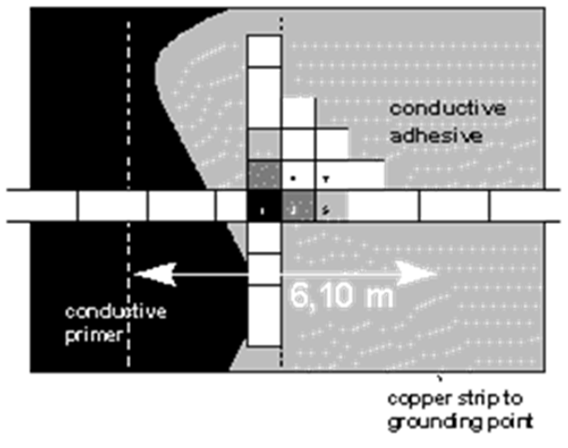

Figure 1: Installation Layout

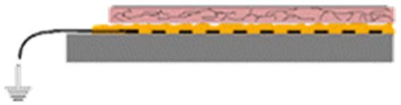

Figure 2: How ESD Tile work

• ESD tile conducts vertically through the tile
• The adhesive conducts horizontally and vertically
• Primer conducts horizontally
• Copper strip connects to ground

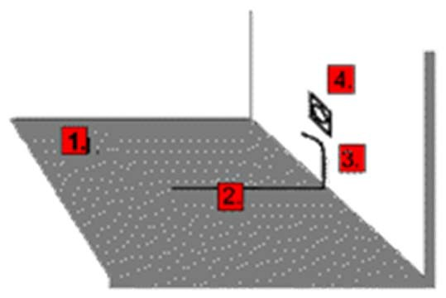

1=Primer and conductive adhesive over total floor surface
2=Copper strip about 3ft (1m)
3=Glue the copper strip to the wall
4=Wall socket with ground connection

Figure 3: Example of connecting COLOREX to ground

Page 3 of 6

HEXATECH | Project Implementation Method Statements Manual: Elec. MS for ESD Floor Installation | Issue  No: 1 | Effective Date:  01/03/17
HEXATECH |  | Rev  No: 0 | Document Ref:  MS-E002

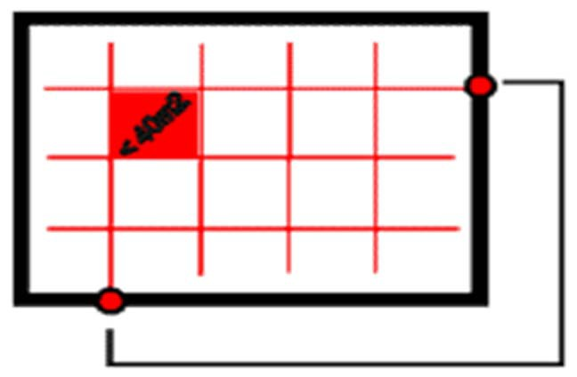
Figure 4: Installing copper strips as a grid

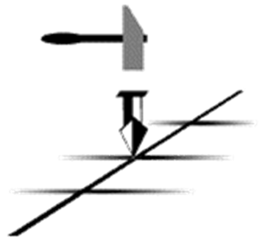

Figure 5: Punching copper strip to assure contact

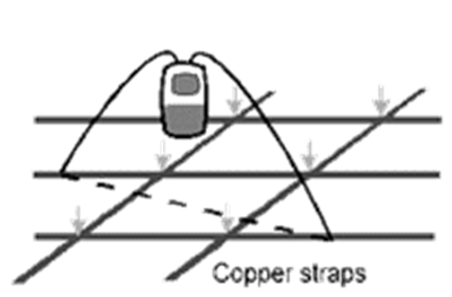

Figure 6: Testing the contact of the copper strips

HEXATECH | Project Implementation Method Statements Manual: Elec. MS for ESD Floor Installation | Issue  No: 1 | Effective Date:  01/03/17
HEXATECH |  | Rev  No: 0 | Document Ref:  MS-E002

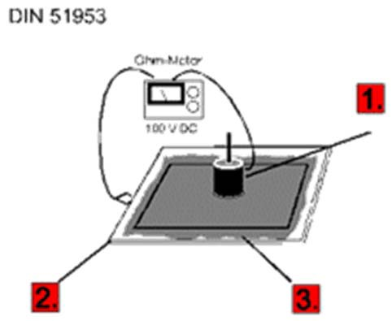

• 1=Electrode: ca.1Kg/dia.5cm/conductive rubber
2=Ground electrode: steel plate larger than floor-tile
3=Contact between steel-plate and floor-tile: wet fabric or graphite-coating

Figure 7--Measuring resistance on uninstalled tile according to DIN-51953

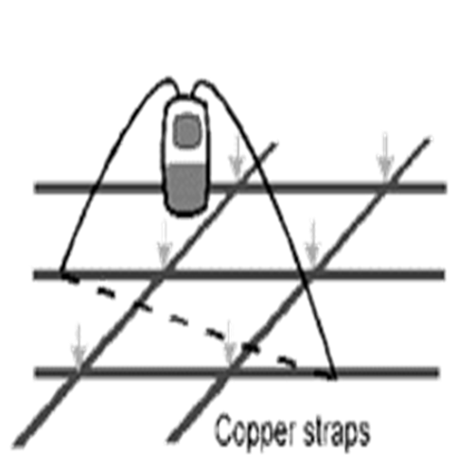

Figure 8--Measuring resistance point-to-point on the surface of the flooring

HEXATECH | Project Implementation Method Statements Manual: Elec. MS for ESD Floor Installation | Issue  No: 1 | Effective Date:  01/03/17
HEXATECH |  | Rev  No: 0 | Document Ref:  MS-E002

5 meters

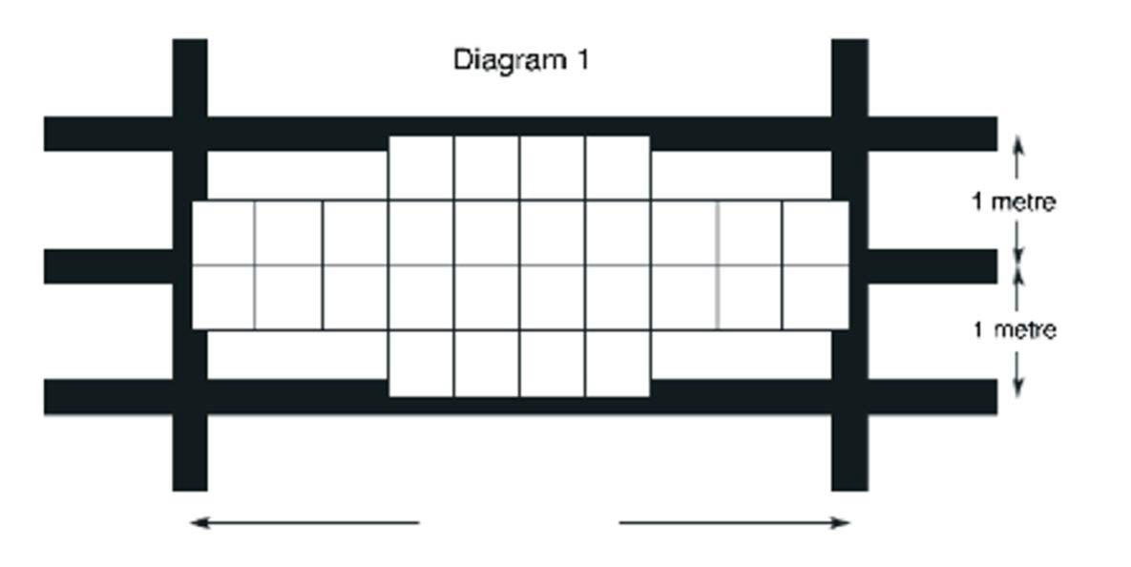Diagram 2 (Seamwelding)
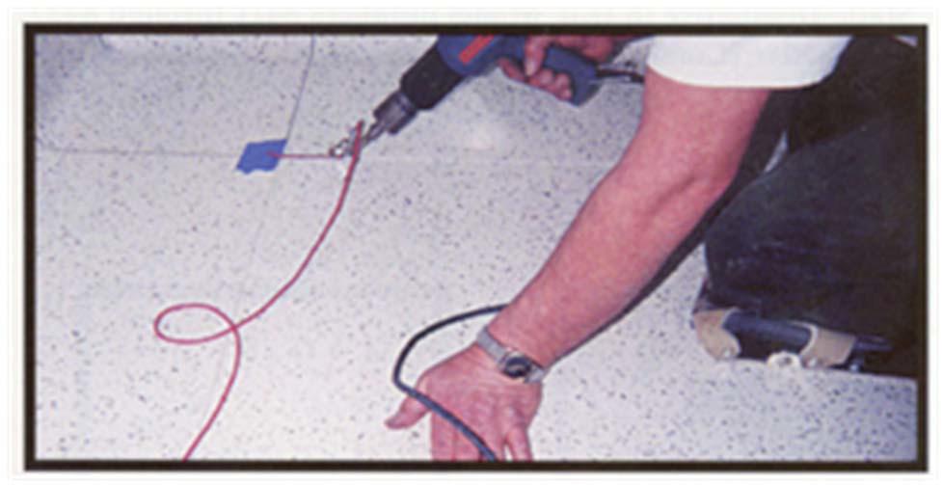

Diagram 3 (Trowel and Roller)



