- OBEJECTIVE
This procedure provides details for Submain Cable installation with Quality Control and Safety Plan pertaining to this project.

- SCOPE OF WORKS
Method of installation is in accordance to the latest IEC, IEE, MS, BS and local authority standards.

- REFERENCES
- IEC 62305 Part 1 to 3
- BS 7671, Regulation for Electrical Installation

- HANDLING AND STORAGE
Only approved site lay down areas, will be used for storage. All cable will be delivered on cable drums and covered with canvas to prevent contamination through water and dust.

- WORK METHODOLOGY

a. Determine the cable quantity and routing clear of obstacles ie: above ground/under ground/in the cable tray/ in the conduits. Further evaluate the space available for work to be carried out.
b. Re-check the actual routing PVC
c. Material Preparation
i) Cable of appropriate length or slightly longer than actual measurement shall be used for laying and no joint shall be allowed.
ii) Cable of different types shall be used as per tabulation below:

Item | Nature Of Load | Type Of Cable
1 | External lighting points and sub-main cables | Multi-core 600/1000V PVC/SWA/PVC Cable
2 | Sub main cables to normal supply LV board, in building | Single core 600/1000V PVC/PVC or single core 600/1000V XLPE/PVC cable
3 | Sub main cables to essential supply LV board, in building | Single core 600/1000V fire rated cable

d. Sub main Cables Installation (Trunking / Tray and Cable Ladder)
- All sub main cabling shall be consists of the following :
~ PVC/PVC, XLPE/PVC, PVC/SWA/PVC, XLPE/SWA/PVC and Fire Resistant cable.
- Cable shall be laid in full length. The approximately length of cable shall be determined prior to the installation works. No cable jointing is allowed.
- Care shall be taken to avoid damages to the outer sheathed of cable during cable laying onto the cable tray/ladder. In case of long cable, cable roller pulley shall be provided and to secure onto the cable support to form a rolling effect. Cables will then be laid onto the rollers from starting to the end point.
- All sub main cable install on cable support shall be in appropriate spacing and allow for bending larger than the minimum recommended radius by manufacturer. When single core cables are used for three-phase supply, the cables shall be laid in trefoil formation, a minimum gap equivalent to diameter of single conductor. Size between two groups of cables.
- All sub main cables shall be properly secured onto cable support with cable cleats at 1.5m (max) interval for vertically installed cable and 3m (max) interval for horizontal run cable.
- Sub main cables on tray/ladder/trunking shall be carefully arranged to minimize unnecessary cable crossing. Cable nearest to the feeding end shall be installed to the edge of tray/ladder and follows by the next feeder. This installation is similar for cable tray and cable ladder.
- Nevertheless, the installation of cables onto the trunking is a little bit different. The cables will be arranged first before put into the trunking.
- Fire seal around cable trunking/cable tray/cable ladder at all penetration of fire-rated walls and slabs to maintain fire rating.

e. Riser Cable Installation
- Install cable in riser shaft by lowering the cable from the upper floor to a lower floor. Hoist cable drums and place it securely on the upper floor.
- To prevent the cable uncontrollable release from cable drum under its own weight by installing an appropriate braking system.
- Pull cable down in the riser-shaft guided by cable roller guide suitable for holding the cable in position.
- Pull cable after placing cable stocking at the pulling end by a winch places at the lower floor.
- Excess length of the cable must be properly coiled and protected from damage.
- Do not expose cut cable ends using self-adhesive PVC tape.
- After cable is pulled, install cable on the cable tray immediately before pulling the next cable. Cable shall be held to cable tray using proper metallic cable strap at 1.5 meter intervals.
- Fire-seal around the cables at all penetrations of fire-rated walls and slabs to maintain fire-rating.

- Cable Identification
  - Cables shall be identified with color coding as per tabulated below:
  - The type of protective conductor to be used shall depend on the sizes of phase conductor.

Cable Size | Color Of The Sheath | Color of The Core | Type of Protective conductor
50 mm sq to 1000 mm sq Single Core PVC/PVC Cable (for Sub-main cable) | Black Outer Sheath | Red = Red Phase  Yellow=Yellow Phase  Blue =Blue Phase  Black = Neutral Phase | Bare Copper Tape = Earthing
1.5 mm sq to 35 mm sq Single Core XLPE/PVC Cable (for Sub-main Cable) | Black Outer Sheath | Red = Red Phase  Yellow=Yellow Phase  Blue =Blue Phase  Black = Neutral Phase | Green Color Core = Earthing
50 mm sq to 1000 mm sq Single Core XLPE/PVC Cable (for Sub-main Cable) | Black Outer Sheath | Red = Red Phase  Yellow=Yellow Phase  Blue =Blue Phase  Black = Neutral Phase | Bare Copper Tape = Earthing
1.5 mm sq to 35 mm sq Multi-Core PVC/SWA/PVC Cable (for Sub-main Cable) | Black Outer Sheath | Red = Red Phase  Yellow=Yellow Phase  Blue =Blue Phase  Black = Neutral Phase | Green Color Core = Earthing
50 mm sq to 400 mm sq Multi Core PVC/SWA/PVC Cable (for Sub-main Cable) | Black Outer Sheath | Red = Red Phase  Yellow=Yellow Phase  Blue =Blue Phase  Black = Neutral Phase | Bare Copper Tape = Earthing

- Cable Termination and Cable Identification Method
  - Cables terminated at MCB shall be terminated directly to the breakers.
  - Cables terminated at MCCB shall be terminated onto breaker by using cable lugs.
  - For termination of cables above 6 mm sq, cable lugs will be tightened at the cables and terminated to the breaker.
  - Fix cable marker at both end of sub-main cable.

HV Heat Shrinkable Termination
- Ensure that HV cables are laid to respective HV panels according to approved drawings. All HV cables shall be properly terminated by experienced cable jointer
- The shrinking operation should be done using a “quite” yellow tipped blue gas flame (avoid pencil type-blue flame). Keep the flame moving continuously in a brush-like motion to avoid scorching of the sleeves and other heat shrinkable parts, Direct the flame at a 45-degree angle in the shrink direction intended.
- Ensure that the heat shrinkable components are shrunk uniformly and free void and wrinkle before continuing with the next installation sequence that follows.
- Both the tubing and moulded parts change their length to some extent when they are shrunk. (heat Shrinkable Sleeves are subject to a longitudinal change of +/- 5%).
- With Breakout, heating should begin at the shoulder (mould-line) followed by the Breakout fingers. The shrinking process should be completed by applying the flame to the Breakout base.

- When it is necessary to cut the heat shrinkable material, either a sharp knife or scissors should be used. Ensure that a clean cut is made, since a rugged edge may cause splitting when the material is subsequently heated.
- Some joints between heat shrinkable tubing and other parts are sealed by means of an integral heat-meat adhesive within the part, or with a separately applied heat-melt tape.
- Sufficient heat must be applied, not only to shrink the material, but also to ensure that heat-melt adhesive has bonded correctly.
- In circumstance when adhesion is required on the lead sheath, the outer surface of the lead sheath should be thoroughly cleansed and preheated to assist the bonding process.
- Cleanliness is essential with heat shrinkable material as surfaces must be kept clean of oil and dirt. Cleaning should be done using a rag soaked in a suitable solvent such as Tricloroethane.
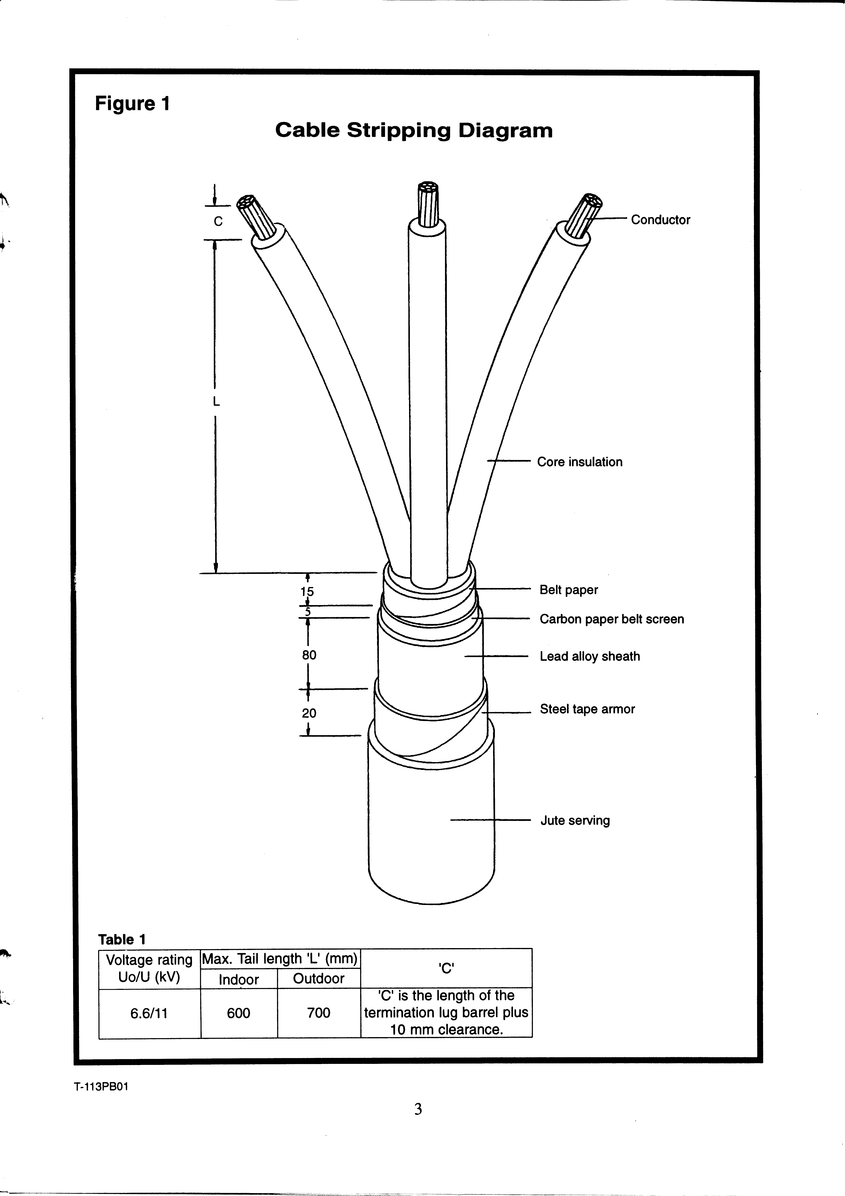
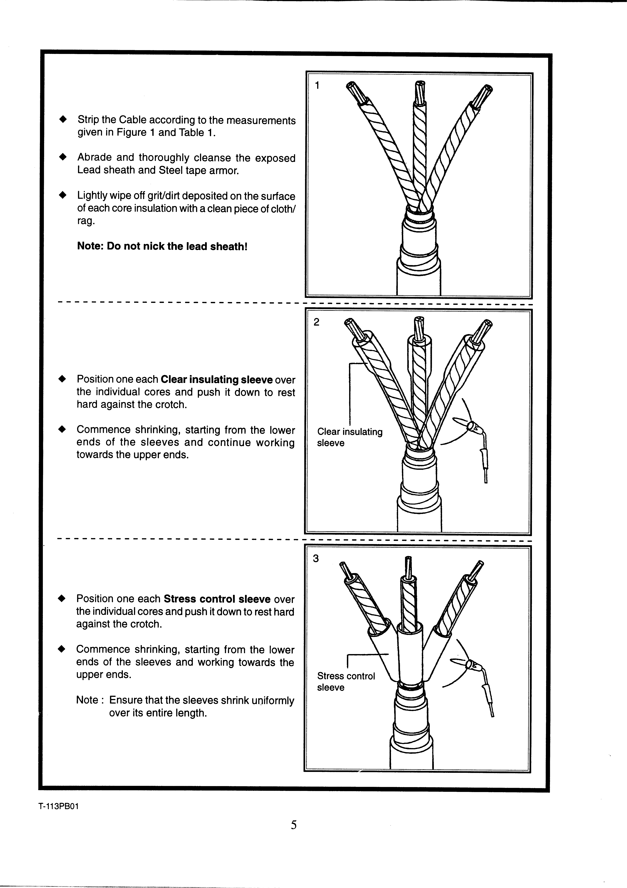

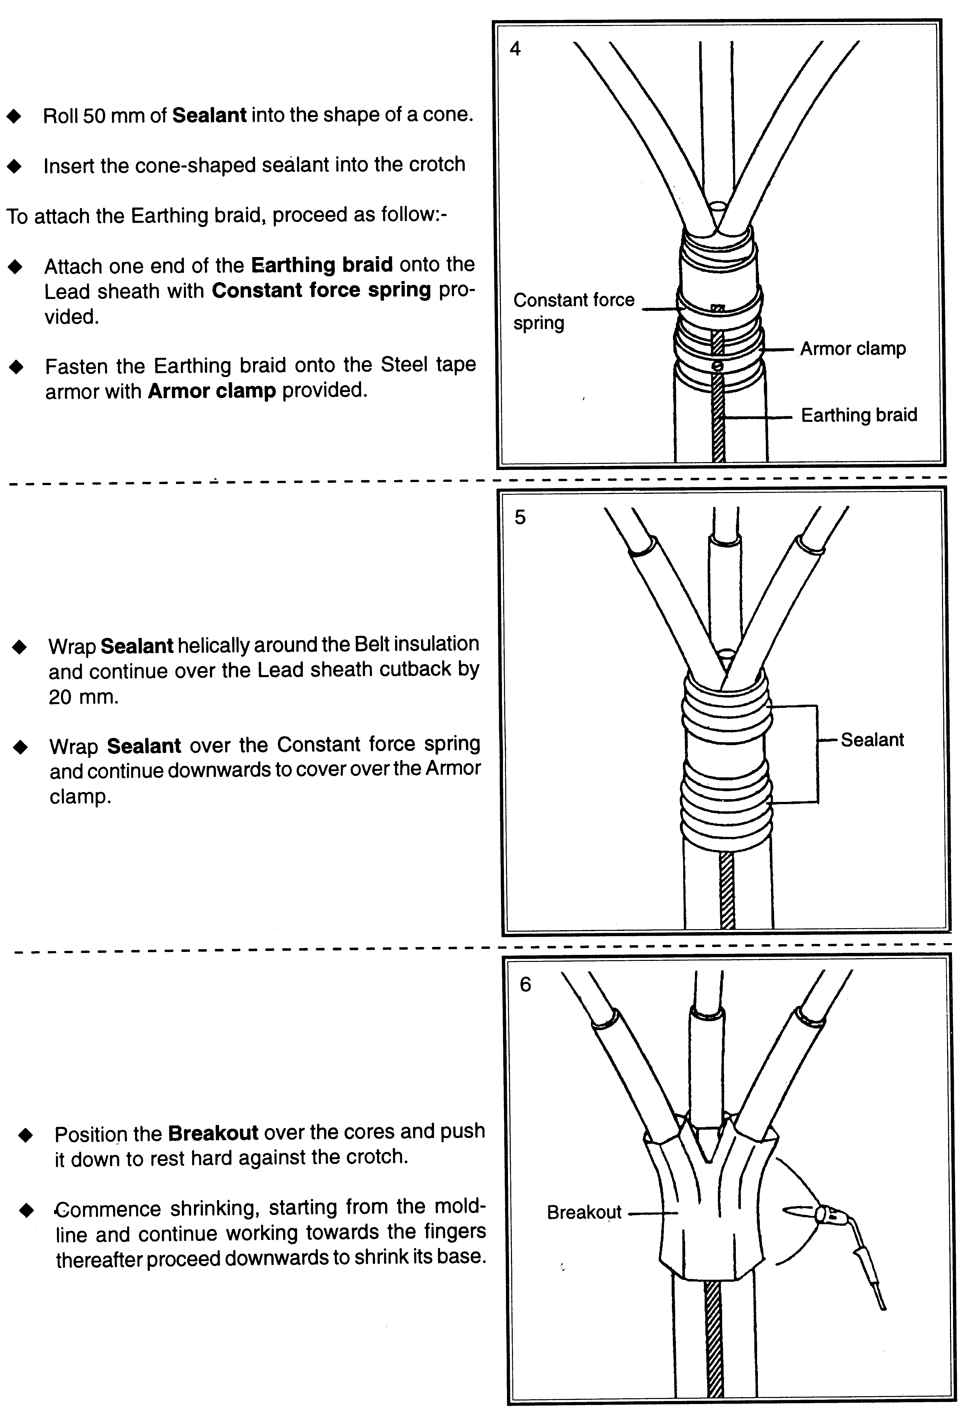
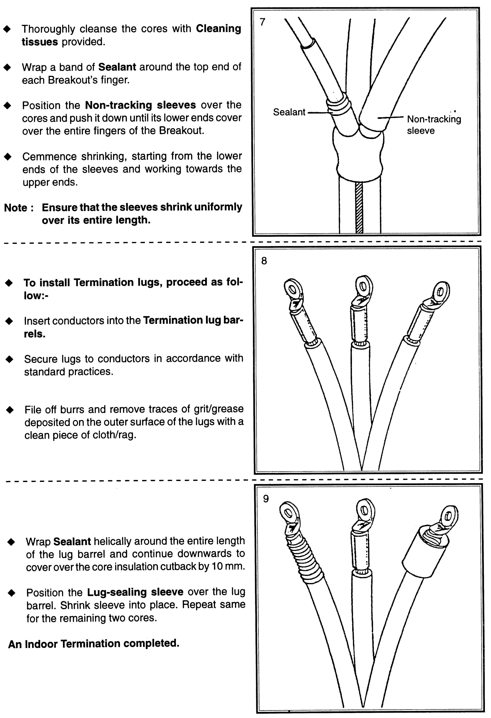
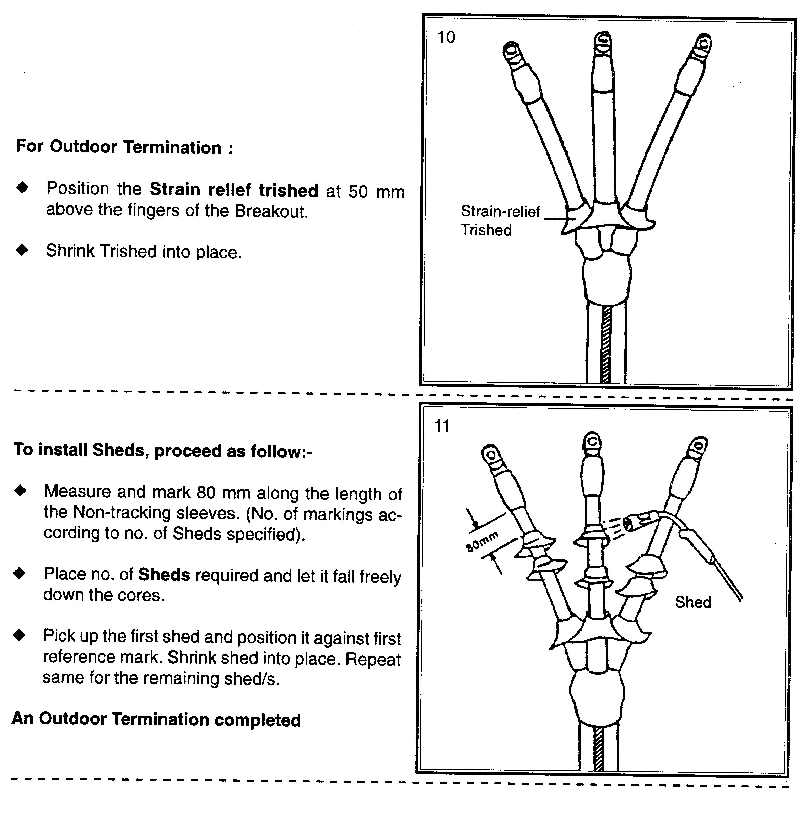

7.0 HEALTH, SAFETY, SECURITY AND ENVIRONMENT

- All installation works will be carried-out in accordance with Project Safety & Environmental Plan, client's Safety Procedures and statutory regulations.

- All necessary personal protective equipment will be provided and worn.

- All the tools and equipments used at site must be compliance to safety requirement.

- The site of all work activities will be kept in clean and tidy manner.

- Safety personnel will closely supervise and checked the safety of the construction area. Safety measure will be intensified when the risk are higher during period of work.

8.0 LIST OF ATTACHMENT

Attachment | Description | Remarks
1 | List Of Material, Tools and Safety Facilities

ATTACHMENT 1: LIST OF MATERIAL

List of Material
A | Equipment and tools
1 | Cable roller
2 | Hydraulic cable jack
3 | Cable cutter
4 | Cable gland
5 | Cable lugs
6 | Clamping tools
7 | Cutter
8 | Measurement Tape
9 | Cable Stand Jack
10 | Torch Gun
11 | Heat Shrink Kit
12
13
14
15
16
17
18
19
20
21
22
23
24
25
26
27
B | Safety tools
1 | Safety helmet
2 | Safety shoe
3 | Hand Glove
4 | Goggles
5 | Safety Harness
6 | Basic First aid Kid

