PURPOSE

The Building Owner shall engage its own Electrical Building Maintenance Crew or outsourced an Electrical Contractor to undertake electrical building systems maintenance work with the purpose of facilitating the efficient operation and functionality of the Building Owner’s electrical equipment located at the building as stipulated at Appendix I.
DEFINITIONS
In this method statement, unless the context definition otherwise requires:
‘Building Owner Representative’ means the Building Owner’s appointed manager in charge of building maintenance.
‘Building Maintenance Crew’ means those qualified electrical maintenance personnel engaged by the Building Owner Representative as their permanent staff to undertake maintenance works on the electrical equipment of the building.
‘Electrical Contractor’ means a qualified electrical contractor engaged/outsourced by the Building Owner Representative to provide maintenance works on the electrical equipment of the building (refer to ‘Service to be Provided’ below).
‘Electrical equipment’ means those existing electrical equipment and its associated components or parts identified in the building that warrants maintenance (refer Appendix I to this method statement).
‘Condition of electrical equipment’ means the condition of the electrical equipment in the building on its ‘as-it-is’ condition.
‘Access’ means the Building Maintenance Crew or Electrical Contractor shall have access to the electrical equipment in the building with the permission or supervision of the Building Owner Representative.
‘Service to be Provided’ means the provision of works of a particular trade undertaken professionally and timely by either the Building Maintenance Crew or the Electrical Contractor, relating to the maintenance of the electrical equipment in the building. The Building Maintenance Crew or Electrical Contractor shall be required to obtain/provide the necessary labour, material, test equipment, tool, vehicle and subcontracted service, to meet the maintenance requirement of the electrical equipment.
- Electrical Equipment Coverage

  - The existing electrical equipment which had been identified at Appendix I for maintenance in accordance to a particular trade requiring the Service to be Provided shall be also specified in the Appendix I hereto.

  - In general, this method statement covers the maintenance of the Electrical Equipment and Equipment Added/Deletion by the Building Maintenance Crew or by the Electrical Contractor whereby it is also the responsibility of both the Building Maintenance Crew or the Electrical Contractor to determine the existing Condition of the Equipment before the start of any maintenance works and to record for purpose of monitoring and reporting on the ongoing status for continual efficient functionality of the electrical equipment as and when required.

- Scope of Works

2.1 The types of Service to be Provided by either the Building Maintenance Crew or the Electrical Contractor are categorized as follows:

    - Remedial Maintenance - unscheduled failures of electrical equipment which requires immediate downtime or emergencies repairs and breakdown service.

    - Preventive Maintenance - scheduled repair of any electrical equipment failure or breakdown of any magnitude such as in anticipation of the expiry of electrical equipment life span.

    - Predictive Maintenance - unscheduled maintenance of electrical equipment shall be carried out on as-required basis.

2.2 The General Specification for Service to be Provided (if any) for the electrical equipment shall be specified in the Appendix I hereto.

- Remedial, Preventive and Predictive Maintenance
3.1 The Building Maintenance Crew or Electrical Contractor shall obtain all materials, supplies, supervision, technical and engineering assistance expertise, and subcontracted services necessary to undertake the Service to be Provided relating to remedial, preventive and predictive maintenance on the electrical equipment in original factory operating specification condition that are consistent with manufacturer’s maintenance recommendations. This includes repair of any electrical equipment failure or breakdown of any magnitude, using OEM procedures and guidelines, OEM parts, and OEM recommended supplies, etc. OEM parts or supplies are to be used except when they are not available and they are replaced with parts or supplies approved as equal by the Building Owner Representative. The parts to be used are to be obtained/procured separately and are subjected to the approval of Building Owner Representative.

3.2 The recovery time for remedial maintenance carried out by the Building Maintenance Crew or Electrical Contractor on any of the electrical equipment shall be within reasonable period of time subjected to the age, nature, type and condition of electrical equipment involved and its parts availability.
3.3 The Building Maintenance Crew or Electrical Contractor shall ensure that all preventive maintenance, repairs or replacements indicated by inspections or testing, are completed in accordance to the required schedule. Whereas, predictive maintenance shall be carried out on as-required basis subject to the approval by Building Owner Representative provided that specialized work and tools are required. The Building Owner Representative shall approve the scheduling of each preventive maintenance work to be conducted by the Building Maintenance Crew or Electrical Contractor and shall also grant approval to carry out each predictive maintenance work based on the necessary requirement.
3.4 All necessary safety precautions are to be taken at all stages of the work by the Building Maintenance Crew or Electrical Contractor. It will be the responsibility of the Building Maintenance Crew or Electrical Contractor to ensure that all safety, health and environment guidelines or legislation, issued by any statutory body or by the Building Owner Representative, that are in force or any amendment or additions to the said guidelines from time to time (even those on short notice) are adhered to.
- Building Maintenance Crew or Electrical Contractor Maintenance Team

  - The Building Maintenance Crew or the maintenance personnel belonging to the Electrical Contractor who carry out the Service to be Provided on the electrical equipment at the Building must be qualified for the specific work function.

  - The Building Maintenance Crew or Electrical Contractor shall engage a qualified maintenance person to be present on Building site during the execution of the Service to be Provided. The said qualified maintenance person must ensure work progress on is carried out on schedule, good quality of workmanship, adherence to work methodology, maintain law and order, etc. The Building Maintenance Crew or Electrical Contractor is expected to follow the Building Owner Representative’s security and safety requirements and procedures at all times.

- Response Time

  - The Building Maintenance Crew or Electrical Contractor shall provide remedial maintenance by conducting routine checks or when notified by the Building Owner Representative that the Equipment is inoperative. The Building Maintenance Crew or Electrical Contractor will endeavour to conduct the required remedial maintenance or respond to the call for remedial maintenance within the response time shall be immediate in the case of the Building Maintenance Crew or not more than twenty-four (24) hours for the Electrical Contractor from the time of notification.

  - The Building Maintenance Crew or Electrical Contractor shall also provide preventive and predictive maintenance either by arrangement with the Building Owner Representative or which may be performed concurrently with remedial maintenance.

7. Building Owner Representative’s Responsibility

7.1 In connection with the commencement of the maintenance work on the electrical equipment, the Building Owner Representative shall undertakes the following:

    - To provide the Building Maintenance Crew or Electrical Contractor with consultation and advice concerning the location, accessibility, functionality and current status of the Equipment.

    - To provide the Building Maintenance Crew or Electrical Contractor with past electrical equipment maintenance records, occurrence or technical reports and other maintenance documents pertaining to the condition and serviceability of the electrical equipment.

8. Building Maintenance Crew or Electrical Contractor’s Responsibility

  - The Building Maintenance Crew or Electrical Contractor is fully responsible for the commitment of all work-related guidelines in its provision of Service to be Provided granted by Building Owner Representative and is required to observe the following:

    - Housekeeping has to be fully observed by the Building Maintenance Crew or Electrical Contractor. The Building Maintenance Crew or Electrical Contractor will clear any rubbish that may obstruct any of Building Owner Representative’s operation immediately after the completion of the maintenance work.

    - Tools, instrument and ladders used by the Building Maintenance Crew or Electrical Contractor at the job site must comply with standard safety requirement. Appropriate PPE must be worn at all times by the Building Maintenance Crew or Electrical Contractor and enforced to the workers who carry out work. Proper barricade must be provided to ensure safety.

    - The Building Maintenance Crew or Electrical Contractor shall be covered with adequate insurance on all its liabilities arising from the maintenance works carried out including third parties claims made against Building Owner Representative on the grounds of damage, and if the cause of the damage is within the area of responsibility and risk of the Building Maintenance Crew or Electrical Contractor. Such insurance coverage either provided by the Building Owner Representative or the Electrical Contract must indemnify Building Owner Representative against any third parties claims, unless the damage would inevitably occur even if the work was carried out properly, and if the Building Maintenance Crew or Electrical Contractor was unable to avoid it.

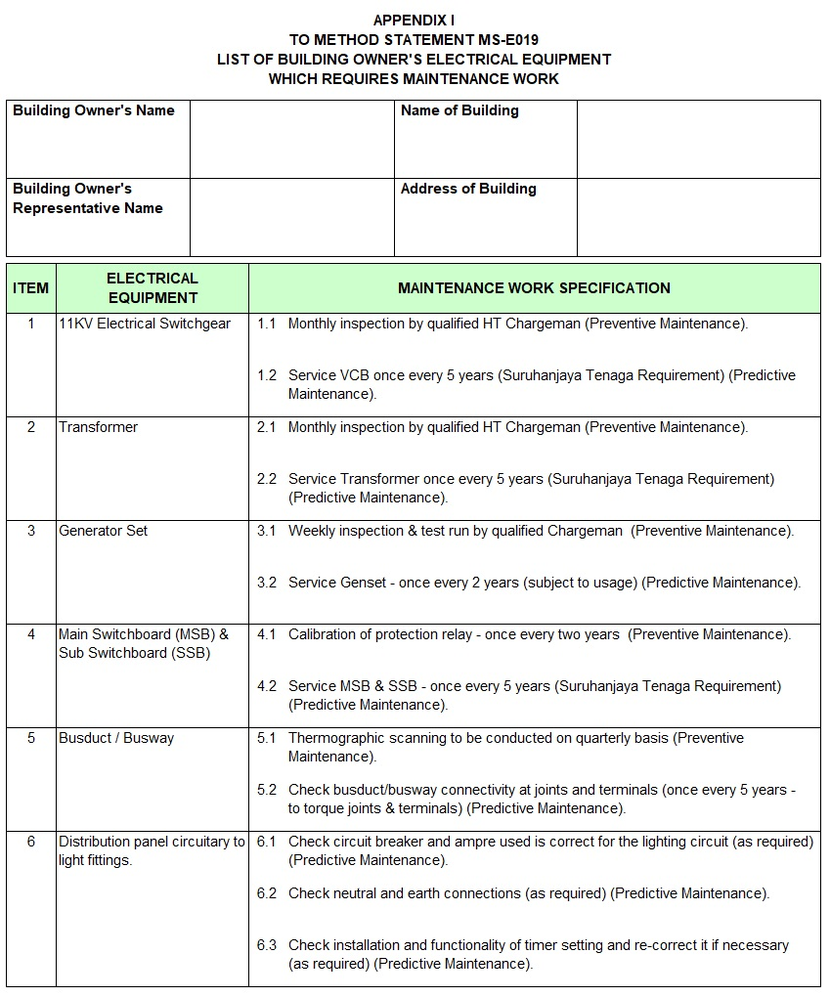

End

