WORK METHOD STATEMENTS, RISK ASSESSMENT &

SAFE WORK METHOD STATEMENT

Project: SAMPLE
Nature of Work: Electrical and Instrument System
Activity: Building Management System Installation Works
Date of Submission: 16 November 2017

 |  |  | AUTHORISATIONSTATUS
Activity | Company |  | Name | Designation | Signature/Date
Prepared by | HEXATECH |  |  | - Senior Project Manager  - Project Manager  - Asst. Site Manager  - M&E Engineer  - Safety Supervisor | - _____________  - _____________  - _____________  - _____________  - _____________  - _____________
Sub- Contractor |  |  |  | - PM  - CM  - Engineer  - QA/QC  - Safety | - _____________  - _____________  - _____________  - _____________  - _____________  - _____________
Acknowledge  By |  | PMC` | - Peter Scott  - James Chan  - S.Gopalan | - Snr. Proj. Manager  - Snr. Con. Manager  - M&P Dept.  - SHE Manager | - ______________  - ______________  - ______________  - ______________

 | DOCUMENT STATUS
Revision No | Status |  | Note
 |  |  | The initial commencement of the task has been reviewed in the field for compliance to the SWMS.

Items | Yes | No | Status/ Remark
Subcontract Signed
Workers Compensation

TABLE OF CONTENT

S/NO DESCRIPTION

- SCOPE OF WORK & ACTIVITY
- SITE LAYOUT PLAN
- WORKING HOURS
- MACHINERY & EQUIPMENT
- PERSONNEL
- WORK PROCEDURES & METHODOLOGY
- SAFE WORK PROCEDURE (Attachment)
- HEALTH & SAFETY RISK ASSESSMENT/JOB SAFETY ANALYSIS
- RESCUE PLAN/ EMERGENCY PROCEDURES
- ENVIRONMENT

- SCOPE OF WORK & ACTIVITIES

1. | Mobilization of manpower.
2. | Transportation of equipment, tools, machinery & materials.
3. | Storage of materials, tools box & equipment.
4. | Access to work site.
5. | Conduit installation.
6. | Trunking installation.
7. | Cabling work.
8. | Cable insulation and continuity test.
9. | Cable termination work.
10. | Rescue plan/ Emergency situation.
11. | Housekeeping.
12. | Behavioural based safety.

- SITE LAYOUT PLAN – TOTAL WORKING AREA

  - P2 area

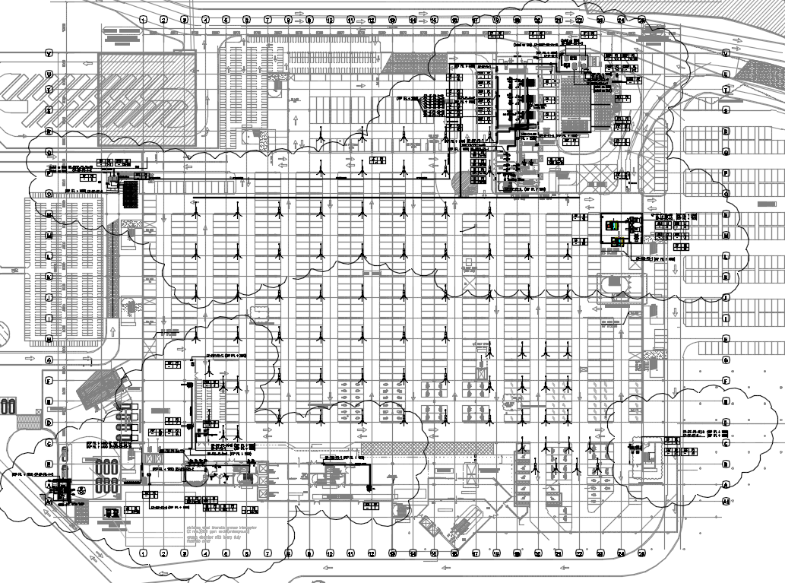

  - P1 area

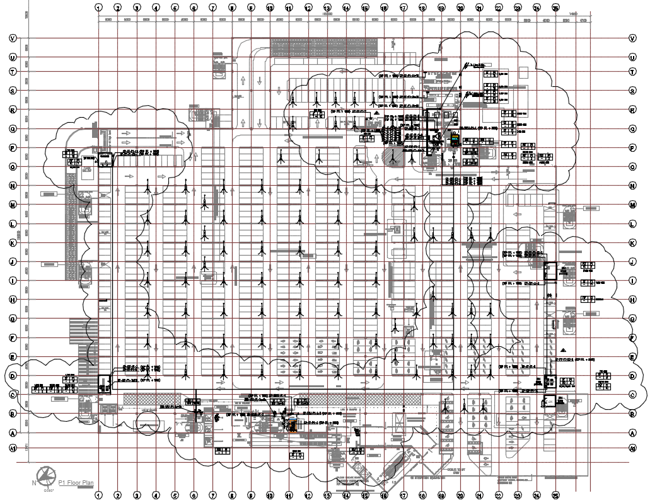

  - L1 area

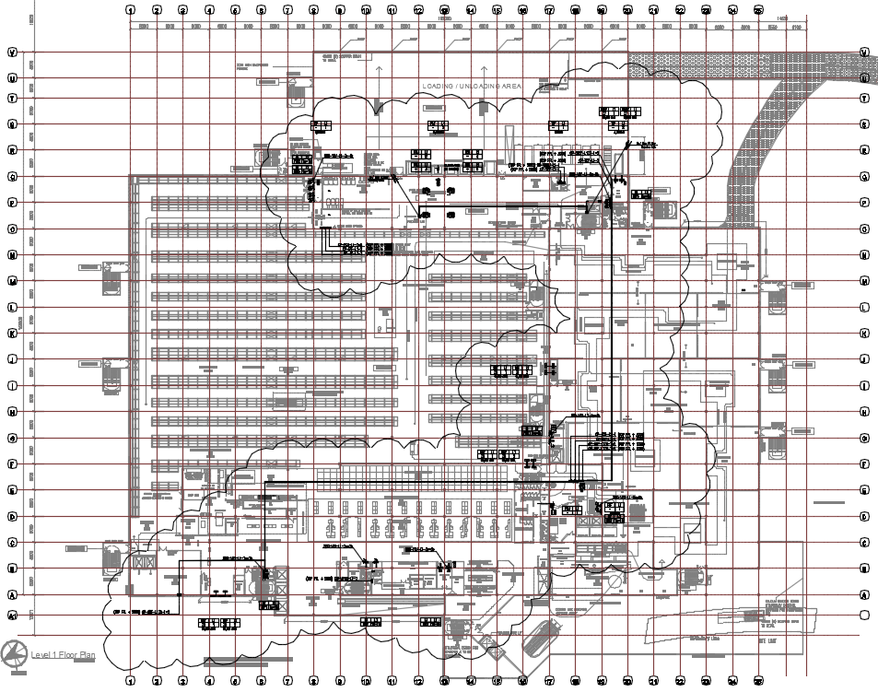

  - L2 area

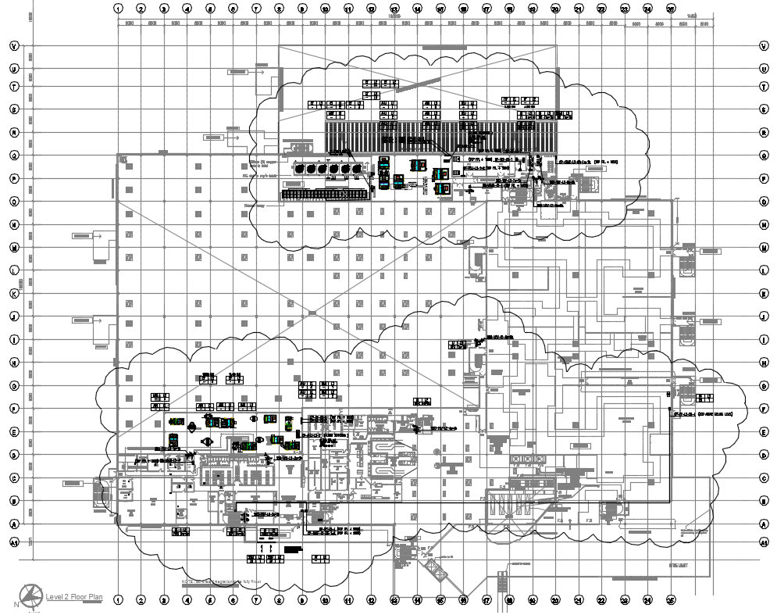

  - RF area

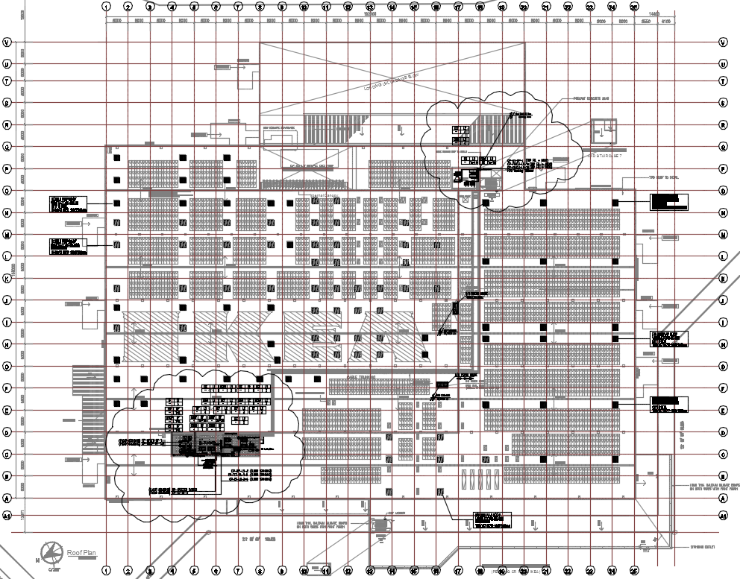

3. WORKING HOURS

0800 hrs. to 2200 hrs. (Monday to Friday). To apply night work permit for work after 1900 hrs.

0800 hrs. to 1800 hrs. (Saturday and Sunday). Working on Sunday must apply for permit to work.

Note: No delivery of materials from 0800 hrs. - 0830 hrs. Delivery of materials will be allowed only after all workers attend toolbox talks, daily pre-task briefing and the work permits been approved to start work. No delivery of materials on Sunday / Public Holiday.

All deliveries must submit Material In/Out Request Form and approved by Main Contractor Logistics Manager/Coordinator.

4. MACHINERY & EQUIPMENT

  - Wall plug
  - Measuring tape
  - Marking equipment
  - Power drill
  - Spanner set
  - Hammer
  - Hole saw
  - Scissor lift / Boom lift / Scaffolding
  - Extension wire
  - Insulation tape
  - Crimping tools
  - Cutting tools
  - Cable cutter
  - Certified testing equipment
  - Screw driver
  - Cable puller

- PERSONNEL (HEXATECH)

PROJECT ORGANIZATION CHART

- WORK PROCEDURES AND METHODOLOGY

S/N | Work Description | Method Plan
A. | Control Panel Installation Work
1 | Mobilization of Manpower.  - In-house safety induction  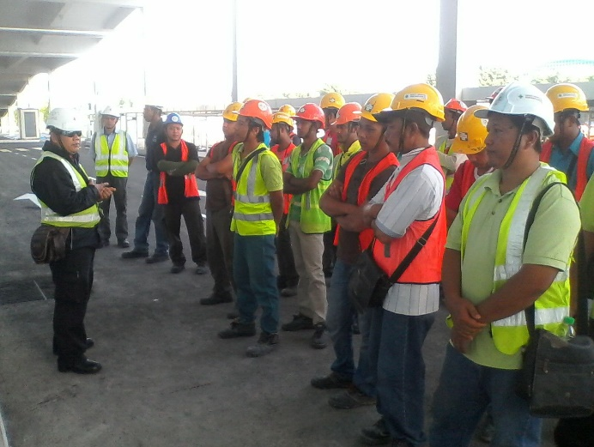  - Briefing before start work | - Check work permits & CIDB Green Card to ensure that all the workers are legal before they are allowed to attend for Main Contractor’s safety induction course.  - All workers must attend the in-house safety induction before they are allowed to enter the site to perform any job.  - All workers been briefed on the fire escape route and site emergency procedures.  - All workers shall be briefed on the approved SWMS / Risk assessment to make sure they understand the details and they must sign the attendance record before start the activities.  - All workers shall be issued with suitable PPE’s that related to their work activities as per approved SWMS.  - Ensure pre-task briefing is been done daily before allowing any worker performing their daily task.
2 | Transportation of equipment, tool, machinery and materials to site.  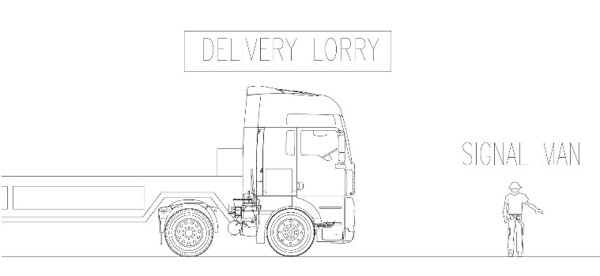  - Signal man and transportation | - Signal man must ensure transportation travel at a speed of not more than 10km/h.  - Signal man must ensure transportation is park a safe distance away from working zone and maintain at eye contact with the driver.  - Signal man must alert all personal who will be passing through the transportation.  - To provide wheel choke for transportation parking at any incline slope.  - Ensure the transportation go through the process of the washing bay before moving off the site.  - Upon materials / equipment delivery to site, check serial no., model no., and damage during transportation, to make sure same as shipping list / delivery order. Check catalogues for specification compliance.
3 | Conduit installation work  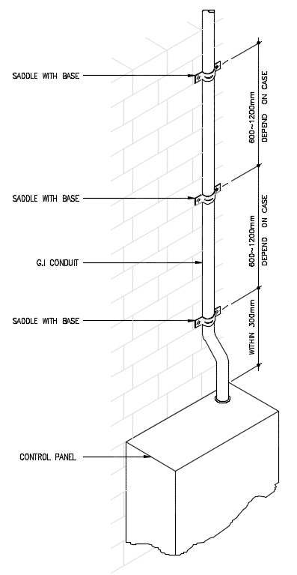  - Conduit connection to control panel  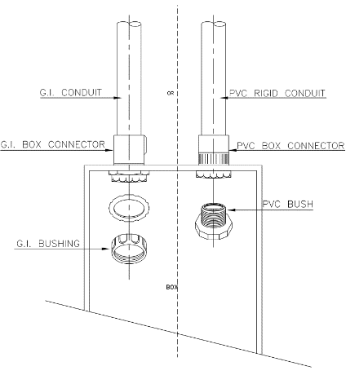  - Fixing threaded conduit at entries of BMS panel  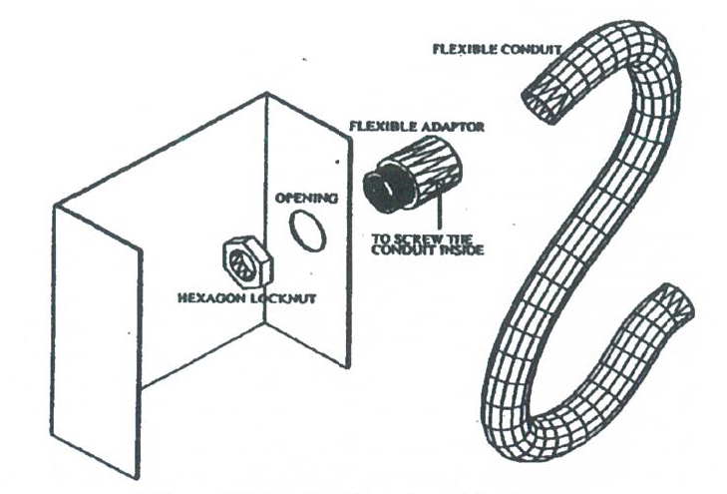  - Flexible conduit tap from trunking  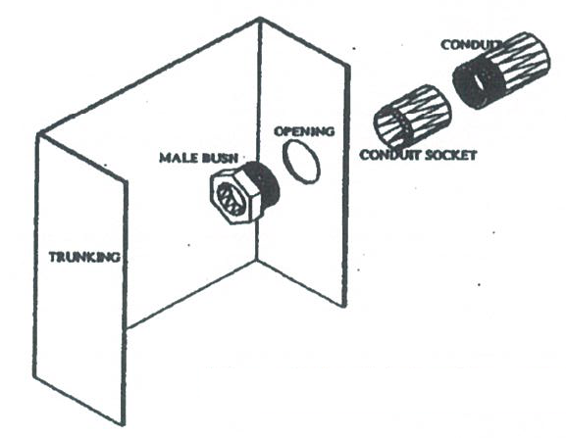  - Conduit tap from trunking  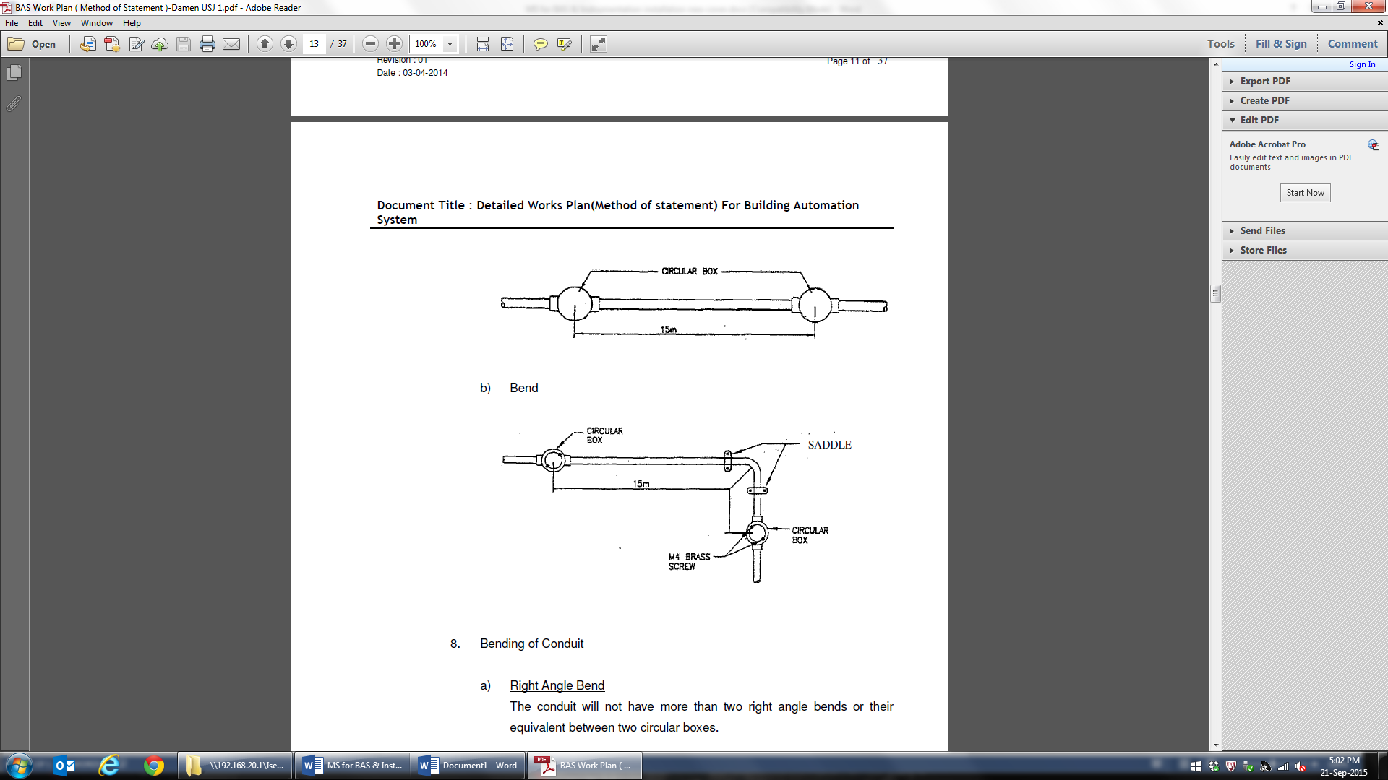  - Spacing Between two inspection box  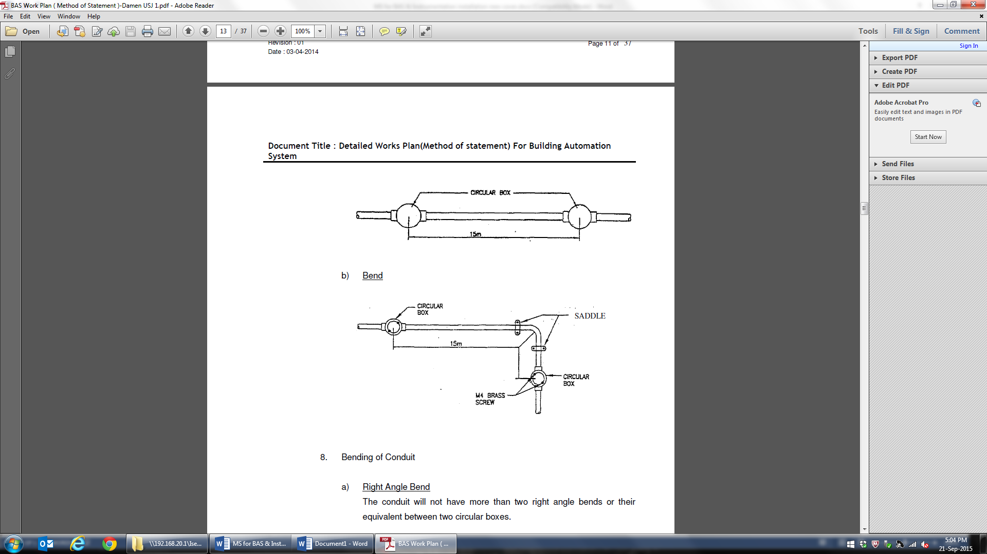  - Bending of conduit  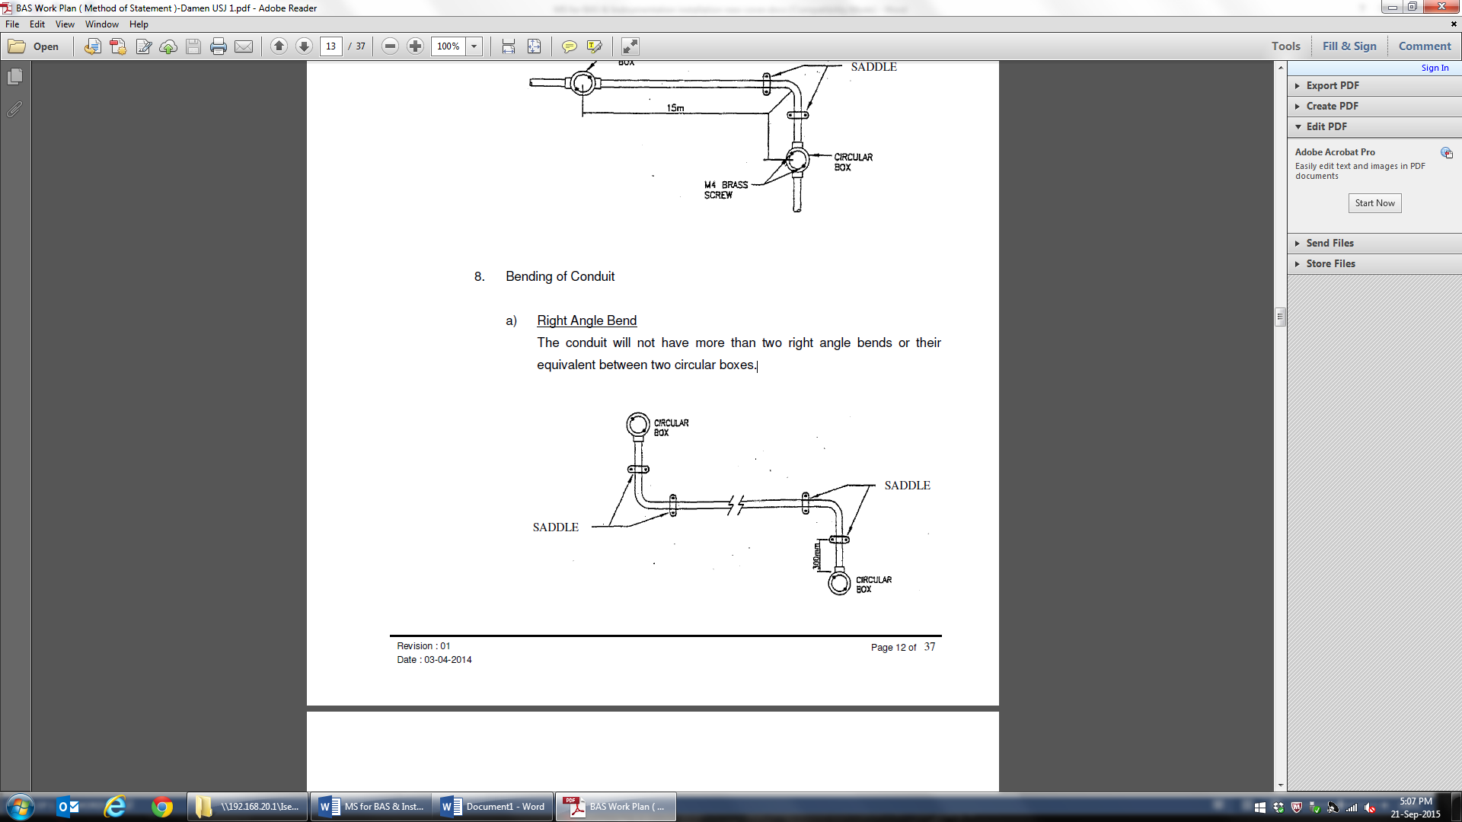  - Angle bend  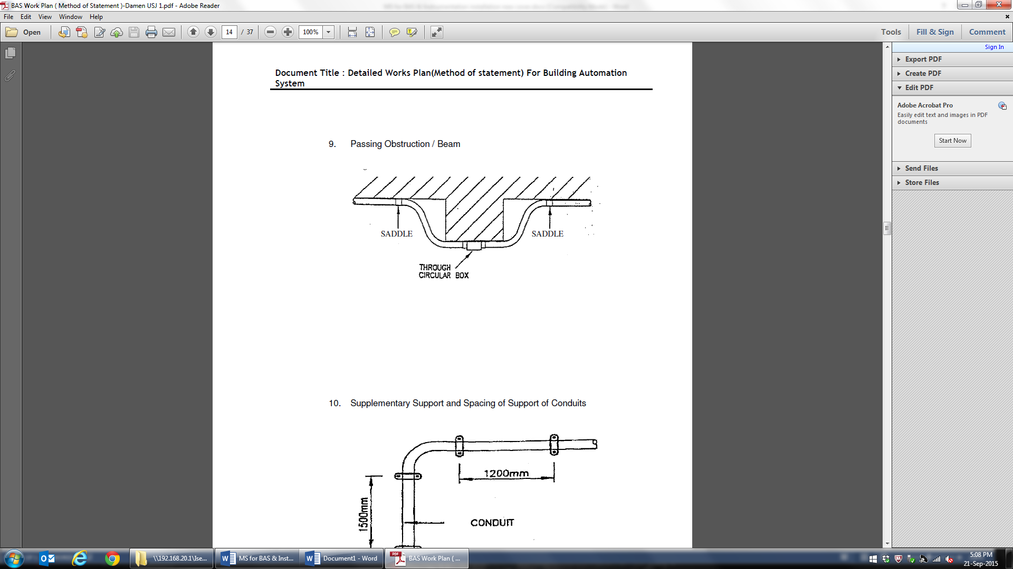  - Passing obstruction / beam  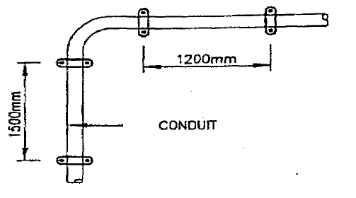  - Supplementary support and spacing of conduit | - The conduit pipe sizes being used are either 20mm or 25mm in diameter to meet the sectional area of wiring laid inside.  - The edge and internal surface of the conduit is to be reasonable smooth to ensure that the cables are not damaged while drawing them.  - All materials are to be installed free from cement, dirt or any debris prior to installation.  - Secure all the necessary reference drawing layout and determine the actual position to commence installation with the mobilisation of required work force, tools and equipment.  - After confirming the layout of the conduit pipes routes, use a line marker to mark out the intended routes.  - Avoid soffit areas where the tendons of the slab are, for pre-cast concrete slabs. This is to prevent damage to the slab when the anchor bolts are inserted.  - Using an electric drill, drill the soffit where the markings are at Max.1500mm interval for the conduit saddles locations.  - Using a hammer, drive in the anchor bolt till it flushes with the soffit. Proceed to install the saddle base with steel screw and turn until tight.  - Install the conduit pipes onto base of the saddle and clip the conduit onto the base with the saddle tops provided. Retaining screws are to be tightened.  - Saw off any excess length with hacksaw and remove burrs with a rounded file. Joints between conduits are to be coupled with approved socket.  - Ensure that the total number of bends along one conduit pipe route from one box to another are limited to maximum 4 nos. and the total angle of the bend do not exceed 270 degrees.  - All bends are executed with proper tube bender as described and the section of the conduit shall not be altered after bending.  - Care will be taken to ensure that the capacities of the conduits are adequate to carry the cable proposed for in the contract and that it complies with the requirement stated in the IEE regulations.  - A minimum of 30% spare space shall be provided in the conduit run when installed the interfacing cable.  - Maximum Allowance Spacing Between Two Inspection Boxes or Circular Boxes Shall Not Be More Than 15m Straight Run.  - Flexible conduits are used to connect the fixed conduit to:-  - Air flow sensor  - Duct humidity sensor  - Duct probe temperature sensor  - Room temperature sensor  - Water temperature sensor  - Water pressure sensor  - Water level sensor  - Motorize valve actuator  - Motorize damper actuator  - Etc.
4 | Trunking Installation Work  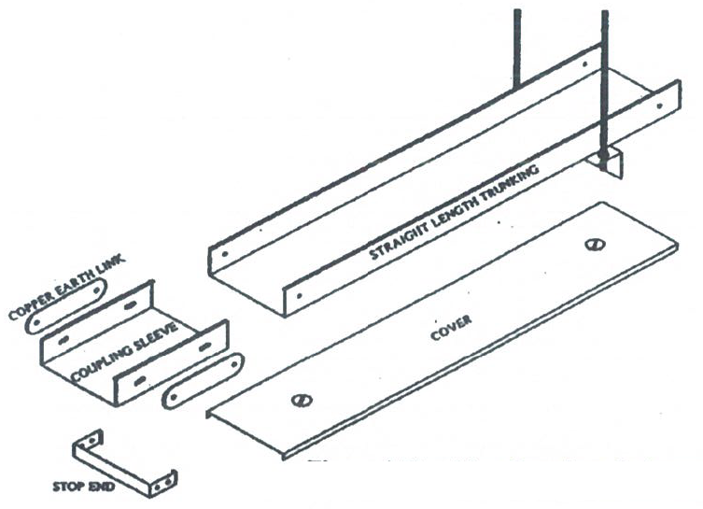  - Trunking and accessories  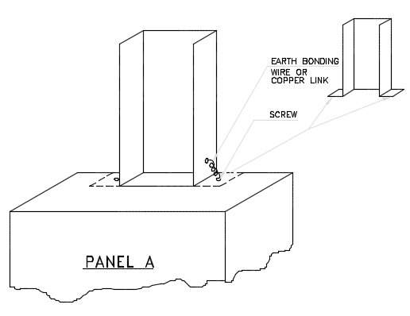  - Trunking connection to control panel  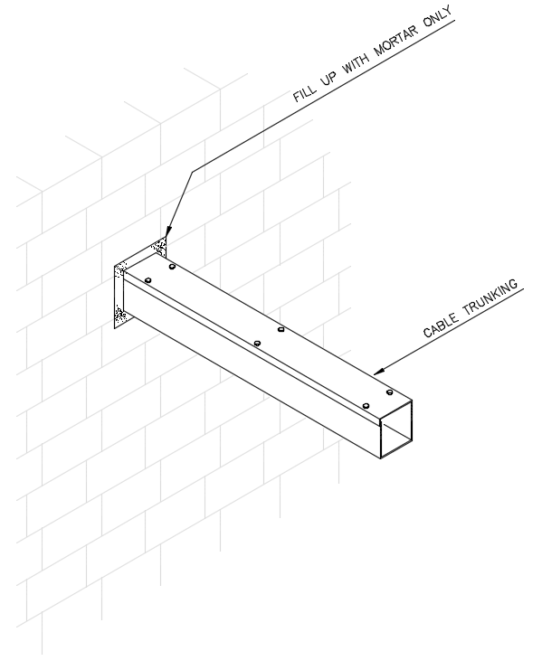  - Trunking penetration through wall | - Tray/Trunking/Conduit installation shall consider the following items:-  - Tray shall be joined together in straight runs, using the supplied fishplates and grounding straps.  - Trunking shall be joined together with factory-supplied joints. At each joint, plates and grounding straps will be provided.  - All holes in trunking for fixing conduits shall be drilled by using the correct size drill bit.
5 | Cable installation work  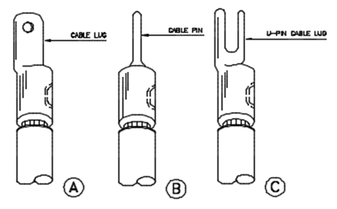  - Type of cable lug | - The minimum conductor size shall be 2.5mm² and 1.5mm² for power and control circuit respectively depending on the voltage drop calculation.  - For stranded copper conductor cables, the banding radius shall not be less than 12 times the overall diameter of the cable and where single core cables are installed, run in trefoil formation.  - Installation of these cables shall be carried out in such a manner to keep tension forces and stresses on cables to a minimum and to prevent stretching.  - All cables or wires shall be installed without damage to insulation and without kinking. Cables or wires with damaged insulation shall be replaced.  - All cables shall be run horizontally or vertically, parallel to building members and fixed in an approved manner. All kinks, sags etc., shall be removed to give maximum neatness to the finished installation.  - Cables shall be installed such that the spacing between circuits do not affect the current rating specified.  - Wiring shall be colour coded throughout by using a standard and approved colour codes. The uniformity of phase colour shall be preserved due to balancing requirements and the installation shall be reviewed or coded in a manner approved by the Engineers as necessary.  - Cables and wires shall be installed by using the loop-in system. Cables shall be terminated only on the terminals of equipment or accessories.  - All cables and wire ends shall be prepared for termination without damaging strands. Approved lugs or clips shall be fitted to prevent strands from spreading when terminals are tightened.  - All cable termination shall be crimped unless specifically stated otherwise. Use special crimping tools as recommended by the cable manufacturers for lug termination clamp type. Soldered or brazed connections are not acceptable. All joints shall be made by using crimped or compression type fittings on all conductors.
6 | Operator Workstation installation work | - Operator Workstations (OWS) will comprise a Network Computer together with Operator terminals. The OWS will be fully integrated to the primary BAS network.  - Provide workstations as indicated in the drawings. Each workstation shall have one or more PC. The I/O devices at each workstation may vary as indicated in the drawing.
7 | Instrument installation work  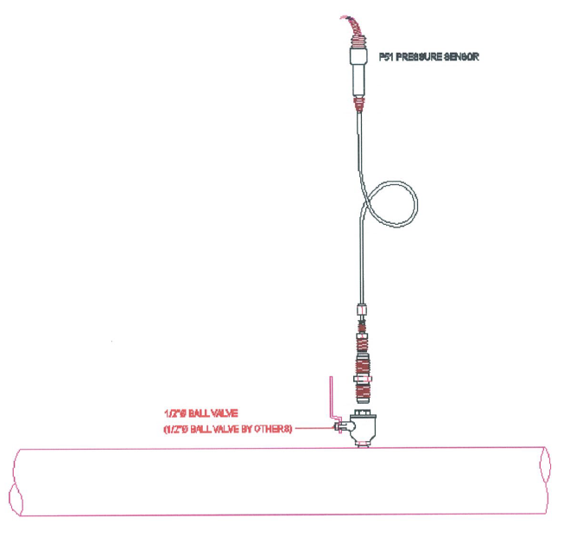  - Water pressure sensor installation method  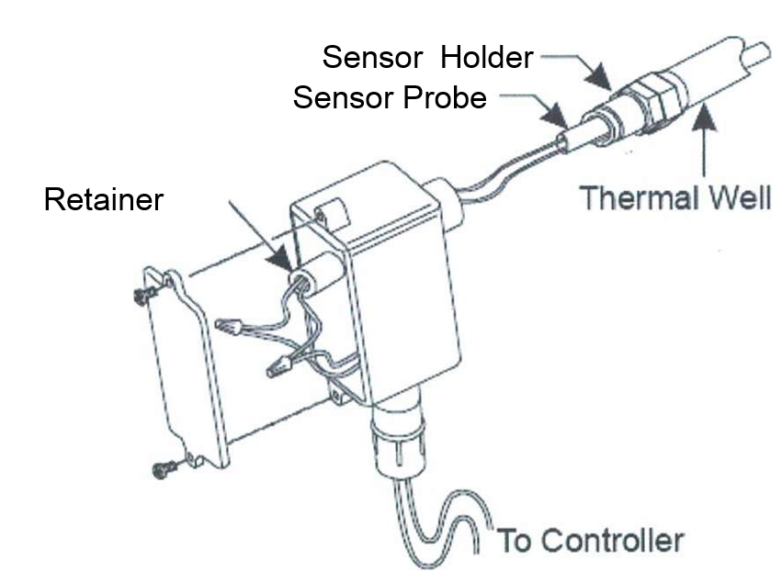  - Water temperature sensor installation method  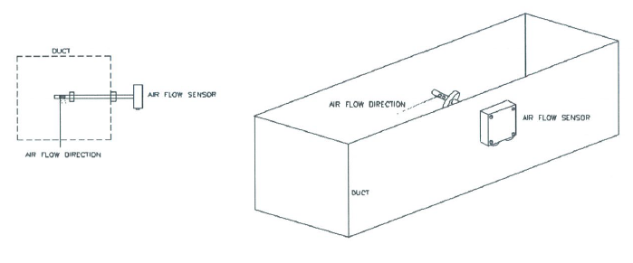  - Air flow sensor installation method  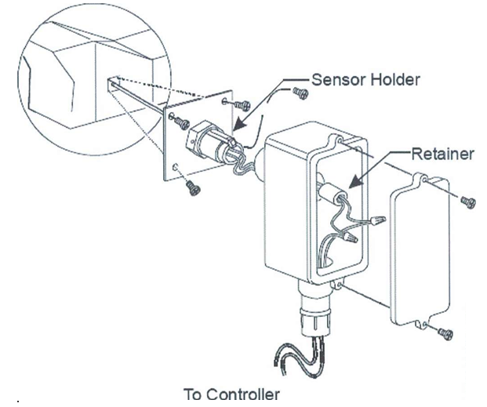  - Duct temperature sensor installation method | - Engineer must study and counter check the proposed location of the sensor. No sensors shall be installed until specific location instructions are given.  - All sensors provided shall meet the following overall end-to end accuracy requirements.  - Installation of Water Temperature Sensor  - Select location where water can circulate freely around the sensor pocket ensuring that the whole of the pocket is immersed in the water to be controlled.  - For chilled water applications, pocket should be mounted horizontally or sloping downwards towards moth to allow condensation to drain away.  - Make sure thermal well install in the pipe.  - Fix the sensor holder in the thermo well. Allow a sufficient length of flexible conduit to permit complete withdrawal of the sensor.  - Insert sensor and tighten clamping screw.  - Remove cover for access to terminals.  - Connect wires (non-polarized).  - Replace cover and tighten fixing screws.  - Installation of Differential Pressure Switch (Filter Dirty Sensor)  - Identify the location and orientation of the AHU filter.  - Mount the sensor directly via the screw holes in the base.  - Fix the poly tube on the AHU between the filter and the cooling coil. Make sure there is clearance from both the filter and the cooling coil are sufficient and acceptable.  - Connect the PVC air tubing from the poly tube to the low pressure port. Leave the high pressure port unconnected if the return air is not ducted to the AHU.  - Connect wires and close the cable entry by rotating the gland nut.  - Installation of Room/Air Temperature Sensor  - Select a location for the sensor which is representative of the space to be controlled and where it will be readily affected by changes in the general space temperature level. The sensor location  should also be reasonably clean and free from damp and condensation.  - Remove the back plate by pushing in the fixing lugs on the top and bottom of the sensor with a small screwdriver or similar tool.  - Thread the wires through the back plate and baffle card and fix it to the wall or conduit box with the arrow pointing upwards. The baffle card is used to ensure that there are no draughts from the cable entries to influence the sensed temperature.  - Connect the wires to the sensor terminals on the sensor.  - Refit the sensor housing to the back plate.  - Installation of Air Duct Temperature. Humidity, Air Flow, Static Pressure & CO² Sensor  - Select a location where the sensor sensitive stem is fully immersed in the controlled air stream. The location must not suffer from direct hot or cold radiation effects.  - Fix the sensor to the duct using the fixing screws provided. Allow a sufficient length of flexible conduit to permit complete withdrawal of the sensor.  - Remove the cover for access to the terminals.  - Connect wires (non-polarized).  - Replace the cover and tighten the fixing screws.  - Installation of CO sensors (for Room & Driveway)  - Select a location where at it is +/- 500mm above average human height. If fixing location is in the driveway, the sensor’s location should be facing or near to the driveway.  - Remove the back plate by pushing in the fixing lugs on the top and bottom of the sensor with a small screwdriver or similar tool.  - Thread the wires through the back plate and baffle card and fix it to the wall or conduit box with the arrow pointing upwards. The baffle card is used to ensure that there are no draughts from the cable entries to influence the sensed temperature.  - Connect the wires to the sensor terminals on the sensor.  - Refit the sensor housing to the back
8 | Inspection and testing | - The testing of cabling/wiring shall be as follows:  - Before beginning the testing of cables, ensure that there is sufficient separation between electrical and communication cables.  - Visually check that all boxes, outlets etc., are closed.  - Check that all terminations are tight (not too tight).  - Check connections as per approved schematic drawings.  - If any electronic or PCB boards are fitted before testing begins, remove the items or disconnect the outgoing circuits.  - Before beginning the insulation resistance test, perform a continuity test from the equipment to the outlets or services items.  - Also perform a ground loop test.  - The testing of panel and instrumentations shall be as follows:  Software  - Ensure that all the PCs can communicate with each other, with other sub-networks and beyond their default gateway by using the following methods:  - Ping its own IP address  - Ping other PC IP address within its own sub-network  - Ping default gateways IP address on its side  - Ping default gateway IP address on the other side of sub-network  - Ping other PC IP address on other sub-network  - Ping loop-back address  - Ping class A and class B as well as class C IP addresses.  - Ensure that the server is online in order for the Operator workstation to access the database in the BAS system. The method for checking is as follows:  - From the workstation operator terminal click on the Enter icon and after typing the Login and the Password (assuming both entries are correct) no error “pop up” occurs.  - Ensure that the NIU for all parcels can communicate with their respective server or workstation.  - Check the equipment windows to determine whether the NIU is online.  - Check if all connections are tight.  - Check that the IP addresses for the entire server, workstation and NIUs are as required by the Engineer.  - Ensure that the Ethernet hub is working in good condition.  - The visual test is done by viewing the LED indication on the hub itself  - Pinging from PC to PC ensures connectivity.  Hardware  - Test all the wiring connections through out all the zones and floor for NCU.  - Prepare all the tools for the testing (Multitester)  - Test, end to end wiring by shorting the front and test the resistance at the end or vice versa.  - Test all the field devices for all related zones and monitoring control points.  - Verify the actual scenarios to the graphics shown in the workstation.  - Test all the DDC for all the system.  - Visual tests by checking all the connections are properly done from field devices.  - Use the HyperTerminal to key in all the addresses, test card database and appropriate data for control and monitoring point to the system graphics.  - All the inspection and testing of the BAS and instrumentation shall be recorded down in the related forms.
9 | Working at height  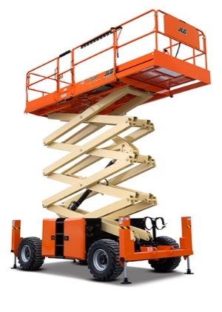  - Scissor lift  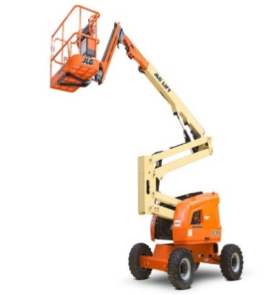  - Boom lift  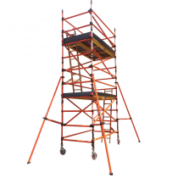  - Scaffolding with SIRIM MS1462 material standard or tubular type | - Before using scissor lift/ boom lift on slab, floor protection must be done by using plastic sheet/ plastic canvas to avoid any contaminant on the concrete slab and to protect the concrete slab floor finishing.  - For high level installation, scissor lift / boom lift / scaffolding are normally used.  - All machinery or scaffolding must be inspect by main con safety department to confirm safe to use before operation begin at site.  - Before start work, only authorised or trained/experience worker are allowed to use the scissor lift/ boom lift/ scaffolding.  - Scissor lift/ boom lift/ scaffolding are make sure fully charge before used for installation work.  - Operator/ worker are compulsory to wear full body safety harness to operate the scissor lift/ boom lift/ scaffolding.  - Work area must be barricade and hazard signage must be put first before start work.
12 | Rescue plan/ Emergency situation.  - If Worker not feeling well on site. (First aid cases)  - Worker falling into excavated hole.  - Working under the hot sun. (Heat Stroke)  - Electrocution/ hit by lightning.  - Worker hit by moving machinery.  - Worker hit by lifting appliance/ falling objects. | Situation 1:  - Worker will be accompany by another worker/ first aider going to the first aid room to give some treatment before sending to hospital.  - Get the nearest stretcher, and bring down the worker to safe area, where the emergency vehicle can access.  Situation 2:  - Ensure trained first aider been contacted and do not move the injured worker for further injuries.  - The first aider must assess the condition of the injured worker.  - Use the nearest stretcher to take the injured worker to the safe area, where the emergency vehicle can access.  Situation 3:  - While waiting for the rescue, ask the worker to move his leg and thigh. If the person is unconscious, take a wood stick and move his leg to allow blood circulation.  - If the worker is near to a higher level, hook him by a rescue hook with a rope and bring him down slowly to the safe ground.  - Ensure the victim is lying down to the ground, before removing his body harness.  - The first aider will assess the victim’s injuries, before putting him on the stretcher/ man cage.  - If the victim is in higher level, instead of using the staircase, use the tower crane to lift down the victim to the ground using the man cage.  - Immediately take victim to the nearest hospital.  Situation 4:  - Move the victim to the shaded area.  - Remove the victim’s shirt, loosen his tight pants. If wearing harness, remove the harness.  - Cool down the victim, by using a wet towel or ice pack.  - Immediately bring down the victim using stretcher or man cage to the safe ground.  - Immediately take the victim to the nearest hospital.  Situation 5:  - Assess the victim situation, if the victim is not breathing, immediately respond by providing CPR by a competent first aider.  - While the first performing CPR, immediately call the hospital to bring an ambulance to the area.  - If the victim is conscious bring him down by a stretcher or a man cage to the safe ground while waiting for the ambulance.  - In case of lightning, lightning alert system will be monitored at all time. Whenever there is a lightning alert level category 1 or 2. Category 1 all work will be stopped and Category 2 all work at height and lifting will be stopped immediately and all the workers will be directed to the safe sheltered area. (Eg. Lower Floor or Workers rest area)  Situation 6:  - Ensure trained first aider been contacted and do not move the injured worker for further injuries.  - The first aider must assess the condition of the injured worker.  - Use the nearest stretcher to take the injured worker to the safe area, where the emergency vehicle can access.  - If the injuries are serious, immediately call for ambulance and bring to the nearest hospital.
13 | Housekeeping. | - Ensure the housekeeping equipment is adequate and dust bin in place at the work area.  - Ongoing housekeeping throughout work and ensure every day before the workers leave the site all worker will be involve in cleaning up the workplace.  - Daily housekeeping after work at the end of the day will be perform by the team to increase the awareness of all the workers on the importance of clean work area.
14 | Behavioural based safety. | - SWMS Briefing.  - Close monitoring & full time supervision.  - Tool box before start work to remind the importance of complying with site safety requirements.  - Pre-task briefing before start work daily.  - Safety award for good practice & worker who comply with good safety performance.  - Training & education program for workers.
15 | Environment | - All chemicals must have their Material Safety Data Sheet.  - Waste materials must be disposed on designated rubbish bin.  - All excess earth must be dump at the designated area of dumping.
15 | Working Environment Condition | - Make sure other contractors are been inform on the work activity for the day.  - Tool Box meeting to be performed before start of work and this information will be shared to other contractors.  - Adequate exclusion zone will be in place to prevent in unauthorized entry to the working area.  - Full time supervision will be in place to ensure proper coordination been done between the contractors at the workplace.

7. SAFE WORK PROCEDURE

S/N | Work Description | Risks | Control Measures
1 | Transportation of equipment and materials to site | Injury to persons not related to work or to pedestrians.  Injury to guards and other workers in the site due to not following site safety roles.  Damage to public property. | - All delivery must be reported to Main Contractor’s authorised personnel (Logistic Manager/Coordinator).  - Traffic controller shall be in place to guide the lorry when entering the work site.  - Check the road condition and access is in good condition and clear of vehicle movements.  - Provide exclusion zone, proper signage and place banks man at all time.  - No material shall be placed at any emergency access..  - Lorry drivers must comply with site safety regulation.
2 | Storage of materials, tools box & equipment | Bodily injury and equipment damage. | - Supervisor to supervise the work  - Work place to be barricade and warning signage  - Carry out housekeeping during and after work
3 | Conduit & Trunking installation  *Working at height | Injury to worker due to improper method.  Injury to workers due to faulty tools.  Finger Injury due to failure to wear hand gloves  Falling object  Fall from height | - Workers to be briefed on their task prior to start work.  - Check and ensure the tools to be use is safe to use.  - Apply PTW prior to start work.  - Ensure workers are equipped with completed PPE  - Carry out housekeeping during and after work.  Ensure full time supervision.
4 | Cabling installation | Injury to worker due to improper method.  Injury to workers due to faulty tools.  Finger Injury due to failure to wear hand gloves | - Workers to be briefed on their task prior to start work.  - Check and ensure the tools to be use is safe to use.  - Apply PTW prior to start work.  - Ensure workers are equipped with completed PPE  - Carry out housekeeping during and after work.  - Ensure full time supervision.
5 | Cable insulation and continuity test | Finger Injury due to failure to wear hand gloves | - Workers to be briefed on their task prior to start work.  - Check and ensure the tools to be use is safe to use.  - Apply PTW prior to start work.  - Ensure workers are equipped with completed PPE  - Carry out housekeeping during and after work.  - Ensure full time supervision
6 | Cable termination work | Injury to worker due to failure to comply with safety procedures.  Worker trip and fall due to poor material arrangements | - Barricade the working area and provide warning signs.  - Workers to be briefed on their task prior to start work.  - Check and ensure the tools to be use is safe to use.  - Provide proper access for the worker.  - Apply PTW prior to start work.  - Always wear and use proper PPE at work.  - Full time supervision by supervisor in charge.  - Carry out good housekeeping during and after work.
7 | Housekeeping | Worker injury due to blocking of access  Worker fall due to tripping hazard  Hand injury due to pinch point and poor material arrangements  Workers have breathing problem due to exposure to dust  Workers had back aches due to poor material arrangements | Access point clear of waste materials at all times.  No accumulation of waste materials.  Waste materials disposed at designated dustbin or skip bin  For disposal of waste materials which are heavy, either provides more manpower or mechanical means.  To maintain barricades & warning signs on a daily basis.  To wear appropriate PPE whenever necessary (ie: N95 dust mask in dusty environment or hand gloves during manual handling).  Daily housekeeping shall be performed daily before finish work.
8 | Behavioural based safety | Major injury to worker due to fail to follow safety procedures and safe working methods | Supervisor to brief all the workers on the safe working procedures in a language that the workers understand.  Briefing on Safe Work procedures.  Toolbox Talk before work commences.
9 | Health & Environment | Illness to workers due to bite of mosquito  Illness to workers due to poor housekeeping at the rest area/ site office  Noise immune deafness | Remove any water bearing receptacles and drain away any stagnant water around work area.  Site office to be kept at least 300mm above ground with roofs covering flat tops.  Provisions of rubbish bins.  Workers must wear ear plug.
9 | Working Environment Condition | Injuries to workers due to insufficient knowledge on the work condition or un authorized entry. | Make sure other contractors are been inform on the work activity for the day.  Tool Box meeting to be performed before start of work and this information will be shared to other contractors.  Adequate exclusion zone will be in place to prevent in unauthorized entry to the working area.  Full time supervision will be in place to ensure proper coordination been done between the contractors at the workplace.

PROJECT PARTICULARS |  |  |  |  |  |  | RA / JSA No: | SM/KM/IPG/RA/BMS/401
Project Name: | IKEA Batu Kawan |  | Name of Contractor: |  | SHINRYO ( MALAYSIA )
Project No: | TBA |  | Trade: |  | Electrical Works
Task / Activity: | Building Management System Installation Works |  | Prepared by:  Name & Signature |  | Nasharemei |  | Designation: | Elect. Eng
 |  |  |  |  |  |  | Date:
Location of Work: | Refer to site layout plan |  | Reviewed by:  Name & Signature |  | Muhammad Rezim |  | Designation: | Construction Manager
 |  |  |  |  |  |  | Date:
Work Commencement: | TBA |  | Works Supervised by:  Name & Signature |  | Rosli |  | Contact: | 012-3352847
Work Completion: | TBA |  |  |  |  |  | Date:
Equipment/Tools Used: | Wall plug, Measuring tape, Marking equipment, Power drill ,Spanner set, Hammer, Hole saw, Scissor lift / Boom lift / Scaffolding, Extension wire, Insulation tape, Crimping tools, Cutting tools, Cable cutter, Certified testing equipment, Screw driver, Cable puller |  | Safety Coordinator:  Name & Signature |  | Muhammad Fakhri |  | Contact: | 018-9692813
 |  |  |  |  |  |  | Date:
Equipment/Tools Used: |  |  | Safety Supervisor:  Name & Signature |  | Muhammad Fakhri |  | Contact: | 018-9692813
 |  |  |  |  |  |  | Date:
 |  |  | Date of Last Review: |  |  |  | Date of Next Review:
Reference: |  |  | Approved Code/s Of Practice (COP) Applicable to the Works/ Applicable Relevant Safety Legislation:
Tender Document – Volume 2B Of 4 attachments)  IKANO Health & Safety Management System; IWAY Standard ;IWAY Commitment; IKEA Guideline Procedures for Health Safety on Construction Work;IKEA Mandatory Fire Safety Measures During IICG Construction Projects; IKEA Southeast Asia – Good Neighbour Guideline; Site Requirements, Security / Protection;Environmental Policy and Regulations; Kajiam Site Specific HSE Plan. |  |  | OSHA & FMA Requirements , Excavation Guidelines
Severity (Consequence)  Likelihood |  | 1 - Catastrophic:  Fatality or fatalities, serious injury, permanent disability, major structural or equipment damage, detrimental environmental impact. |  | 2 - Critical:  Serious injury, permanent disability, major disruption and damage to equipment or structure, significant environmental impact. |  | 3 - Marginal:  Temporary disability, lost time injury, outpatient treatment, minor or short-term environmental impact. |  |  | 4 - Negligible:  First-aid treatment injury, minor cuts or bruises, clean-up effort for environmental impact.
1 – Frequent: likely to happen repeatedly. |  | A |  | A |  | A |  |  | B
2 – Probable: likely to happen several times regularly. |  | A |  | A |  | B |  |  | C
3 – Occasional: likely to happen some times. |  | A |  | B |  | C |  |  | C
4 – Remote: not likely to happen most of the time. |  | B |  | C |  | C |  |  | D
5 – Improbable: very unlikely to happen – may assume exposure will not happen. |  | C |  | C |  | D |  |  | D
A - Operation Not Permissible B - High Priority Remedial Action to be Taken Immediately C - Remedial Action to be Taken at Appropriate Time to Lower Risk D - Risk Acceptable; Discretionary Remedial Action to be Taken

INVENTORY OF WORK ACTIVITIES
S/No. | Process / Location | Work Activities / Job Steps | Remarks / Comments
1 | Building Management System Installation | Mobilization of manpower.
 |  | Transportation of equipment, tools, machinery & materials.
 |  | Storage of materials, tools box & equipment.
 |  | Access to work site.
 |  | Conduit installation.
 |  | Trunking installation.
 |  | Cabling work.
 |  | Cable insulation and continuity test.
 |  | Cable termination work.
 |  | Rescue plan/ Emergency situation.

- HAZARD IDENTIFICATION |  |  |  | - RISK EVALUATION |  |  |  | - RISK CONTROL
S/N | Work Activities / Job Steps | Potential Hazards | Possible Accidents / Ill Health & Persons at Risk | Existing Risk |  |  |  | Residual Risk |  |  |  | Action Officer / Designation / Follow-up Date
 |  |  |  | Existing Risk Control / Preventive Measures | Severity | Likeli-hood | Risk Level | Additional Risk Control / Preventive Measures | Severity | Likeli-hood | Risk Level | Action Officer / Designation / Follow-up Date
1 | Transportation of equipment, tools, machinery and materials to site | Personnel hit by moving vehicle(Hit by machinery hazard) | Injury to persons working n site due to hit by lorries delivering materials  Lorry over turn due to no banks-man guiding the lorry & uneven or soft ground | Traffic controller / banks man to guide vehicle to site.  Driver to adhere to speed limits & traffic controller / banks man’s instruction at all times  Provide exclusion zone via means of barricade & warning signs  Material In/Out must be submitted to security guard prior to delivery | 3 | 4 | C | To conduct On Job Training for the banks men.  All banks men will be provided with red flags | 3 | 5 | D | Site Engineer  Name: Rosli  Site Supervisor  Name: Nasharemei  Safety Supervisor  Name: Fakhri
2 | Storage of materials, tools box & equipment | Falling construction material | Bodily injury/Material damage  Equipment/material  damage | Storage area to be barricade and put signages | 3 | 4 | C | Alocate temporary storage area | 3 | 5 | D | Site Engineer  Name: Rosli  Site Supervisor  Name: Nasharemei  Safety Supervisor  Name: Fakhri
2 | Storage of materials, tools box & equipment | Sharp edges | Bodily injury | Material stacking shall be barricaded , warning sign | 3 | 4 | C | Material stack away from walking path/open edge | 3 | 5 | D
3 | Conduit, Trunking & Cabling Installation  *Working at height  - Using scissor lift and scaffolding | Collapse | Bodily injury and equipment damage | Supervisor to supervise the work  Work place to be barricade and warning sign display | 3 | 4 | C | To coordinate with other activities at the area | 3 | 5 | D | Site Engineer  Name: Rosli  Site Supervisor  Name: Nasharemei  Safety Supervisor  Name: Fakhri
3 |  | Falling object & Falling from height | Bodily injury for person scaffold | Working platforms kept clear of loose material  Toe board install at working platform.  Wear safety harness | 3 | 4 | C | Check machinery / material before use  Guard rail and handrail install | 3 | 5 | D | Site Engineer  Name: Rosli  Site Supervisor  Name: Nasharemei  Safety Supervisor  Name: Fakhri
3 |  | Slip & trip | Bodily injury | Use complete PPE include safety harness | 3 | 4 | C | Do not used during /after bad weather | 3 | 5 | D | Site Engineer  Name: Rosli  Site Supervisor  Name: Nasharemei  Safety Supervisor  Name: Fakhri
4 | Cable isulation and termination | Faulty tools | Injury to workers due to faulty tools. | Barricade the work area and display warning sign.  Apply PTW and conduct Tool Box Meeting prior to start work.  Check all the tools prior to use..  Ensure monthly LEW check for all electrical tools.  Ensure workers are equipped with proper PPE.  Ensure full time supervision. | 4 | 4 | D | To conduct On Job Training for the worker. | 4 | 5 | D | Site Engineer  Name: Rosli  Site Supervisor  Name: Nasharemei  Safety Supervisor  Name: Fakhri
 |  | Noise & Dust  (Health hazard) | NID due to excessive noise  Respiratory disease due to dust inhalation. | Ensure the workers are briefed on SWMS prior to commence work.  Ensure workers are equipped with proper eye protection, hearing protection & respiratory protection.  Use water hose with coring machine to minimize the dust and spark.  Carry out housekeeping during and after work.  Ensure full time supervision.  Ensure full time supervision. | 4 | 4 | D | To conduct On Job Training for the worker.  Send the workers who are expose themselves to excessive noise for NID test. | 4 | 5 | D | Site Engineer  Name: Rosli  Site Supervisor  Name: Nasharemei  Safety Supervisor  Name: Fakhri
5 | Rescue Plan / Emergency Situation | Minor injuries due to short cut  Serious injury due to failure to follow safe access | Worker injury due to worker failure to understand the site emergency procedures | Manage at work site by first aid treatment if the case is minor  Report immediately to MAIN CONTRACTOR site representative if complex or serious  All personnel shall understand the site emergency procedures  Stand-by vehicle will be in place to take the injured worker to the hospital | 4 | 4 | D | Only trained First Aiders to attend to injured.  Briefing on the safe emergency procedure will be given to all workers  Explain the stretcher location to all workers and show how to use it | 4 | 5 | D | Site Engineer  Name: Rosli  Site Supervisor  Name: Nasharemei  Safety Supervisor  Name: Fakhri
6 | Housekeeping | Injury to personnel due to poor material arrangement | Trips and falls (from left over materials)  Hand & Eye injuries when picking up rubbish & metal chips | Safe Work Practices  Use hand gloves | 3 | 4 | C | Supervisor to check area of work before workers leave for the day  Workers to use proper gloves when picking up rubbish | 3 | 5 | D | Site Engineer  Name: Rosli  Site Supervisor  Name: Nasharemei  Safety Supervisor  Name: Fakhri
7 | Behavioural Based Safety | Major injury to worker due to fail to follow safety procedures and safe working methods | Unsafe Act due to failure in complying site safety procedures | Briefing on Safe Work Procedures  Toolbox Talk before work commences  Full time supervision. | 4 | 4 | D | Give award for good practice  Remove attitude problem workers from the site  Communicate efficiently to works with the language that they understand | 4 | 5 | D | Site Engineer  Name: Rosli  Site Supervisor  Name: Nasharemei  Safety Supervisor  Name: Fakhri
8 | Health &Environment | Illness to workers due to bite of mosquito  Prolong deafness to workers and nearby residents  Illness to workers due to poor housekeeping | Water ponding causes mosquito breeding  Noise during excavation and compaction  Poor housekeeping at workers area/ site office | Workers deployed to remove any water bearing receptacles and drain away any stagnant water around area  Workers to use ear plug  Site office to be kept at least 300mm above ground with roof covering flat tops.  Provide rubbish bin | 3 | 4 | C | Provision audio of oil by main-contractor for oiling purpose especially during inclement weather  Workers all briefed and educate no littering around site  Provide monitoring system such as noise meter, vibration meter  Minimize to reach alert level | 3 | 5 | D | Site Engineer  Name: Rosli  Site Supervisor  Name: Nasharemei  Safety Supervisor  Name: Fakhri

Engineering Details / Certificates / Work Cover Approvals:

THIS RA / JSA HAS BEEN DEVELOPED THROUGH CONSULTATION WITH THE CREW MEMBERS AND HAS BEEN INSTRUCTED THROUGH INDUCTION, READ AND SIGNED BY ALL EMPLOYEES UNDERTAKING THE WORKS
Induction Conducted by: |  |  |  |  | Signature: |  |  |  |  | Date:
Name/s & Signature: |  |  | Date: |  | Name/s & Signature: |  |  | Date: |  | Name/s & Signature: |  |  | Date:
RA / JSA REVIEW
Review No. | 01 |  |  | 02 |  | 03 |  |  | 04 |  |  | 05
Name:
Signature:
Date:
Review No. | 06 |  |  | 07 |  | 08 |  |  | 09 |  |  | 10
Name:
Signature:
Date:

HAZARD CATEGORIES & ENVIRONMENTAL IMPACT
GRAVITATIONAL | TEMPERATURE | POLLUTION TO LAND
Fall on same level | Contact hot objects, fire, flame etc | Chemical
Fall > 1.8m (Greater than) | Contact cold objects, liquefied gas, dry ice etc | Liquid Waste
Fall < 1.8m (Less than) | Sunstroke, heat exhaustion | Solid Waste (Construction, trade, general waste)
Fall Excavation > 1.0m (Greater than) | Frostbite, hypothermia | Contaminated Waste
Fall Excavation < 1.0m (Less than) | NOISE/VIBRATION | CONSERVATION
Falling objects | Exposure to single sudden sound | Identification and Protection of Ecosystems
Subsidence | Long term exposure to sound | Threatened Species
ELECTRICAL | Noise in excess of statute requirement | Significant Species
Contact with live hidden elect. Wires | Exposure to mechanical vibration | Noise Impacts on Conservation Areas
Contact with visible elect. Wires | COMPRESSED FLUIDS | Visual Impact
Contact with live electrical boards | Fluid under pressure | Heritage
Tool or equipment faults | MICROBIOLOGICAL | Archaeology
MANUAL HANDLING | Contact with fungi, bacteria, parasites, viruses | WASTE MINIMISATION
Back injury | WORK RELATED STRESS | Demolition Waste Reuse
Repetitive Strain | Witness violent events, anxiety at work | Construction Waste Minimisation and Reuse
Other strains/sprains | ELECTRO MAGNETIC RADIATION | Packaging Waste Minimisation
Re-occurring | Sunburn, welding, flash etc | General Litter and Waste Recycling
Posture/physical workload | X-ray, laser, microwave, etc. | Contaminated Waste Handling and Disposal
KINETIC (MOVEMENT) | POLLUTION TO AIR | USE OF RAW MATERIALS AND RESOURCES
Hitting/hit stationary object | Dust/Mist/Vapour/Burning | Energy Resources
Hitting/hit moving object | Plant /Equipment/Vehicle Emissions | Construction Materials
Stepping/kneeling/sitting on objects | Ozone Depleting Substances (refrigerants) | Life Cycle Impacts of Construction Materials
Hit/bitten by animal / insect | Greenhouse Gas Emissions | COMMUNITY RELATIONS
Hit/bitten by person | POLLUTION TO WATER | Adjoining Neighbours
Hit by moving machinery | Sewage Collection and Domestic Waste water (Construction) | Media/Public relations
VEHICLES/MOBILE EQUIP/MACHINERY/TOOLS | Water Body Contamination | Access and Traffic Disruptions
Hit by one of the above | Discharge from Sedimentation Basins | Night Light Spill
Rollover | Spillage from Storage Areas | Visual Impact
Structural failure | Soil Erosion and Sedimentation | Construction Generated Noise
Mechanical failure | Acid Sulphate Soils | Construction Generated Dust
Component failure | Contaminated Land | EMERGENCY
CHEMICAL/SUBSTANCE | Stormwater Discharge and Flooding | Emergency Action Procedures
Single contact | Storm Water Contamination | Environmental Incident
Long term contact | Sewer Contamination | Spill Prevention Control
Insect, spider, snake etc | Ground Water Contamination | Evacuation and Accident Procedures
HAZARDOUS MATERIALS | FIRE/EXPLOSION | Fire-fighting Procedures
Encapsulation and Remediation Design | Ignition of Materials | Bomb Threat Procedures
Runoff Control from Contaminated Land | Combustion of Fuel/Gas/Vapour | Protest Rally
Chemical Storage |  | Media Control in Crisis
Fuel Installations
Chemical Treatments

To Be Completed By Designated MAIN CONTRACTOR’S Representative
Subcontractor: |  |  |  | Contract Package:
SWMS Title/Revision No: |  |  |  | MAIN CONTRACTOR’S SWMS Register No:
Item | SWMS CRITERIA |  |  |  |  |  | Complies (tick)
 | Sets out step by step how the work activity will be carried out
 | Identifies the impacts and hazards associated with each step of the work activity
 | Assesses the risks associated with each step of the work activity
 | Defines the controls to manage risks associated with each step (based on the hierarchy of controls - in order: Eliminate; Substitute; Isolate; Engineer; Administrate; Personal Protective Equipment {PPE})
 | Provides a description of the plant/equipment to be used (including maintenance & inspection checks done, certification of by qualified person and/or registration)
 | Describes the qualifications and training of personnel carrying out the work, including supervisors’ experience/competency, licenses, operator’s certification
 | Notes and confirms compliance to relevant EHS Legislation, Standards, Codes, Regulations, Client Standards/Requirements and Main Contractor Site Specific Health, Safety & Environmental Plan Requirements
 | The SWMS addresses relevant issues identified in the Main Contractor’s Project Impacts and Hazards Risk Assessment. New hazards identified in SWMS are updated into the Main Contractor’s Project impacts and Hazards Risk Assessment.
 | Includes design requirements, engineered details or certification for both temporary and permanent structures, platforms or access ways/ladders?
 | Where PPE is nominated, the type of PPE is specifically listed and when it is required.
 | Defines who is responsible to ensure that the work activity is monitored and carried out in accordance with the SWMS
 | Defines the process and frequency of reviews and methods for ensuring the work complies with the SWMS controls
 | Defines method of consultation/communication used to develop & review SWMS
 | Identifies where any Subcontractors will be used, who is responsible to monitor and supervise works, and how hazards arising from interaction between trades will be communicated and managed (e.g. induction into more than 1 SWMS)
 | Complex or high risk work activities use photos/diagrams/sketches/summary to enhance SWMS (strongly recommended as best practice) where possible
 | Includes the name and signature of the person who developed the SWMS, a current date and revision number.
17. | The SWMS includes specific EHS controls for key high risk hazards as listed below  (Tick all boxes relevant to tasks outlined in SWMS and ensure that they are addressed in SWMS)
Work at height, work near/with penetrations? |  |  | Objects falling/work at height? |  |  | Electrical work?
Use of plant & equipment? |  |  | Work in a confined space? |  |  | Overhead electrical services?
Manual handling? |  |  | Specialized work tasks? e.g. scuba, tunnels, railway |  |  | Demolition?
Haz materials removal and disposal e.g. asbestos? |  |  | Use of Haz Substances or Dangerous Goods? |  |  | Traffic and pedestrian segregation - Work site and public areas? e.g. traffic control
Hot work? |  |  | Excavation? |  |  | Underground services?

I have reviewed this SWMS, and to best of my knowledge it  meets Main Contractor’s acceptance criteria  Print Name:  Package Manager/Site Engineer signature:  Date: |  |  | I have reviewed this SWMS, and to the best of my knowledge,  it meets all Main Contractor’s acceptance criteria  Print Name:  Safety Officer/Supervisor :  Date:
ONGOING SWMS VERIFICATION CHECKS
Main Contractor will monitor the activities of the subcontractor to the extent necessary to determine whether or not the subcontractor is complying with their SWMS. The frequency of monitoring will largely depend on the risks associated with the task and the experience of the operators involved. Subcontractors are required to submit a weekly checklist to Main Contractor indicating the status of compliance with their SWMS. This is required in addition to the checks by designated Main Contractor Project team member as listed below.
Date of Compliance Check | Checked By  (Print Main Contractor’s staff Name) | Signature |  | Verification Actions (list outcomes)  1. Complies  2. Observation (minor changes/new revision)  3. Non-conformance (issue Systems Defect, SOR etc)

