METHOD OF STATEMENT FOR STRUCTURED AND FIBER OPTIC CABLING

TABLE OF CONTENTS
1. GENERAL
2. STRUCTURE CABLING SYSTEM (SCS)
3. FIBER OPTIC CABLE JOINTING AND COMMISSIONING OF THE SYSTEM

- GENERAL

The Site Supervisor will study the new cable route (external and internal building) for structured cabling/fiber optic cabling as per construction drawings .

Upon determining the cable route, the Site Supervisor will also carry out underground duct and manhole route (external building) and trunking/conduit route at site (internal building) to identify the proposed external and internal building cable route with approval from relevant Authorities.

The Site Supervisor will then work-out the quantities of fiber optic cables, ducts, manholes, PVC and G.I. pipes and other required accessories. Necessary requisition order will placed to the Purchasing Department for the said structured cabling materials; with dates of delivery and location.

Delivery will be made to site 2 days prior to usage.

MEASUREMENTS/LOCATION/ SITE SURVEY

The Site Supervisor will be designated to do the duty to take correct measurement as site as soon as the approval of locations and positions of proposed fiber optic cable route covering the external and internal building markings been obtained from relevant Authorities.

Excavation works will then be carry out as indicated in the "Form Work Draw Line" and extra care will be taken to avoid disruptions to existing utilities. The depth and width of the excavation works will comply as per Construction Drawings specifications.

The workers will then lay, install and position the correct size and quantities of duct/manhole/ trunking/conduit at the position been marked and pointed out by the Site Supervisor who had prior to this, studied and counter-check the drawings approved by respective Authorities.

All installation of duct/manhole/trunking/conduit works will be laid under the close supervision of the Site Supervisor and counter verified by the Site Manager who will be at the site at the time this works is being carried out.

- STRUCTURE CABLING SYSTEM (SCS)

Method Statement for Installation of Horizontal Cabling

Preliminary Check of the Unshielded Twisted Pair (UTP) CAT 6 cables by using a multimeter to ensure the continuity of the cables.

Unroll the UTP cable, pull the UTP cable from wiring closet to the Data Floor Distribution Box DFDB where the Multi User Telecommunication Outlet (MUTO). The UTP cable will then be terminated on the RJ45 outlet either under service box or wall faceplate.

The Site Supplier will ensure the horizontal cabling conform to the recommended maximum run distance of 90m (295ft.) from the use interface (floor outlet box) to the distribution area (wiring closet). In no case should the overall length of the cable, from the user terminal device to the distribution are, including connection to network hardware or backbone cable connection, exceed 100m (328ft.) aggregate (the total length of the patch cables, horizontal cable run, and the office line cords.) The maximum patch length should not exceed 6m (20ft.) with a combined total of patch cables and office line cords not exceeding 10m (33ft.).

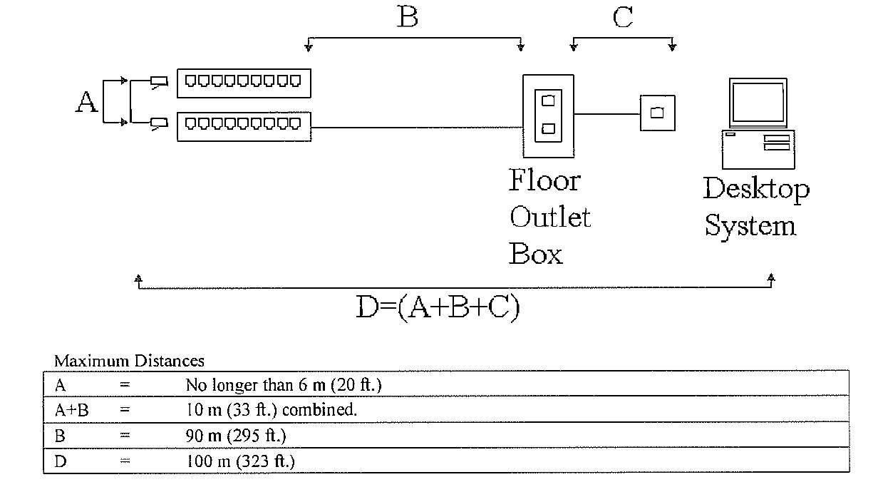

The cables will be installed to enter and exit major run areas at 90 angles while adhering to bend radius specifications. This method will simplifies the maintenance of the installed cable plant by making it easier to access and making Run locations more predictable. In addition, the cables runs will be parallel and perpendicular to corridors with a minimum of corridor crossovers.

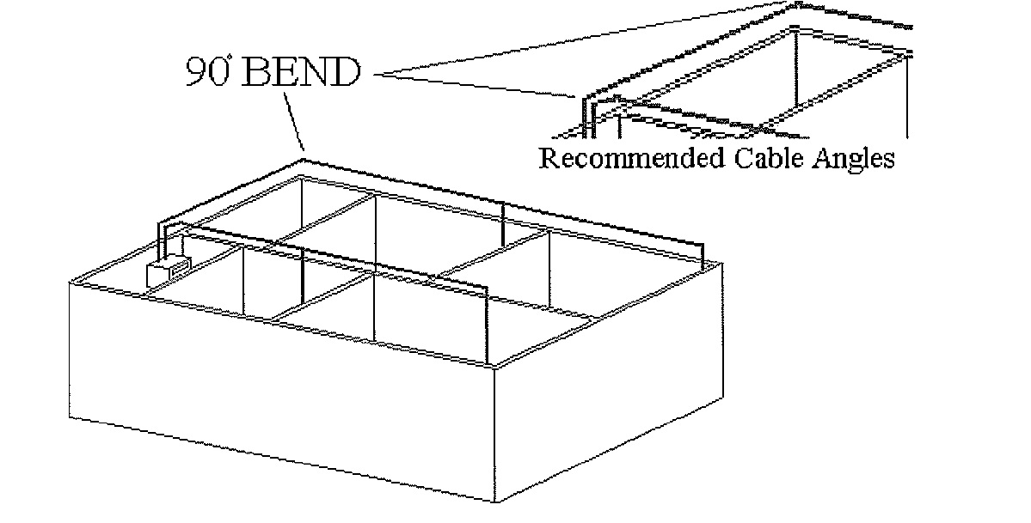
The UTP CAT 6 cables runs will be free of tension at both ends as well as over the length of the run. In open access, cables will run in a single plane and will not be draped over HVAC ducts, beams or pipes.

The UTP CAT 6 cable runs will be installed free of bridges, taps or splices between the distribution frame.

When routing UTP cable, the following minimum distances from power sources will be maintained:

15cm (6in.) from power lines of 2 KVA OR LESS.
30cm (12in.) from high power voltage lighting (including fluorescent).
90cm (36in.) from power lines of 5 KVA or greater.
100cm (40in.) from transformers and motors.

In all CAT 6 cable installation G.I. Conduit and Electrical Metallic Tubing (EMT) will be utilize to house the cables.

The following bend Radii for conduit installation will be complied as follows:

For conduit with an internal diameter of 5.1cm (2in.) or less, the bend radius will be six
(6) times the internal diameter.

For conduit with an internal diameter greater 5.1cm (2in.), the bend radius will be ten
(10) times the internal diameter.

For conduit that will contain fiber optic cable, the minimum bend radius will be ten (10) times the internal diameter of the conduit.

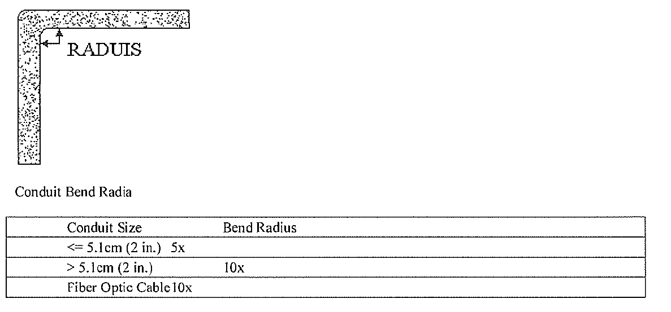
Conduits will be installed with no more than two 90 degrees bends in the overall conduit path. In a run requiring more than two bend, or in excess of 30m (100 ft.), and to install a pull box between the second and third bends as close as possible to the second bend (but not in place of the second bend). As a rule of thumb, n 90 bend is equivalent to the friction of 9m (30 ft.) of straight conduit.

Installation of a third bend into a conduit run without introducing a pull box is acceptable if the run is less than 9m (30 ft.) long or the following criteria:

Increase the conduit at least to the next trade size OR
Locate one bend within 30cm (12 in.) of the cable feed end.

A pull or splice box will be installed, in area that offer easy access and suitable space to facilitate cable pulling. Depending on the size of the size of the location and personal preference, a slip-sleeve, gutter box, or standard pull box will be utilized.

Standard pull boxes will be installed with a minimum length of eight (8) times the diameter of the largest conduit diameter entering the box. The recommended size for pull boxes and the corresponding conduit dian1eter is show below.

Conduit Size Table

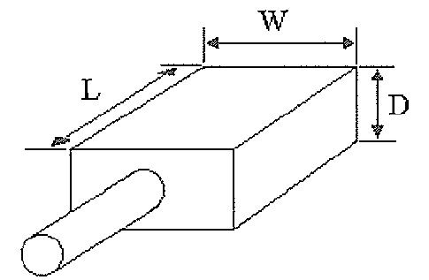

Maximum Trade Size | Size of Box |  |  | For Each Additional Conduit
of conduit in inches | Width | Length | Depth | Increase Width
0.75 in. | 102n11n  (4 in.) | 305mm  (12 in.) | 76mm  (3 in.) | 51mm (2 in.)
1.0 in. | 102mm  (4 in.) | 406mm  (16 in.) | 76mm  (3 in.) | 51mm (2 in.)
1.25 in. | 152mm  (6 in.) | 508mm  (20 in.) | 76mm  (3 in.) | 76mm (3 in.)
l.5 in. | 203mm  (8 in.) | 686mm  (27 in.) | 102mm  (4 in.) | 102mm (4 in.)
2.0 in. | 203mm  (8 in.) | 914mm  (36 in.) | 102mm  (4 in.) | 127mm (5 in.)
2.5 in. | 254mm  (10 in.) | 1067mm (42 in.) | 127mm  (5 in.) | 152mm (6 in.)
3.0 in. | 305mm  (12 in.) | 1219mm (42 in.) | 127mm  (5 in.} | 152mm (6 in.)
3.5 in. | 305mm  (12 in.) | 1372mm (54 in.) | 152mm  (6 in.) | 152mm (6 in.)
4 in. | 381mm  (15 in.) | 1524mm (60 in.) | 203mm  (8 in.) | 203mm (8 in.)

Method Statement for Installation of Vertical Cabling, Fiber Optic Cable

The vertical cabling consist of fiber optic cables only.

The first step when installing fiber optic cable is to conduct a continuity test on the roll of fiber cable. A light source applied to one end of the cable and visual inspection on the other end of the cable to ensure the continuity of each fiber.

Backbone or vertical cabling is the cabling that run between the (Server Room to each floor) and outlying Intermediate Distribution Frame (IDFs). Most often this cable runs vertically between floors of a multi-story building, but it may also run horizontally if the floor area is too large for services by the MDF.

The recommended maximum run distance for the backbone cabling according to the maximum distance:
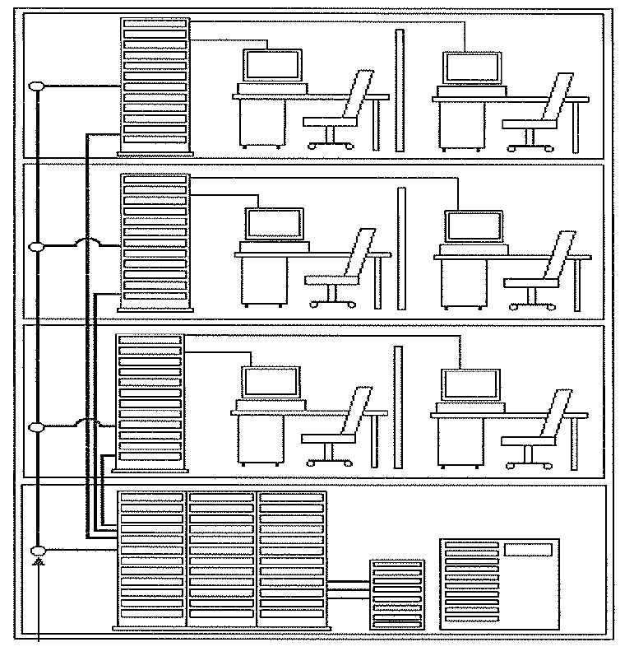
Media | Distance
100 OHM | 800m (874 yds.)
150 OHM | 700m (766 yds.)
50OHM | 500m (547 yds.)
50/125 micro Fiber | 2000m (2187 yds.)

BACKBONE

The system will be utilized with the sleeves or slots methods to establish a pathway for the backbone cables system runs between floors.

It is recommended that a minimum diameter of 10cm (4 in.) for sleeves. The sleeve should extend from 2.54cm (1 in.) to 10cm (4 in.) above floor height. The minimum slot (rectangular opening) size should be 15cm (6 in.) by 22.5cm (9 in.).

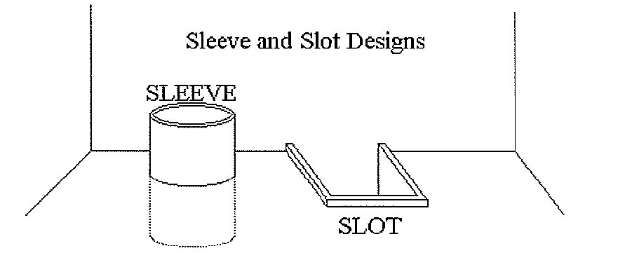

The following tables indicate the minimum size for slots and sleeve based on the size of the floor area serviced by the cables feeding that floor:

Sleeve Requirements
Floor Area In Square Meters (Feet) | Number of Sleeves
Up to 4,500 (50,000) | 2
4,500 (50,000) to 9,000 (100,000) | 3
9,000 (100,000) to 28,000 (300,000) | 4
28,000 (30,000) to 45,000 (500,000) | 5

Slot Size Requirements
Floor Area Served by Shaft  in Square Meters (Feet) | Size of Slot  in Centimetres (inches)
Up to 23,000 (250,0000 | 15 (6) X 23 (9)
23,000 (250,000) to 50,000 (600,000) | 15 (60 X 46 (18)
50,000 (600,000) to 90,000 (1,000,000) | 23 (90 X 51 (20)
90,000 (1,000,000 to 130,000 (1,400,000) | 30 (12) X 51 (20)
130,000 (1,400,000) to 185,000 (2,000,000) | 38 (15) X 61 (24)

The vertical cable runs to the cable trays will be secured.
The cable will be supported over the length of the run by using a support stand between the highest floor and the basement. The cable will be strap to the support strand every 90cm (36 in.) with a minimum of three (3) ties per floor. Steel ties will be utilized for this purpose. To reduce the stress off the bend radius at the top of the run, the cables with a collar grip or similar device will be adequately supported. The collar grip would grasp a minimum of30cm (12 in.) of cable length immediately below the bend.

The backbone cabling will be secured via the following methods:

Affix a support collar around the cable where it passes down through a slot (or sleeve).

Rest the support collar on the edge of the opening so that it support the weight if the cable at the floor.

Wire-tie the cable between collar-supported points to supporting members on each floor.

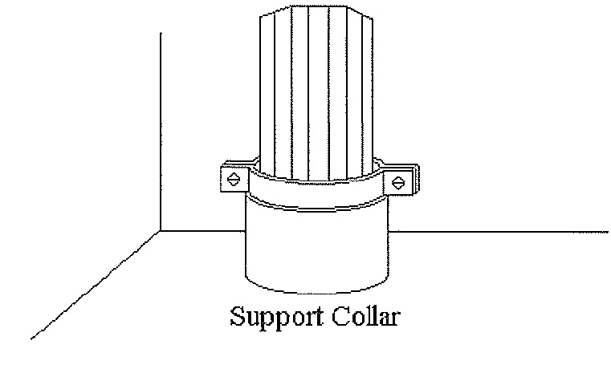

NOTE :

FAILURE TO ADEQUATELY SUPPORT THE CABLE OVER THE LENGTH OF THE RUN WILL RESULT IN DAMAGE TO THE INTERNAL COMPONENTS OF THE CABLE. (i.e. FIBER STRANDS CONDUCTORS, ETC.).

TAKE CARE NOT TO COMPRESS THE JACKET OF OPTIC FIBER CABLES WITH TIES OR OTHER SUPPORTS.

- FIBER OPTIC CABLE JOINTING AND COMMISSIONING OF THE SYSTEM

Termination of Fiber Optic Cable

Before performing the fiber termination, the fiber should be checked for continuity. The fiber ends should be cleaved and a light source is used to ensure no problems exist with the fiber end to end, i.e.: breakage.

The installation of optical fiber cable must meet the physical requirements of the manufacturer for bend radius, strain relief and cable support.

To do a mechanical splices using fiber termination tool, either using ST or SC as a connector and patch into fiber optic panel's coupler.

To perform OTDR (Optical Time Domain Reflectometer) testing after completed the fiber termination. The maximum loss should be less than 11db (EIA/TIA 568A Standard).

End

