Method Statement for Set Up Scaffolding
Assembling: 1st Level
Step 1: Make sure Wooden Plank / Sole Plates is using.
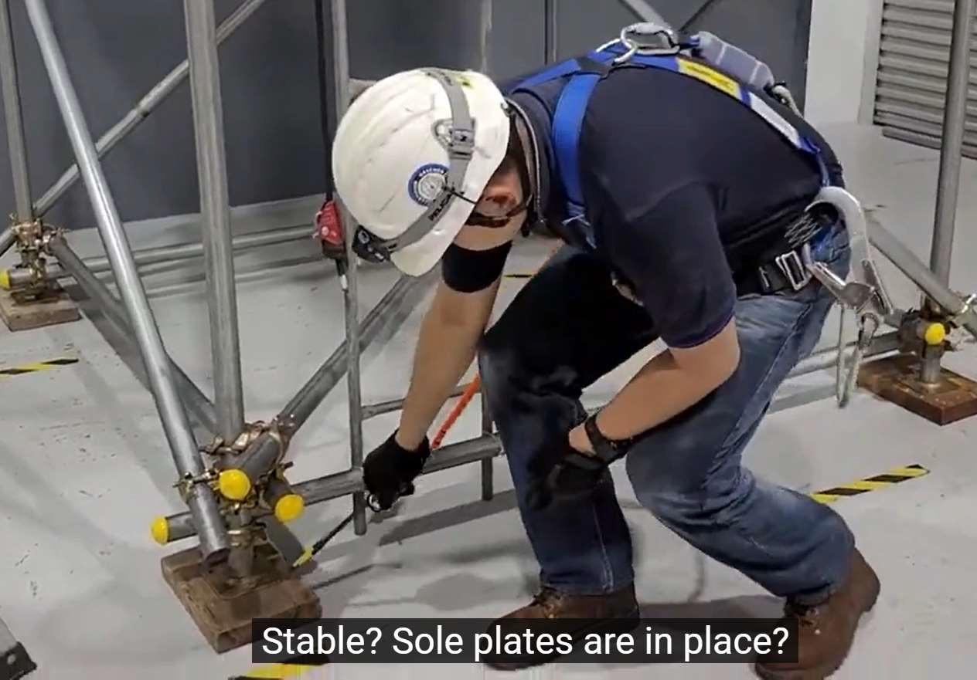

Step 2: Make sure Base Jack is in place before erect Vertical Frame
HX Solutions Sdn. Bhd. Project Department Issue No.: 1
Revision No.: 0
Effective Date: 01 Jul 2024 Document Ref.: MS-E025

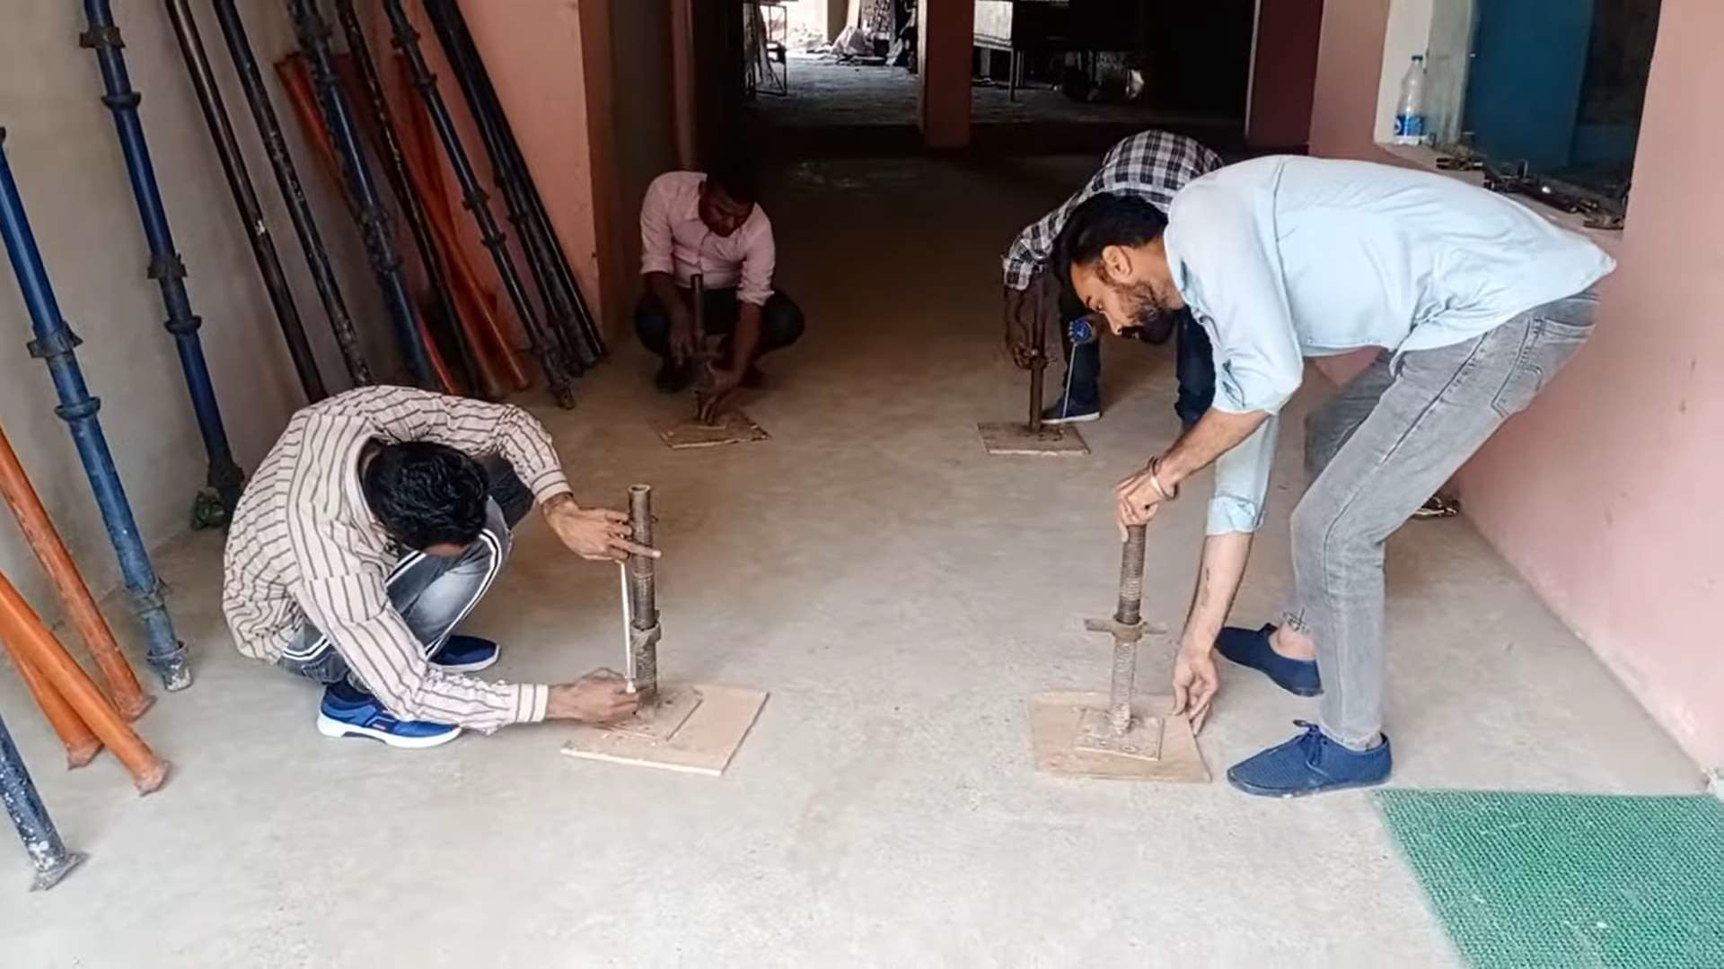

Step 3: Install the Vertical Frame for left and right follow by scissor bar.
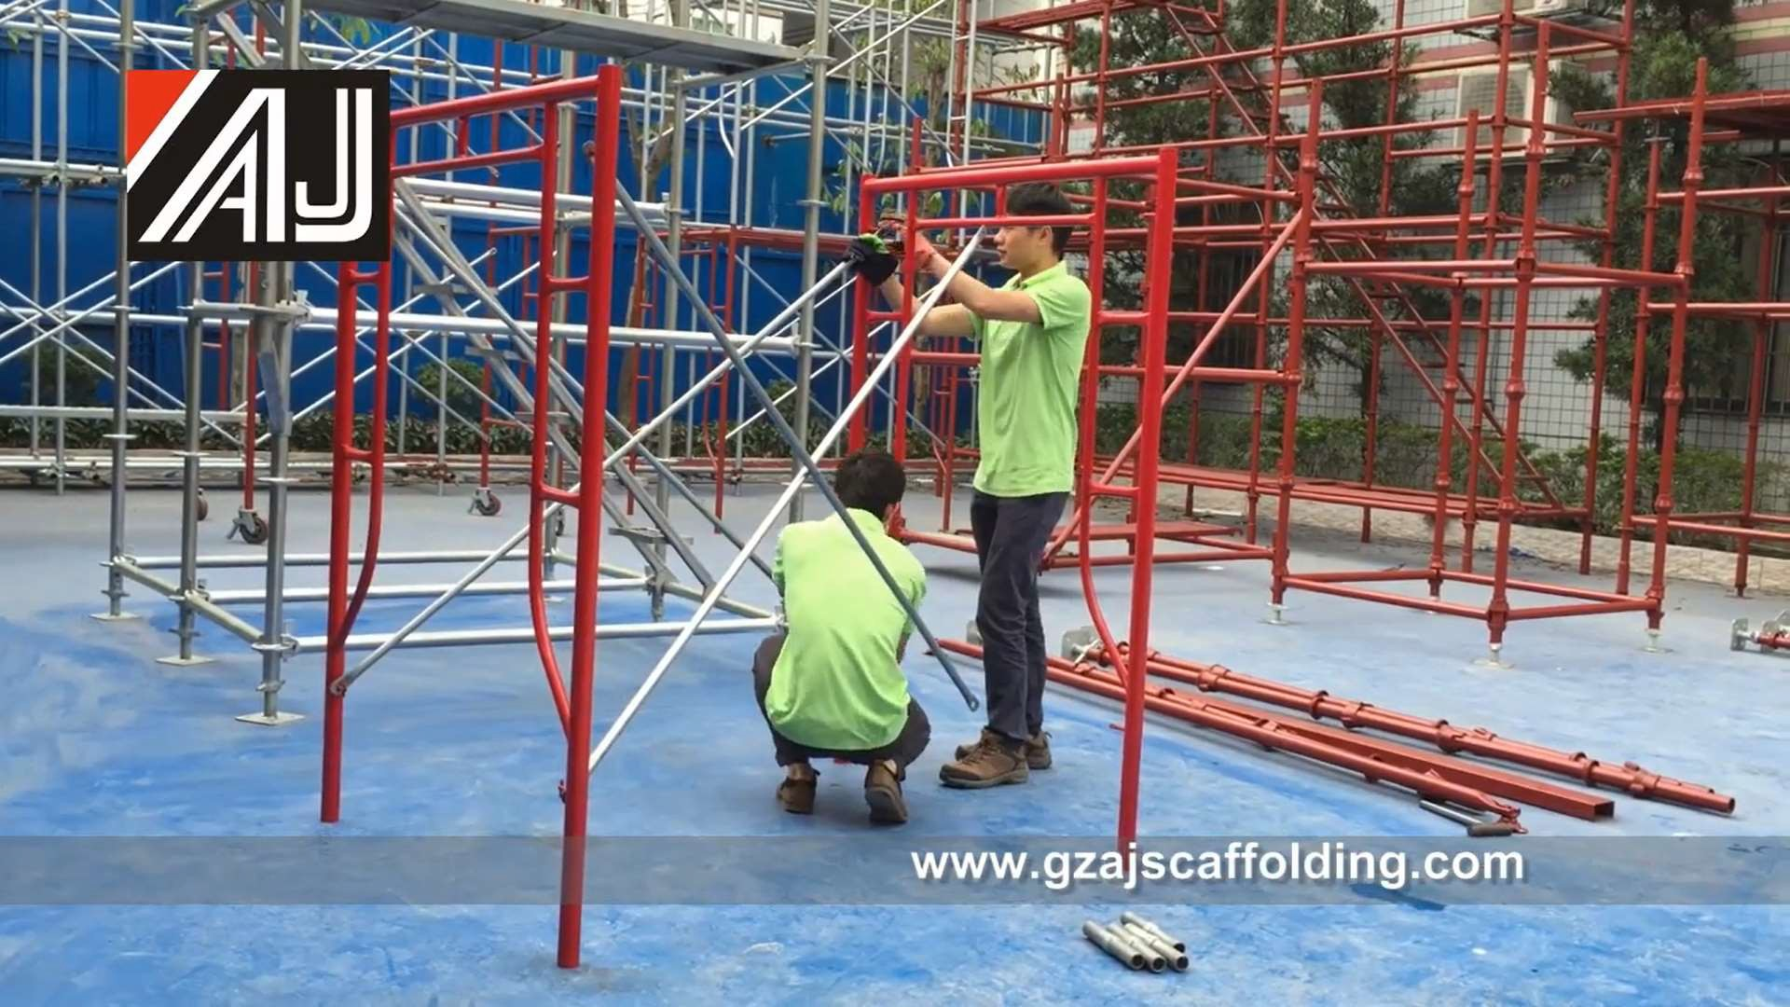

Step 4: After Install the scissor bar, make sure the latch is working fine
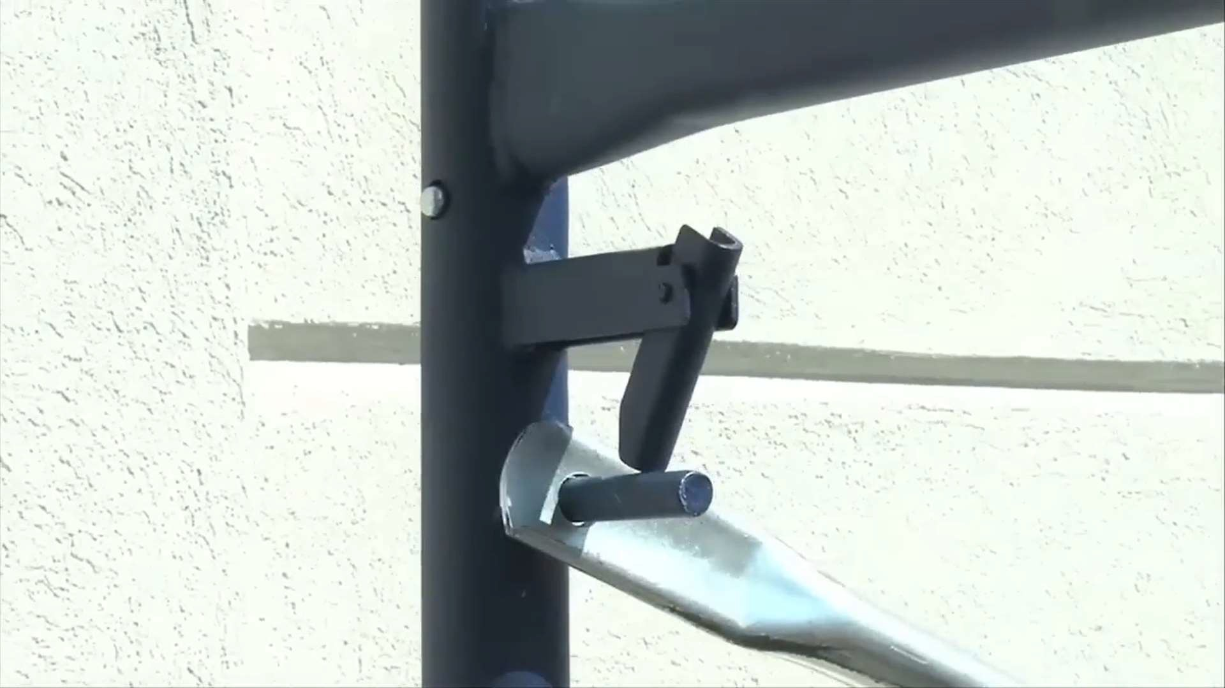
Step 4: Level 1 installation completed. Water level check for the scaffolding before continue to next level
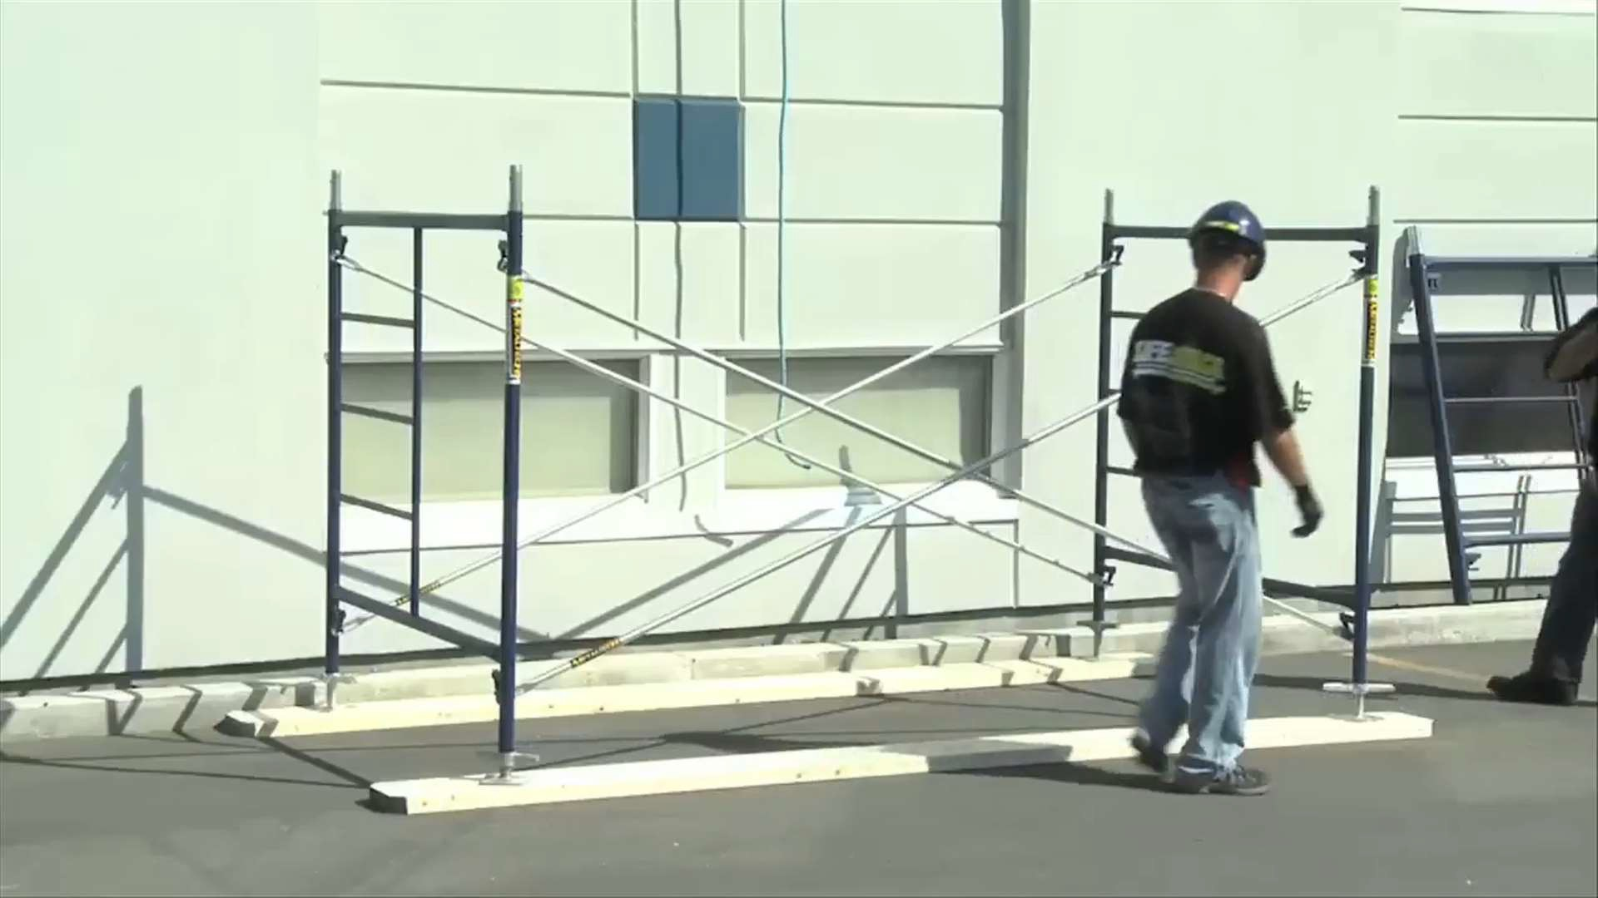

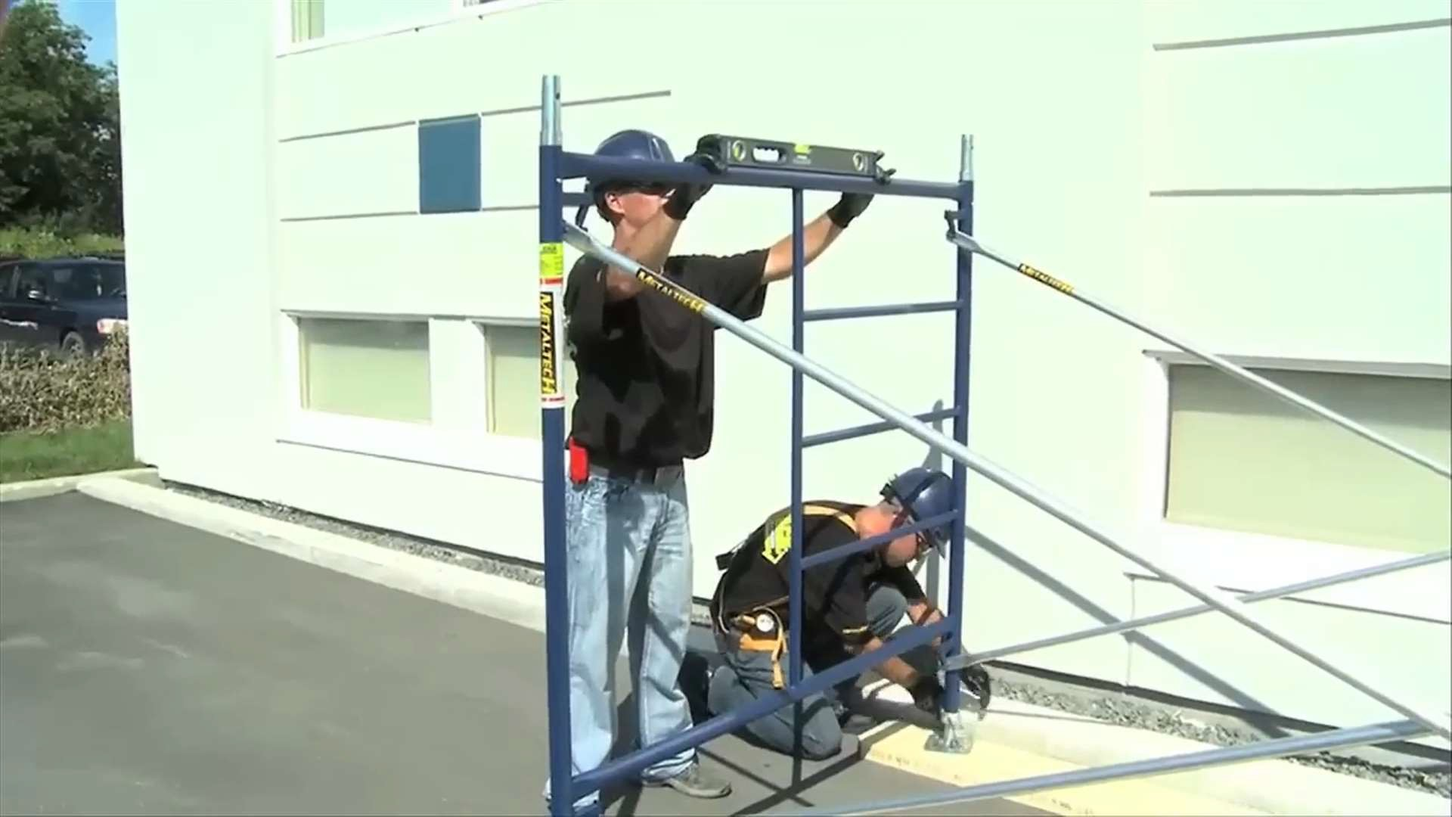

Assembly For Additional Level
Step 1: Apply Plant Plate, before continue to erect left and right frame for the next level
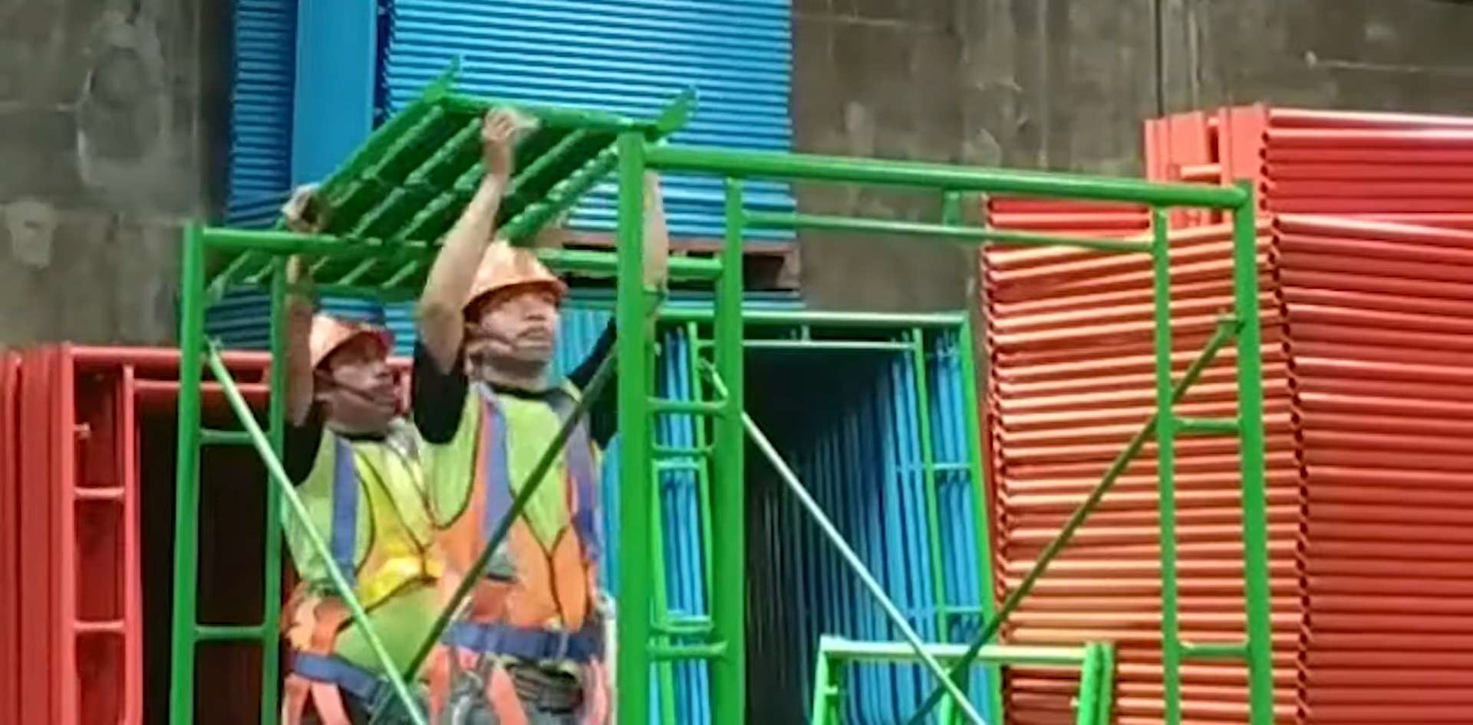

Step 2: Install staircase for access step to next level
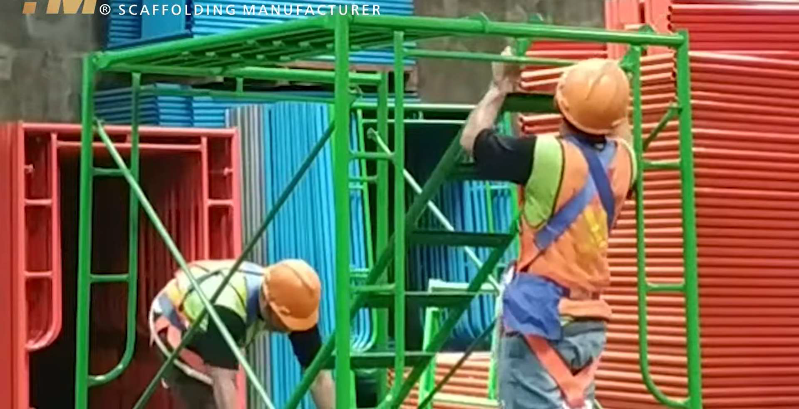

Step 3: Continue erect to the next level.
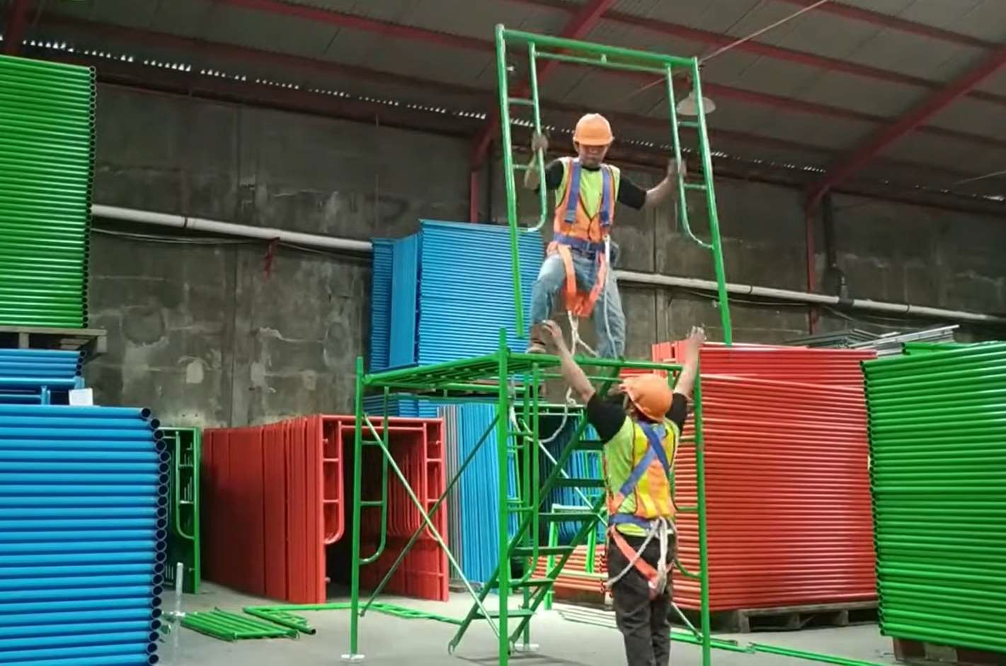

Step 4: Install guardrail at working high level (>6 feet), there is 2 option to install Option 1: Using Scissor Bar
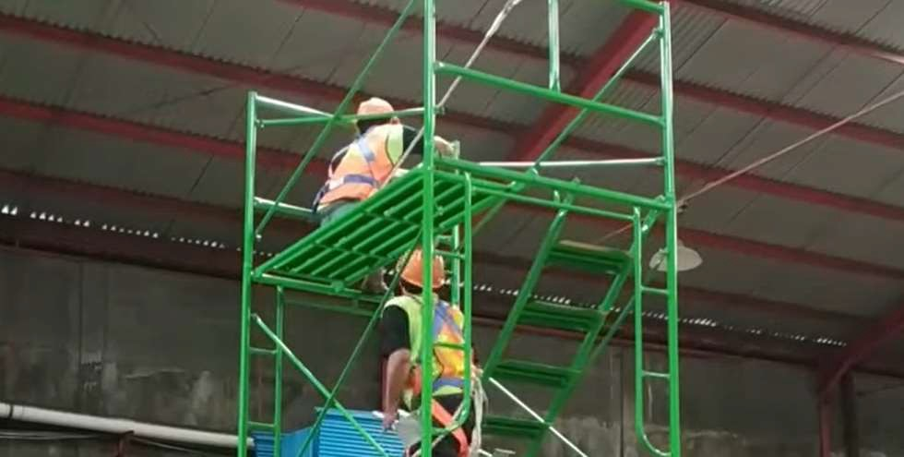

Option 2: Using GI Pipe
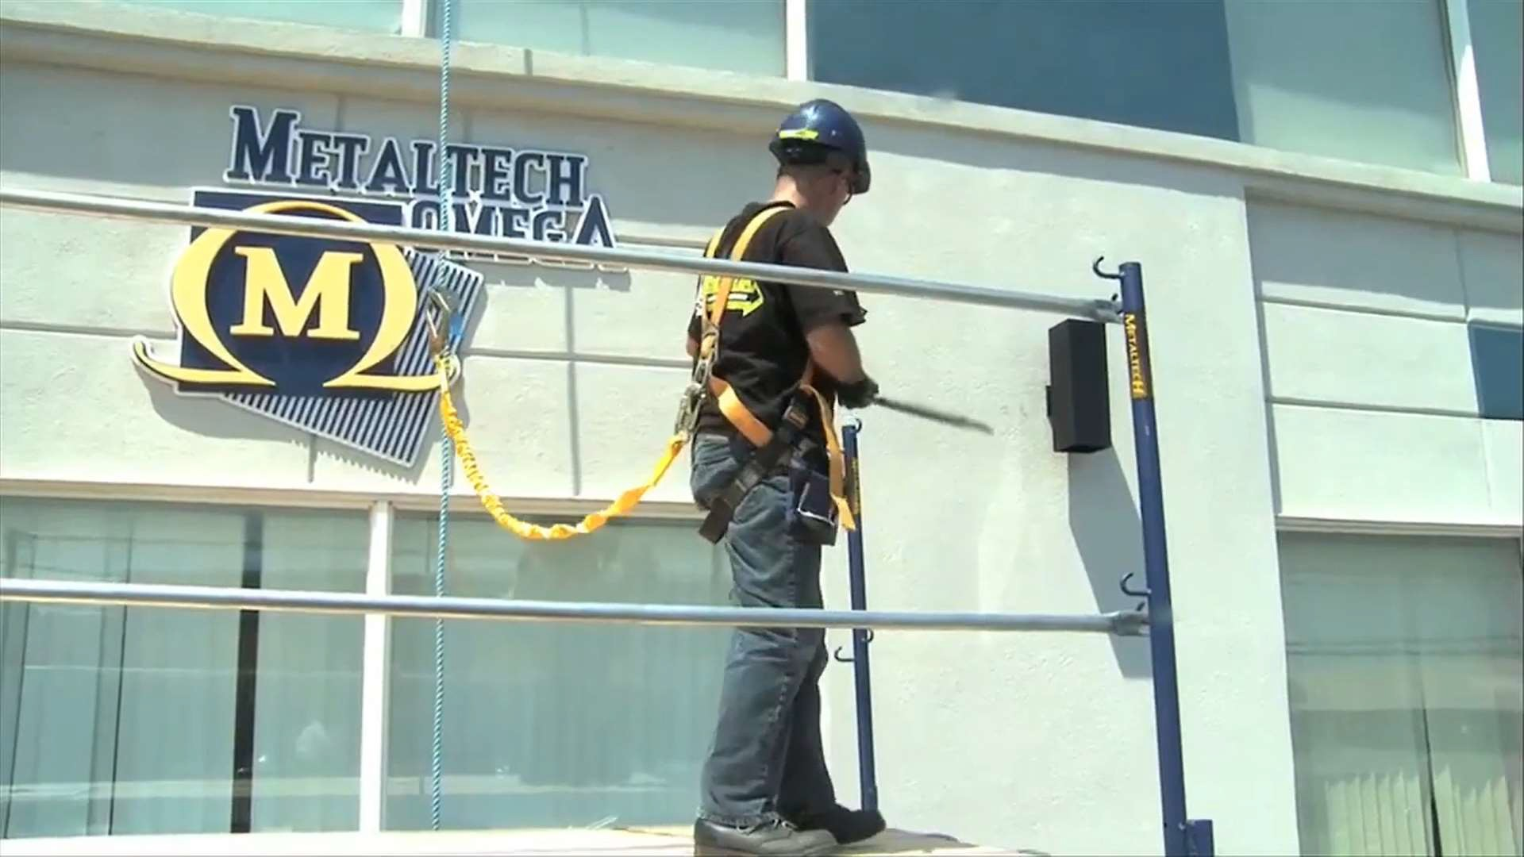

Stabilizing scaffolding
Note: Any scaffolding erect < 3 times of vertical frame need additional support for stabilizing. There is 2 option to install
Option 1:
Example: Extent the coverage for 1st level by add in vertical frame for stabilized as show below
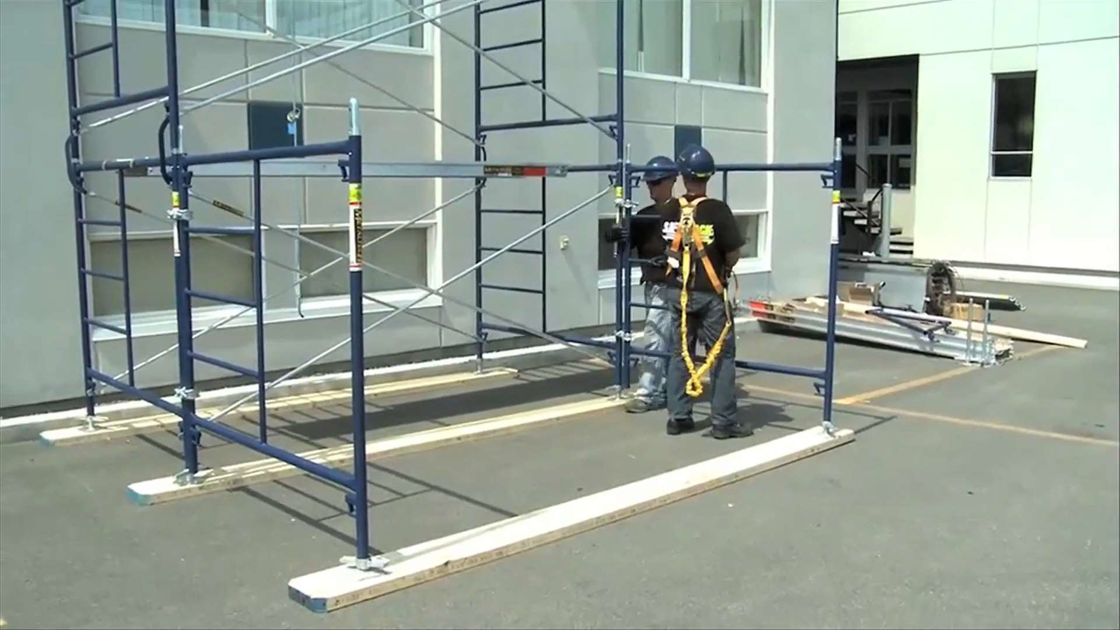

Option 2:
Example: Add GI pipe to support the scaffolding as show below
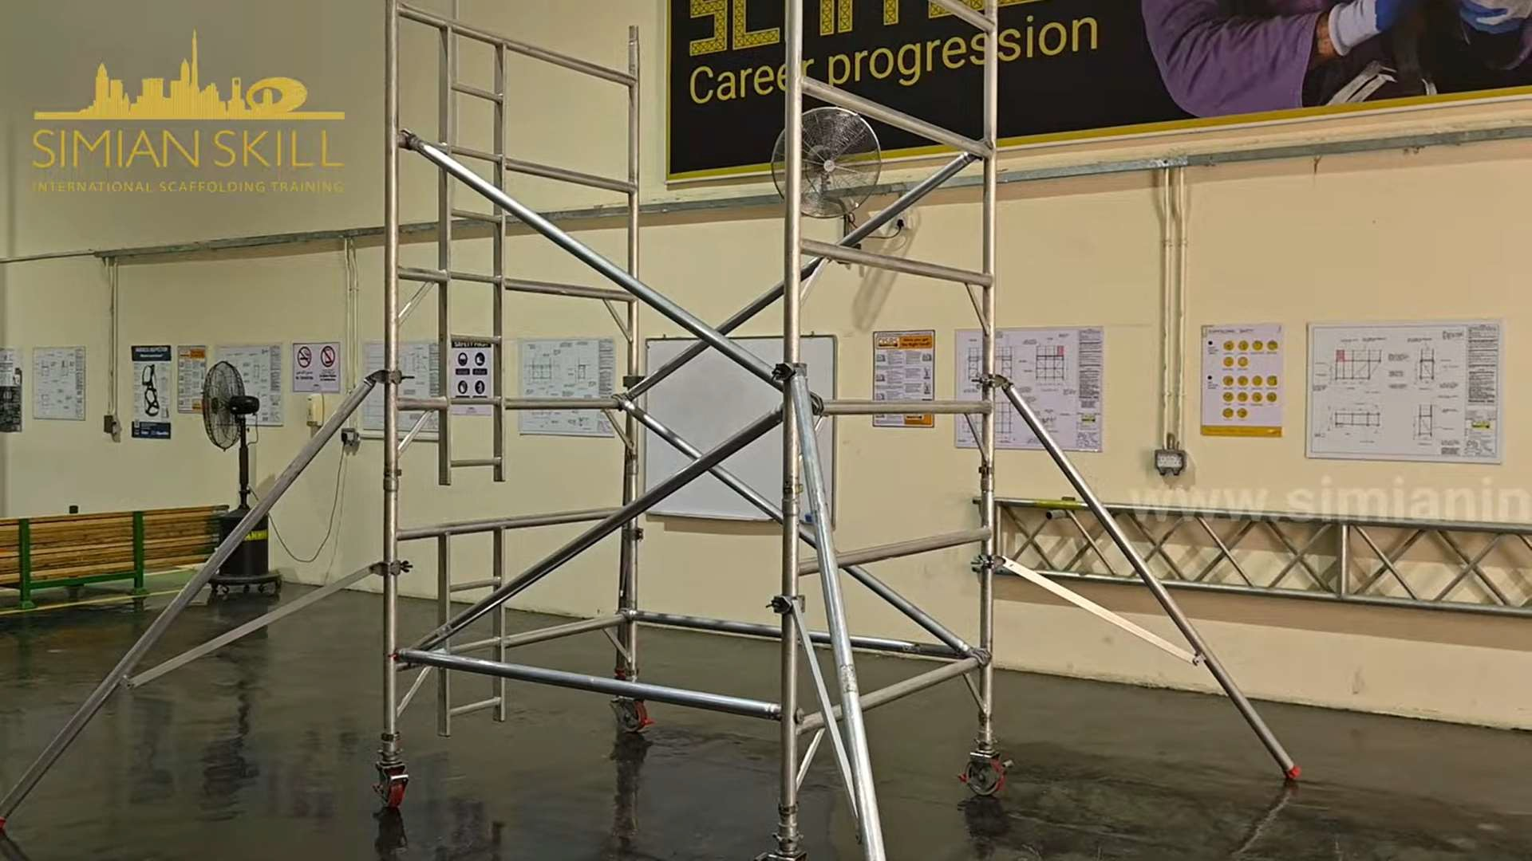
----END----
Prepared by: Ho Chan Hoong 1/07/2024

